**THE EFFECTIVENESS OF GUESSING GAME ON**

**STUDENTS’ SPEAKING SKILL AT SMP NEGERI 3**

**NGRONGGOT NGANJUK**

**THESIS**



**By:**

**DEA FALIHA RUCITA**

NIM. 204180018

**ENGLISH LANGUAGE TEACHING DEPARTMENT**

**FACULTY OF TARBIYAH AND TEACHER TRAINING**

**STATE ISLAMIC INSTITUTE OF PONOROGO**

**2024**

**THE EFFECTIVENESS OF GUESSING GAME ON**

**STUDENTS’ SPEAKING SKILL AT SMP NEGERI 3**

**NGRONGGOT NGANJUK**

**THESIS**

Presented to Islamic Institute of Ponorogo in Partial Fulfillment of

Requirement for the Degree of Sarjana in English Language Teaching Department



**By:**

**DEA FALIHA RUCITA**

NIM. 204180018

**ENGLISH LANGUAGE TEACHING DEPARTMENT**

**FACULTY OF TARBIYAH AND TEACHER TRAINING**

**STATE ISLAMIC INSTITUTE OF PONOROGO**

**2024**

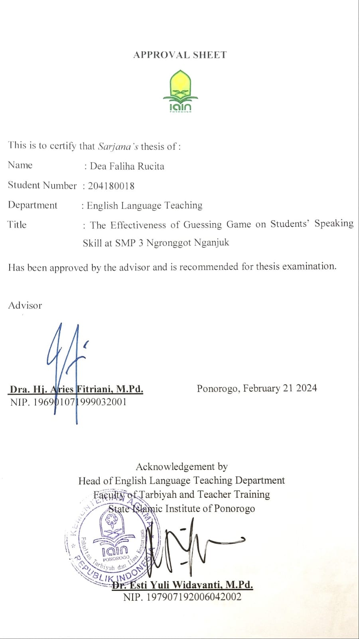

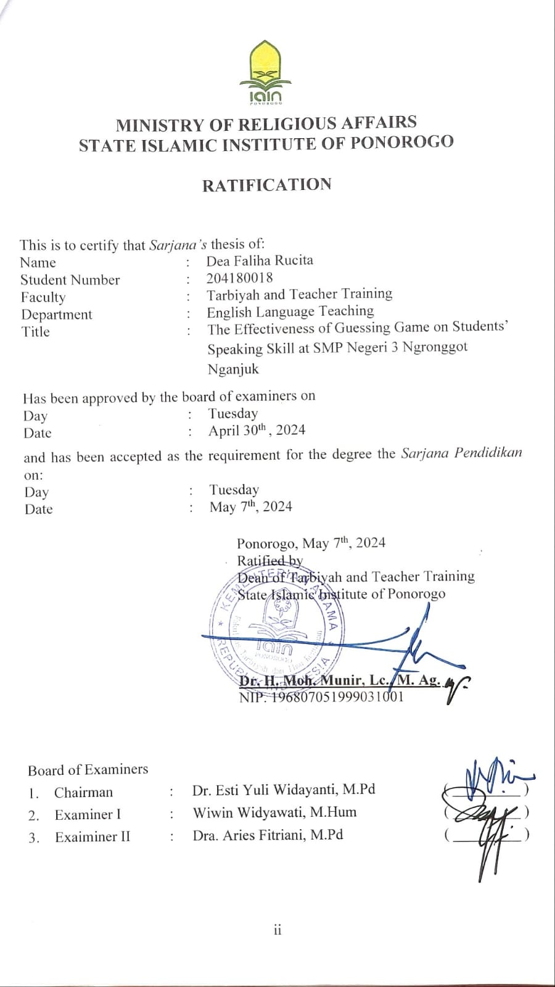

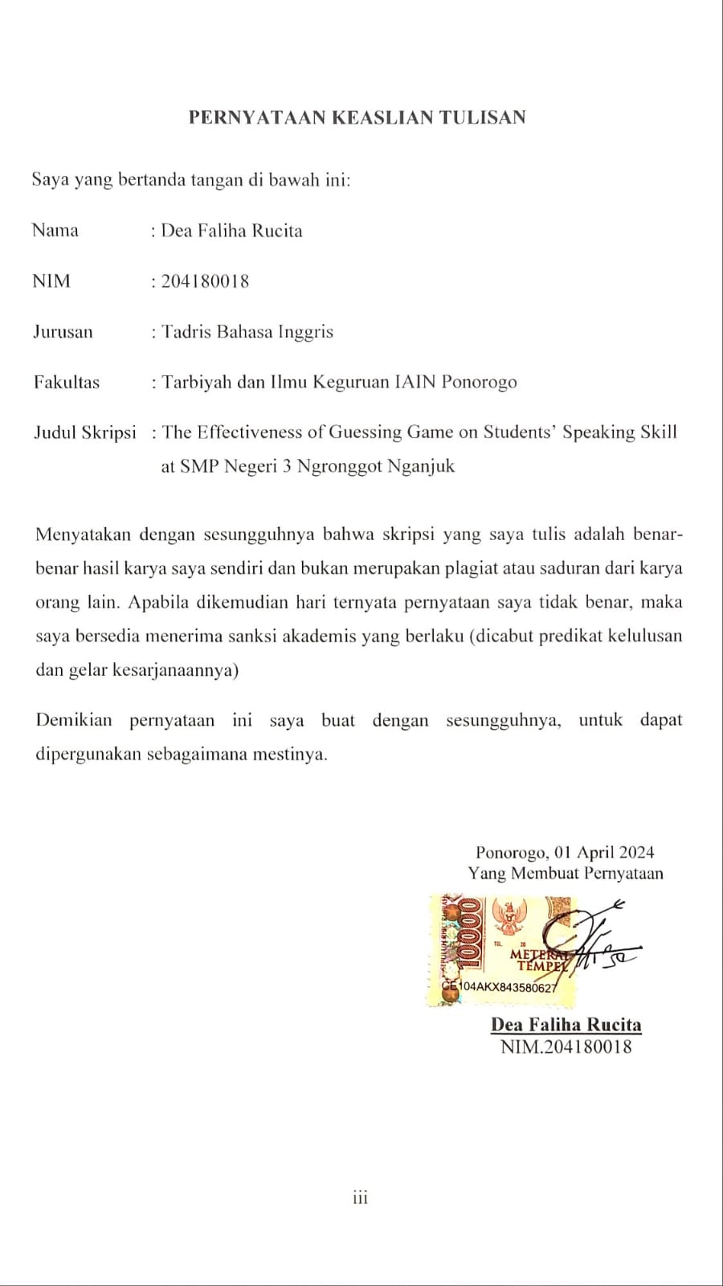

# DEDICATION

This thesis is dedicated to:

* My beloved parent Hery Santoso and Evi Wahyuningsih. Thankyou for all of your support, your prayers and also your famous line that you have always said to me.
* My beloved grandmother who always takes care of me, pray for me and has a very kind heart, also my grandfather who has return in peace.
* My younger sister who always annoying but I still love.
* All my goodfriend and everyone who loves me, your support is greatly appreciated.

# MOTTO

مَنْ كَانَ يُؤمِنُ بِاللهِ وَاْليَوْمِ الآخِرِ فَلْيَقُلْ خَيْراً أَو لِيَصْمُتْ

Whoever believes in Allah and the Last day, They should speak goodness or remain silent.

“Barangsiapa yang beriman kepada Allah dan hari akhir, hendaklah ia berkata-kata yang baik atau diam”

(HR. al-Bukhari).[1]

# ABSTRACT

**Rucita, Dea Faliha.** 2024.*The Effectiveness of Guessing Game on Students’ Speaking Skill at SMP Negeri 3 Ngronggot Nganjuk in Academic Year 2021/2022.* **Thesis**, English Language Teaching. Faculty of Tarbiyah and Teacher Training, State Islamic Institute of Ponorogo. Advisor Dra. Hj. Aries Fitriani, M.Pd.

**Keywords** *:English Teaching Learning, Guessing Game.*

Speaking is one of the abilities that we got to be mastered in learning English. Through speaking, people can express their thoughts and reason orally to the audience members. In this research, the researcher focused on speaking skill and used the “Guessing Game” technique. Guessing games can be a very effective tool in improving students' abilities and can help to develop the student abilities in teaching learning, including speaking skill.

This research aims to find out whether there is any significant different between students who are taught using Guessing Game Technique and Students who are not taught using Guessing Game Technique in speaking skill?

This research applied a quantitative approach and used the quasi experimental design. The population was the seventh grade students’ of SMPN 3 Ngronggot Nganjuk academic year 2021/2022. The sample for this research included a total 64 students’, with 32 students in the experimental group and 32 students in the control group. Data were collected using two methods: testing and documentation. The research followed a structured procedure, which involved conducted a pre-test, giving treatment, and conducted a post-test. Subsequently, data analysis was performed after scoring the tests, and the analysis was carried out using the T-test formula in SPSS.

The result of the research showed that the Guessing Game technique can improve students’ speaking skill. It can be concluded that the experimental group achieved a significantly higher mean score on the post-test compared to the control group. Specifically, the post-test mean score for the experimental group was 90.31, whereas it was 65 for the control group. Furthermore, the calculated T-test result yielded a t-value of 9.208, which was notably higher than the critical t-value (t-table) of 2.042 with 62 degrees of freedom. Based on these outcomes, we can confidently conclude that the alternative hypothesis (Ha) is supported, and the null hypothesis (Ho) is rejected. Based on the provided explanation, it can be inferred that there was significant difference in the speaking skill achievements of students who were taught using the Guessing Game Technique compared to those who were not. In simpler terms, the Guessing Game Technique proved to be effective in improve the speaking skills of seventh-grade students at SMPN 3 Ngronggot Nganjuk.

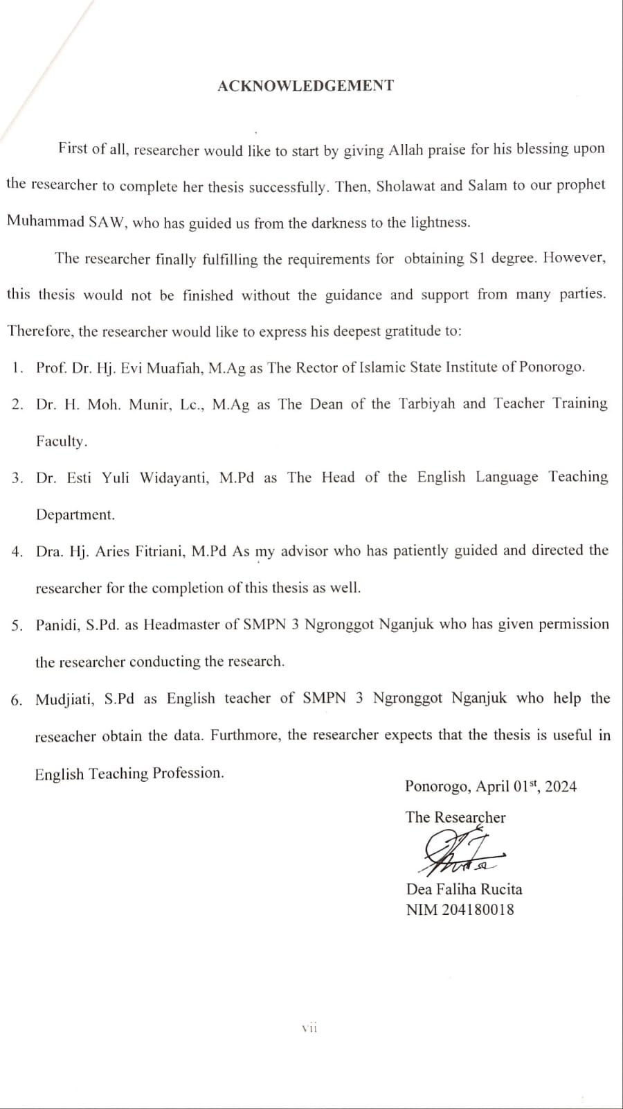

# TABLE OF CONTENTS

**COVER** i

**PAGE TITLE** ii

**APROVAL SHEET** iii

**RATIFICATION** iv

**STATEMENT OF AUTHENTICITY** v

**DEDICATION** vi

**MOTTO** vii

**ABSTRACT** viii

**ACKNOWLEDGMENT** ix

**TABLE OF CONTENTS** xi

**LIST OF FIGURES** xiii

**APPENDICES** xiv

**CHAPTER I: INTRODUCTION** 1

1. Background of the Study 1
2. Statement of the Problem 5
3. Objectives of the Study 5
4. Significant of the Study 5
5. Organization of the Study 6
6. Limitation of the Study 7

**CHAPTER II: REVIEW OF RELATED LITERATURE** 8

1. Theoretical Background 8
2. Speaking Skill 8
3. Game 16
4. Guessing Game 21
5. Previous Research Finding 26
6. Theoretical Framework 29
7. Hyphothesis 29

**CHAPTER III: RESEARCH METHOD** 31

1. Research Design and Approach 31
2. Location and Time of research 33
3. Population and Sample 33
4. Operational Definition of Research Variable 35
5. Research Instrument 35
6. Data Collection Technique 37
7. Data Analysis Technique 38

**CHAPTER IV: RESEARCH RESULT** 43

1. Statistic Description 43
2. The Procedure of Experimental Class 44
3. The Procedure of Control Class 47
4. The Results of Students' Pre-Test and Post-Test in Experimental Class 48
5. The Results of Students' Pre-Test and Post-Test in Control Class 48
6. Inferential Statistic 54
7. Discussion 58

**CHAPTER V: CLOSING** 61

1. Conclusion 61
2. Suggestion 61

**BIBLIOGRAPHY** 63

**APPENDICES**  66

# LIST OF TABLES

Table 2.1 Assesing Rubric of Speaking 14

Table 3.1 Experiment and control class schedule 33

Table3.2InstrumentofDatacollection 36

Table 3.3 The result of Validity Statistical Calculation 39

Table 3.4 The Result of Reliability Statistical Calculation’ 40

Table 4.1 The result of students’ pre-test and post-test in experiment class 48

Table 4.2 The categorization students’ pre-test in experiment class 50

Table 4.3 The categorization of students’ post-test in experimental class 51

Table 4.4 The result of Students’ Pre-test and Post-test in Control Class 51

Table 4.5 The categorization of students’ pre-test in control class 53

Table 4.6 The categorization of students’ post-test in control class 54

Table 4.7 One-Sample Kolmogorov-Smirnov Test experimental class 55

Table 4.8 One-Sample Kolmogorov-Smirnov Test Control Class 55

Table 4.9 Homogeneity of variances 56

Table 4.10 The mean of score of experimental and control class 57

Table 4.11 The calculation of T-test 57

# LIST OF FIGURES

1. Figure 4.1 Shapes of Geometric Objects 44
2. Figure 4.2 Example of Preposition 45
3. Figure 4.3 Picture of the test 45
4. Figure 4.4 Histogram of Pre-test in experimental class 49
5. Figure 4.5 Histogram of Post-test in experimtal class 50
6. Figure 4.6 Histogram of Pre-test in control class 53
7. Figure 4.6 Histogram of Pre-test in control class 54

# LIST OF APPENDICES

Appendix 1. 1 Title Submission Sheet

Appendix 1. 2 Research Matric

Appendix 1. 3 Lesson Plan Experimental Class

Appendix 1. 4 Lesson Plan Control Class

Appendix 1. 5 Item Validity Calculation

Appendix 1. 6 Test Paper

Appendix 1. 7 Documentations

Appendix 1. 8 From Construct Validiy

Appendix 1. 9 Research Permit

Appendix 1.10 Letter of Having done research

Appendix 1.11 Statement Later

# CHAPTER I

# INTRODUCTION

## Background of the Study

Mastery of four essential skills like reading, listening, writing, and speaking is imperative in learning English. Among these, speaking stands out as a crucial ability that requires diligent honing. As Thornbury aptly pointed out, "Speaking is so integral to our daily lives that we often overlook its significance."[2] ”This underscores the capacity of speech to effectively articulate thoughts and ideas to others. Consequently, attaining proficiency in speaking a foreign language necessitates dedicated practice. In Indonesia, English holds a central position in the school curriculum, with students required to study it from elementary through senior high school levels.

Burns acknowledged that speaking in a foreign language poses a significant challenge for most learners, as it entails more than just understanding grammar and semantics.[3] A similar situation was observed among second-grade students at SMPN 3 Ngronggot Nganjuk, where they struggled to articulate English words accurately and appeared perplexed when attempting to convey their thoughts. Many students lack enthusiasm and confidence in using English, particularly during speaking activities. Their lack of excitement and confidence, coupled with low motivation, hinders their English-speaking proficiency.

Two fundamental considerations in teaching speaking require attention when planning activities for an English class: determining the specific speaking skills to be emphasized and identifying effective teaching strategies for Richard.[4] Guessing game is a kind of a joyful and interesting game, which is almost loved by everyone.It can promote interactions among group of people. It is one of simple games which can be applied in the class involving all students. The guessing game, a universally enjoyable and engaging activity, fosters interaction within groups and can be easily implemented in class, involving all students. This approach finds support in various previous studies, including those by Maqfiroh, Fitriani, Chairina[5], Dewi, Kultsum, and Armadi[6] , Anggreyni[7], Yusri[8], and Virvou & Papadimitriou[9]. which successfully utilized the guessing game technique to enhance students' speaking proficiency. This underscores the technique's utility in speaking instruction and highlights its significance for English educators to incorporate into the teaching and learning process.

Fulcher emphasizes that in the process of education and learning, students often become disinterested in studying English due to repetitive materials and strategies, as well as limited opportunities for English practice.[10] Consequently, teachers should employ effective strategies for teaching speaking that engage students actively and foster motivation. Encouraging students to initiate discussions and providing opportunities for speaking practice can enhance motivation and create possibilities for interactive activities. Aligning with Savignon's perspective, teachers who allocate time for students to apply practiced skills in authentic, real-life contexts can significantly improve their speaking proficiency. Introducing diversions, such as games, is recognized as a successful approach to teaching speaking, as games can captivate students and encourage them to use English in an enjoyable manner. Integrating games into the teaching and learning process can enhance effectiveness and engagement.

A game that can be effectively utilized is the guessing game, where participants either compete individually or in teams to discern something. As Klippel[11] notes “The fundamental principle of the guessing game is remarkably straightforward “one person possesses knowledge that others seek to uncover.”. In addition, Similarly, according to Merriam Webster[12] ” a guessing game involves participants competing individually or in teams to identify something indicated obscurely, (such as in riddles or charades.)”. Wright and Buckby[13] further elaborate that in both guessing and speculating games, one individual possesses information while others endeavor to ascertain it. Additionally, the guessing game promotes active engagement in the learning process, encourages collaboration among students, and fosters enjoyment in learning.

It is important for them to practice speaking everyday to improve his or her ability to speak fluently and comprehensively. Quoted from Scott “speaking is like any other skills, such as driving or playing a musical instrument: the more practice you get, the more likely it is you will able to chunk small units into large”. So they should have stimulation to speak up.[14] Teachers have to take a part here. Teachers have a responsibility to prepare the students as much as possible to be able to speak in English in the real world outside the classroom.

Furthermore supported by Wright, games provide assistance and encouragement for many learners to sustain their engagement and efforts. This suggests that games inspire students to maintain their enthusiasm for studying and working during the teaching and learning process, as they find relaxation and enjoyment in the activities. Regarding strategies for teaching speaking skills, guessing games emerge as a valuable tool for this purpose. Wright emphasizes that in guessing and speculating games, one individual possesses knowledge while others strive to uncover it through purposeful inquiry. From this definition, it can be inferred that guessing games entail participants, either individually or in groups, attempting to identify or discover an answer based on provided clues.[15]

Teaching speaking remains a challenging endeavor for educators, despite its inclusion in the curriculum from early education stages. The perception of English as a foreign language in Indonesia presents a daunting prospect for students, particularly those in senior high school. Consequently, teachers must devise effective methods for teaching speaking skills. Through the integration of picture-guessing games into the instructional process, educators aim to support their students' success in learning, particularly in developing speaking proficiency.

The researcher's conclusion underscores the teacher's pivotal role in motivating and guiding students to explore and enhance their speaking abilities autonomously. Emphasizing students' speaking proficiency within descriptive texts is essential. The Guessing Game Technique, specifically tailored to improve English-speaking skills, is designed to ignite motivation and prompt students to actively participate in their learning journey. Moreover, by employing this technique, educators can cultivate a vibrant and enjoyable classroom environment, fostering students' comfort and enthusiasm as they immerse themselves in English language learning.

Hence the researcher is interested in conducting research on students’ speaking ability, with the title “The effectiveness of using Guessing Game on Students Speaking Ability at Seventh Grade of Smp Negeri 3 Ngronggot Nganjuk in Academic Year 2021/2022”**.**

## Statement of the Problem

Drawing from the preceding background information, the researcher formulated the research problem as follows: Is there any significant different between students who are taught using Guessing Game Technique and Students who are not taught using Guessing Game Technique in speaking skill?

## Objectives of the Study

In response to the stated problem, this study aims to examine the significance difference in speaking skills among students taught using the guessing game technique and those without it.

## Significant of the Study

The findings of this research are supposed to provide both theoretical insights and practical implications to the field of education..

1. Theoretical Importance
2. The outcomes of this investigation are poised to enrich the pool of scholarly resources available within the realm of education.
3. Subsequent research endeavors can draw upon the references and data provided by this research, enabling them to conduct more thorough and advanced research compared to the present study.

.

1. Practically
2. The teacher

The results of this research are supposed to provide English teachers with valuable insights to explore alternative solutions in teaching speaking.

1. English Students

The results of this research can serve as a valuable resource for English students, offering them an opportunity to address and overcome challenges in pronunciation skills.

## Organization of the Study

The researcher has structured this thesis systematically to facilitate the readers. The thesis comprises five interconnected chapters outlined as follows:

Chapter I serves as the Introduction, encompassing the study's background, problem statement, scope and limitations, research questions, objectives, significance, and organizational structure.

Chapter II focuses on the Review of Related Literature, exploring existing literature, previous studies, conceptual frameworks, and hypotheses.

Chapter III details the Research Method, elucidating the research design, approach, location, timeframe, population, sample, operational definitions of variables, validity and reliability measures, research instrumens, data collection methods, and data analysis techniques.

Chapter IV presents the Results and Discussion, providing a comprehensive overview of statistical data, inferential statistics, and discussions.

Chapter V serves as the Conclusion, summarizing the findings and proposing recommendations for future research endeavors.

## Limitation of the Study

Drawing from the background mentioned earlier, the researcher specifically concentrates on the activities integrated into the teaching and learning process of speaking. This focus is selected because engaging, stimulating, and dynamic activities play a crucial role in enhancing the effectiveness and appeal of speaking instruction. Employing the guessing game technique, this research endeavors to enhance the speaking proficiency of seventh-grade students at SMPN 3 Ngronggot Nganjuk.

# 

# CHAPTER II

# REVIEW RELATED LITERATURE

## Theoritical Background

### Speaking Skill

1. **Definition of Speaking skill**

Speaking is not only the sound of language coming out of the speech apparatus, it is also not speaking without meaning, but speaking is considered a language, which means conveying thoughts and feelings to others verbally or through speech. Speaking as a communication process, the process of changing the form of thoughts or feelings into the sound form of language.[16]

Arsjad and Mukti stated that speaking ability is the ability to pronounce sentences to express, state, convey thoughts, ideas, and feelings. The listener receives information through a series of pitches, pressures and joint placements (junctions). If it done face-to-face, hand gestures and facial expressions also play a role.[17]

Speaking is the ability to pronounce sounds articulation or words to express, state or convey thoughts, ideas and feelings. Speaking is a tool to communicate ideas that are compiled and developed according to the needs of listeners.[18]

The definition of speaking is also put forward by Brown and Yule in Puji Sentosa,speaking is the ability to pronounce the sounds of language to express or convey thoughts, ideas, or feelings orally. This understanding in essence has the same meaning as the understanding conveyed by Tarigan, namely that speaking is related to expressing words.[19]

The ability to speak is an indicator of all students development. Because the ability to speak is sensitive to delays or damage to other systems because it involves cognitive abilities, sensorimotor, psychology, emotions and the environment around students. A students will not be able to speak without the support of his environment. They have to hear conversations related to their daily lives as well as knowledge of the world. They must learn to express themselves, share their experiences with others and express their desires.[20]

From some of the opinions above, it can be concluded that speaking ability is the ability to express, state and convey ideas, thoughts, ideas or hearts to others by using spoken language that can be understood by others. Children's activities that can be done are by interacting and communicating with the people around them so that they can train children to be skilled at speaking.

1. **The elements of speaking**

Speaking is a creative product of linguistic strings, speakers make choices of lexicon, structure, and discourse.[21] Ability to speak fluently depends on how the speaker produces utterances to convey the meaning. Harmful states that the ability to speak fluently not only presupposes knowledge of the language features, but also the ability to process information and language “on the spot”.[22] In to do so, there are several elements that the speaker must pay attention to. The elements of oral production are described by Harmer as follows:

1. Connected Speech

Ability to use spoken language as native speakers used deletion, modify, add or modify the verb or auxiliary verb used to make speaking goes smoothly. For example like saying I will go and use in connected talk as in I'd've go.

1. Expressive Device

It is a change of intonation and certain parts of speech using special gestures, expressions or expressions to show how they are feeling. Expressive device supports the speaker to use the extra emotional expression and intensity that is contributes to the ability to convey meanings.

1. Lexis and Grammar

Lexis and grammar are also important elements in oral production, this is related to use of proper grammar and phrases in different and different functions context. Therefore, the teacher must provide various expressions for functions such as agree or disagree, express surprise, surprise, or agreement.

1. Negotiation Language

It is used to seek clarification and to show the structure of the speaker proverb. This allows listeners to ask for clarification from the speaker when they do sodon't understand what they are saying.[23] While part of the productive ability of speakers includes knowledge of . language skills as discussed above, the success of oral production also depending on the fast processing skills required, they are:

a) Language Processing, related to the speaker's ability to process language in their own heads and arrange them coherently so that they appear in the form of which is not only understood, but conveys meaning intentional.

b) Interacting with other people, in speaking absolutely involves interaction with other people one or more participants. This means that speaking is also effective involves a lot of listening, understanding how others participants feel, and knowledge of how to take linguistics turn around or let someone else do it. This is related to communication and interaction between speaker and listener.

c) Information processing (on-the-spot), relating to the speaker the ability to respond to the feelings of others by processing information the speaker recounts the moment. It can be concluded that information processing is the process by which listeners respond to what speaker said.[24]

1. **The functions of speaking**

Speaking's functions include delivering a message or thoughts from the speaker to the listener, as well as assisting the speaker and listener in understanding what the mean is. According to Richard, this distinction between the interaction function of speaking (which is used to develop and sustain social relationships) and the transactional functions of speaking is important (which focus on the exchange of information).[25] According to Brown and Yule, there are three functions of speech. Talk as interaction, transaction, and performance are the three types of talk.

1. Talk as interaction

It refers to what we usually mean by conversation and describes interactions that serve a major social function. When people meet, they exchange greetings, engage in small talk and chat, share recent experiences and so on because they want to be friendly and build a comfort zone interaction with other people. The focus is more on the speaker and how they want present themselves to each other rather than on the message.

2. Talk as a transaction

This type of talk refers to a situation where the focus is on what was said or done. The message is to focus here and make yourself known clearly and accurate, non-participant and how they interact socially with each other other. In the transaction, Jones in Richards said that the conversation about other people activity. For example, students can engage in hands-on activities. (for example in science lessons) to explore concepts related to floating and sinking. in the types of spoken language students and teachers usually focus on meaning or on speak their way to understand.

3. Talk as a show

A useful third type can be spoken of as show. This refers to public speaking. That is, a delivery that sends information before hearings such as morning talks, public announcements, and talks. Recognized by skill, strength, luxury. It is an activity done for entertainment.[26]

1. **The Concept of speaking**

In everyday life, Speaking is the most common form of communicative.building and sharing means to communicate information to listeners is a part of daily life. When children begin to speak, the line says, they experiment with speech that is formed to make words and phrases like bye-bye or see you. Children assimilate these words and structures as they become older. Into both actual and imagined games.[27].This indicates that speaking abilities can improve along with growth well. Students in junior high school should be able to correct their speech more than students in junior high and elementary school. It is possible because high school pupils have more time to study about speaking. They also have numerous possibilities to defeloped their speaking skills. However, students still find it challenging to improve their speaking abilities. Many adult learners’ primary goal is to improve their speaking abilities.

Their characteristics influence how quickly and how well they work. They will succed if they do everything correctly. They are risk takers who are not scared to make mistakes. In general, mistakes will be more active in speaking, but with a large number of faults it can be challenging. Furthermore, speaking skill is determined not only by the amount of time students have spent studying how to speak for a long time, but also by their environment in which they speak English. Because speaking sbility is a form of verbal intelligence, they must practice in everyday activities. Broughton, et al. support this phrase, starting that a students must be able to naturally create the language that has been provided to him and that he has rehearsed in one or more circumstances.[28]

The speaking scale has five criteria. They are grammar, vocabulary, understanding, explanation, pronunciation. In this study, researchers will use Oral English Assessment Sheet submitted by Brown.[29] Based on his explanation above, the researcher concludes that speaking skills are verbal intelligence in produce fairly to achieve communicative competence as measured by five criteria: grammar, vocabulary, comprehension, observation, and pronunciation.

1. **Assessing rubric of Speaking**

The assessment rubric is an assessment guide that describes the criteria that the teacher wants in assessing or grading the results of student work. The rubric needs to list the desired characteristics that need to be shown in a student's work accompanied by a guide for evaluating each of these characteristics.[30] Below is a Speaking assessment rubric as follows:

#### **Table 2.1 Assesing Rubric of Speaking[31]**

|  |  |  |  |
| --- | --- | --- | --- |
| **Indicator** | **Level** | **Description** |  |
| **Grammar** | 1 | Errors in grammar are frequent, but speaker can be understood by a native speaker used to dealing with foreigners attempting to speak his language | **20** |
| 2 | Can usually handle elementary constructions quite accurately but does not have thorough or confident control of the grammar. |
| 3 | Control of grammar is good. Able to speak the language with sufficient structural accuracy to participate effectively in most formal and informal conversations on practical, social, and professional topics |
| 4 | Able to use the language accurately on all levels normally pertinent to professional needs. Errors in grammar are quite rare. 5 Equivalent to that of an educated native speaker. |
| 5 | Equivalent to that of an educated native speaker |
| **Vocabulary** | 1 | Speaking vocabulary inadequate to express anything but the most elementary needs | **20** |
| 2 | Has speaking vocabulary sufficient to express himself simply with some circumlocutions |
| 3 | Able to speak the language with sufficient vocabulary to participate effectively in most formal and informal conversations on practical, social and professional topics. Vocabulary is broad enough that he rarely has to grope for a word. |
| 4 | Can understand and participate in any conversation within the range of his experience with a high degree of precision of vocabulary. |
| 5 | Speech on all level is sufficiently accepted by educated native speakers in all its features including breadth of vocabulary and idioms, colloquialisms, and pertinentcultural references |
| **Fluency** | 1 | No specific fluency description. Refer to other four language areas for implied level of fluency. | **20** |
| 2 | Can handle with confidence but not with facility most social situations, including introductions and casual conversations about current events, as well as work, family and autobiographical information. |
| 3 | Can discuss particular interests of competence with reasonable ease. Rarely has to grope for words |
| 4 | Able to use the language fluently on all levels normally pertinent to professional needs. Can participate in any conversation with a high degree of fluency. |
| 5 | Has complete fluency in the language such that his speech is fully accepted by educated native speakers |
| **Pronunciation** | 1 | Errors in pronunciation are frequent but can be understood by a native speaker used to dealing with foreigners attempting to speak his language | **20** |
| 2 | Accent is intelligible though often quite faulty |
| 3 | Errors never interfere with understanding and rarely disturb the native speaker. Accent may be obviously foreign. |
| 4 | Errors in pronunciation are quite rare. |
| 5 | Equivalent to and fully accepted by educated native speakers. |
| **Comprehension** | 1 | Within the scope of his very limited language experience, can understand simple questions and statements if delivered with slowed speech, repetition, or paraphrase | **20** |
| 2 | Can get the gist of most conversations of non-technical subjects (i.e., topics that requite no specialized knowledge). |
| 3 | Comprehension is quite complete at a normal rate of speech. |
| 4 | Can understand any conversation within the range of his experience. |
| 5 | Equivalent to that of an educated native speaker |
| **Total Score** | | | **100** |

### 2. Game

1. **Definition of Game**

Game is an activity with rules Games was applied to make the students easy to keep new words in their mind. The students looked happy when they played game. They like to move their bodies, such as playing games and singing songs. Furthermore,game also helps the students to improve their motivation in learning English. As the result, they will be more serious to learn.

Game is mean an activity which is entertaining and engaging, often challenging,and an activity in which the learners play and usually interact with others.[32] Game is an activity that has fun and enjoyment value inside of that. Game can motivate the students learn the new vocabulary, because only use the new vocabulary they can win the game.[33] Game is an activity to acquire a particular skill in a way encouraging. If the skills acquired in the game in the form of specific language skills, game is called language games. Learning to play is an integrated activity between learning and playing integrated in a subject matter. These acts are undertakings of creating a fun learning activities, with the ultimate goal of achieving a healthy learning and obtaining optimum quality.

Playing game in teaching speaking is very important because teaching through game can create a fun situation and of course can increase students’ motivation. Game not only helps the students to encourage them in learning but also can help the other teacher to create useful and meaningful context.[34] Definition of game is a structured activity, usually under for enjoyment and sometimes used as an educational tool. Definition of game theory: a set of concept aimed at decision making in situation of competition and conflict as well as cooperation and this paper proposes.

1. **Types of Game**

There are some types of game according to Wright,Betteridge and Buckby[35]

1. Care And Share

Caring and sharing games include all those games in which the learner feels comfortable while sharing personal information with other learners. These games relate more to invitation than to challenge.

1. Do: Move, Mime, Draw, Obey

The learner is expected to do something non-verbally in response to a read or a heard text.

1. Identify: Discriminate, Guess, Speculate

The learner is challenged to identify something which is difficult to identify or to hypothesise about something which is then compared with the facts.

1. Describe

The learner is challenged to describe something to another learner, by speaking or writing, so well that the other learner can do something, for example, draw a picture. The learner may describe something objectively or subjectively, communicating his or her own feelings and associations.

1. Connect: Compare, Match, Group

The learner is challenged to connect, compare, match or group various items of information, perhaps pictures or texts, objectively or subjectively. He or she uses language to describe or comment on the pairs or groups of information.

1. Order

The learner is challenged to put various bits of information into an order of quality and importance, subjectively or objectively, or to put texts, pictures, objects, into a developmental sequence, also subjectively or objectively.

1. Remember

The learner tries to remember something and then communicate what he or she has remembered.

1. Create

The learner is challenged or invited to make a story, write a poem or produce some other kind of material using their imagination.

Furthermore Erzos[36] describes games as highly motivating activities because they are amusing and interesting. They can be used to give practice in all language skills and used to practice many types of communication. Games are also as methods or techniques to involve students in learning. Well-chosen and designed games are invaluable as they give students a break and at the same time allow learners to practice language skills. Games generally emphasize on competition and wining, but they assist language learning by challenging students to demonstrate their understanding of English in an interesting way.

ames maybe classified according to whether they emphasize skill, chance,reality, or fantasy, as well as according to whether they are strategic or showdown games. In games or skill the outcome depends on the capabilities of the players, as in chess, tennis, or some types of business. Games of skills reward achievement, encourage individual responsibility and initiative, and discourage laziness. However, games of skill have the possible educational disadvantage of discouraging slow learners, dramatizing student inequalities and feeding the conceit of the skillful.

According to Hadfield[37] in the book of Ceyda Yalçin[38], there are two ways of classifying games to improve language skills. First, she classifies language games into two types, namely linguistic games and communicative games. Second, Hadfield classifies language games into more categories: Sorting, ordering or arranging games, information mixing games, guessing games, searching games, meeting games, labeling games, getting to know games, board games, and role-playing games.

She also said in the book that games, including guessing games, should be used as a teaching method in learning. Because guessing games can be a very effective tool in improving students' abilities, including speaking skill.

1. **The Reason of Using Game**

Few people get excited for a worksheet. Most people enjoy playing games, even if they don't know it. They tap into our emotions through pleasure, reward, competition,surprise, and more. Games harness our intrinsic motivations - in this case the desire to learn for the sake of the enjoyment of the learning process - to motivate us. They give us a sense of autonomy, competency, and relatedness motivation. Game players often reach what's known as the "flow" state. Flow, a term coined by psychologist Mihály Csíkszentmihályi, refers to a mental state of complete focus. It's possibly understood the easiest as the feeling athletes refer to as being "in the zone". This flow state is valuable as a framework to understand learners' emotions and what promotes engagement students.[39]

Generally, game is used to support teaching and learning process. In the past, the teacher formulated the goal of learning base on learners' behavior. To reach it, some media is used by several teachers. Base on their experience using media, audio, etc. the teacher knew that there are differences in process of learning students. Some of the learner is more actively in visual, some of them are good in audio and many learners will be more enjoy when they are learning by using game. From that explanation, game is not just a tool to help the teacher, but also media is a message distributor from the sender to receiver.

### 3. Guessing Game

1. **Definition of Guessing Game**

Researcher conducts guessing game in teaching speaking in order to know the significant effect of it. So, in this part the researcher will explain more about guessing game. Guessing game technique is a way of game to guess an object such as a verb, noun, abstract noun or phrase by giving many clues to the guesser as much as possible. Guessing game can be adopted from a television and radio, which creates the teaching and learning situation based on the student excitement of playing game. In guessing system, every student has time and chance to practice speaking and gives the clues to others until they can guess it correctly. So, in applying the game, students are much courage in thinking what they want to say**.**

Klippel said that the basic rule of guessing games is eminently simple: one person knows something that another one wants to find out. How this is down is determined by an additional sets of rules.[40] As the person guessing has a real urge to find out something, guessing games and as such are very important for foreign language learning. In those statements mentioned that there is an additional sets of rules. So, this means that the teacher must give the rules such as, ask the player to give a clue about something that written in a lottery paper,picture, or box. The words or something to be guessed have to different from game to game. It purposes to avoid the students bored so that they can practice English fun by using the game. Fulcher also said that guessing game give students to do not feel bored during learning process. [41]

The basic rule of guessing game is eminently simple; one person knows something that another one wants to find out”. Based on this opinion the guessing game is essential in guessing and speculating games, some one knows something and the others must find out what it is, and what the mean of that game. Guessing game is one of some games in teaching technique. Guessing game is a game in which the object is to guess some kind of information, such as a word, a title, picture, part of body and an object. It is clear that guessing games will increase students' motivation in learning English and improve their speaking.[42]

According to Houston, there are some principles of using games in the class:

1. Specify your purpose. The teacher must know what the purpose of games that he or she plays in the class
2. Explain the rules clearly before you begin. It is important to make sure the students understand how to play games. The purpose of the game cannot be reached if the students do not understand how to play the game. It is fine if the teacher explain the rule in native’s language.
3. Be prepared for the “extra student”. The teacher has to make sure all of the students join to games
4. Avoid drifting off during the game. When the game is play, watch for potential problem that can be remained. If you feel that is a student who is not understands the rules, stop game and go for the rules again.
5. Look for signs that students are getting tired. If the students look tired, the teacher should stop game before the students lost their attention.
6. Choose games carefully to save money and time. Try to use a game that can be prepared easily
7. Find new sources. Try to use a new game that never be used before
8. Recycle. If there is an old game that success applied in the class before. It is ok to use it again in another class.
9. Make a file. Make a file that consists of games. It can make you easy if you want to use games in another time.
10. Share. If you have a favorite game that you use to play with your best friend. You can use that game to your class.
11. Don’t do overdo it. Game is enjoyment and interesting in the class, but if you do it too much, it can waste the time and make another important thing don't have time to teach in the class.[43]

Finally guessing game is a simply game that can be applied in the class. Several groups in the class play this game. Guessing game can be applied in the course class.

1. **Benefit of Guessing Game**

Guessing games can be utilized to create or strengthen concept, to include redirection to standard exercises, or fair to break the ice. However, there must be an important function is to give practice in communication, stated by Richard Amato It says that guessing games can provide comfort and excitement,students will not feel boredom during learning process in the class.[44] Nevertheless, the most important thing is to give the students an opportunity in practicing their English. There are so many benefits of this guessing game. The students can feel the excitement when learning English because the teacher not only explains the subject matter, but also plays an exciting game. Students can also practice their speaking skills through this game. According to Hidayat[45] in the thesis of Dwi Rahmawati[46], the advantages of using guessing game in teaching speaking[47] are :

1. Guessing game can be used as a new technique in teaching and learning process
2. Guessing game can make students happy in speaking English
3. Guessing game create the well condition and enjoyable in the classroom
4. Guessing game can motivate the students to speak English easily
5. Guessing game can make the students interested to speak English with try to guess word in the guessing games activity
6. Guessing game can show the positive attitudes of each students in the learning process
7. Guessing game can enlarge knowledge, enrich vocabulary, receive and send message, and also can be as problem solving.

And the disadvantage of Guessing game happens when the teacher does not use time effectively. Therefore, the implementation of guessing game in teaching and learning process can be as a reference for the teacher in teaching speaking.

1. **Procedure of Guessing Game**

There are some tasks that a teacher can instruct to the students to perform the activities in the implementation of guessing game. Title, steps of procedure and spell the object, say something about the object and make up sentences using the object.

1. Pre-teaching activities

In the first activities, the teacher greets the students and checks the students' attendance. Then the teacher checks the students' readiness to study and also review the previous lesson to remind the students about the last lesson. In this stage, the teacher builds the students' background knowledge related to the lesson that will be given. Besides that, the teacher tells the students about lesson which are going to be taught and the teacher tells the achievement indicators and the objectives of the lesson which are going to be taught.

1. Whilst-teaching activities

Then in the main activities the teacher begins this stage by introducing the first lesson by using guessing game technique. Here are some of the procedures in applying the guessing game technique in the classroom:

1. The class is divided into two groups; one chairperson is given a picture of shape, and then tells a group a clue about the title, materials, and steps. The group should find the answer by drawing the shape to the correct order. The group which has correct order and a good description of the pictures will be the winner.
2. The teacher has a picture (materials and steps), which the students can't see. Teacher hides it in a box of the envelope. Students are required to guess and describe the pictures available, with the goal at the end of the game can mention the shape and the steps.
3. Post-teaching activities

In the last activities, the students are asked to be a volunteer to tell or conclude what are the lesson for today in front of the classroom. Then the teacher will give feedback by pronounce some words correct or well, which the students pronounce unwell while guessing game activity.

## Previous Research Findings

A few researcher has connected a few significant studies. It can be references of researcher to assist this study within the term of speaking and Guessing game.

There are three relevant previous reaserches related to this study. The first research is from Amelia Resti,Erni,Mahsyur which is entitled *The Effectiveness Of Guessing Games Technique In Improving Student’s Speaking Ability At Mtsn Hasanah Pekanbaru in academic year 2015* This study was about the application of guessing games technique in speaking ability of the first year students. The aim of this study was to find out the improvement students' speaking ability through guessing games technique at MTS Hassanah and to find out the effectiveness of guessing games technique in improving students' speaking ability. 24 out of 120 students were chosen through cluster random technique sampling. The analysis was based on giving oral test to the students. It was found that there were significant improvement: 4 students (16.7%) were in excellent level, 20 students (83.3%) were in good level, and there is no students in mediocre, poor and very poor level. It implies that the students' ability falls into good ability level Based on the result, it is recommended that teachers pay attention more to the students about how to speak English well. It is also important to apply games especially guessing game in the term of motivating the students so that they are brave to speak up and fun to learn English.

Then the second research is from Yunita Rahayu with the title *The Effect Of Using Guessing Games On The Seventh Grade Students Speaking Ability At Mts Negeri 2 Jember In The Academic Year 2013/2014.* In English there are four skills that should be learned by students: listening. speaking, reading and writing. Speaking is one of four skills that must be taught by the students. One of the important this skill to become reason for this research is speaking Considering that problem, teaching speaking was applied using guessing games to develop the students speaking ability. The problem in this research is "is there any significant effect using guessing games on the seventh grade students speaking ability at MTs Negeri 2 Jember in the academic year 2013/2014?"The purpose of this study is to investigate whether there is or not significant effect of guessing games on the seventh grade students speaking ability at MTs Negeri 2 Jember in the academic year 2013/2014. The kind of this research is quasi-experimental research. This research using the technique of cluster random sampling lottery and based on the result of the lottery, the two classes are VII B as experimental class that consist of 37 students and VII C as control class that consist of 38 students. The design of this research is quasi-experimental with pre-test and post-test design. To collect the data, the researcher uses subjective test in speaking test. The researcher uses independent sample t-test formula to analyze the data that collected by using SPSS (Statistical Product and Service Solutions) 16 for Windows. The result of data analysis shows that the obtained value of t-test is 2.815 and the critical value (t-table) from the degree of freedom 73 (df = N-2, df = 75-2 = 73) with the significant level 5% is 2,00. The data showed that the value of t-test is higher than the critical value. It means that the null hypothesis (Ho) is rejected and the alternative hypothesis (H,) is accepted. Considering the result above, it can be concluded that by using guessing games have asignificant effect on the seventh year students speaking ability at MTs Negeri 2 Jember in the academic year 2013/2014..

The third research is *The Use Of Guessing Game To Improve Learners’ Speaking Ability by Rhevaldi Arif Dwiputra, Clarry Sada, Iwan Supardi* in English Education Study Program Language and Arts Education Department Teacher Training And Education Faculty Tanjungpura University Pontianak. The aim of this research is to improve students’ speaking ability, especially in fluency and accuracy. This research was conducted at *the eight grade students of SMPN 3 Pontianak in academic year 2017/2018.* In this research, the subject is class VIIIF that consists of 38 students. The researcher conducted classroom action research. The difference between these research is this research use seventh grade class while those research using eight grade class. Both focused on speaking skill.

From the previous Research above, there are different from the between this study. That shown of third reseachers have been done the research about the use of guessing game to students speaking skill. In this research the researcher will use guessing game technique with shape as the media. It aims to know how this learning model can improve Students’ Speaking Skill.

## Theoritical Framework

Conceptual framework is a conceptual thought that can be connected to the elements that are recognized as the key issue. The following theories are described in the thesis, which is a quasi-experiment are :

X : Shape Guessing Game Technique

Y : Speaking Skill

In this research, the researcher tries to assist students investigate their speaking mastery by applying shape guessing game. The researcher uses Shape Guessing Game Technique in Speaking.. The researcher hopes by using Shape Guessing Game Technique, student’s speaking ability will improve than before.

## Hyphothesis

There are two Hypothesis in this study, those are:

1. Ha (Alternative Hypothesis) There are significant different in speaking ability of the students who taught by using Shape Guessing Game Technique.
2. Ho (Null Hypothesis) : there are no significant differences in speaking ability of the students who taught by using Shape Guessing Game Technique.

The hypothesis criterion states that; if t0 > tt = Ha is accepted and Ho is rejected, and if t0 < tt = Ha is rejected and Ho is accepted t0 is t observation, and tt is the t-test.

# CHAPTER III

# RESEARCH METHOD

## Research Design and Approach

Various types of experimental research designs exist, including pre-experimental designs, true experimental designs, factorial designs, and quasi-experimental designs.[48] In this study, the researcher opted for a quasi-experimental design, specifically employing a non-equivalent control group, pre-test and post-test design. This involved utilizing two classes for comparison to assess the impact of the guessing game on students' speaking abilities.

This study aims to investigate the effects of implementing guessing games on the speaking abilities of students at SMPN 3 Ngronggot Nganjuk during the academic year 2021/2022. The researcher designated two classes, one as the control group and the other as the experimental group. The experimental group participated in the guessing game trials, while the control group did not.

One of the frequently utilized quasi-experimental designs in academic research can be described as:

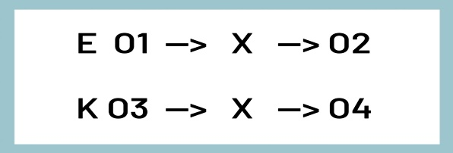

X : Treatment by using Shape Guessing Game Technique

O1 : Pre-test towards experimental Class

O3 : Pre-test towards control class

O2 : Post –test towards the experimental class

O4 : Post-test towards control class

The researcher will carry out this research in three phases, which include:

1. Pre-research preparation involves initial steps such as organizing the experimental and control groups, devising lesson plans, and preparing data collection instruments.
2. During the research phase, the researcher implements the planned treatment by instructing the experimental class using the Shape Guessing Game method. Data collection involves conducting both pre-test and post-test assessments to measure the impact of the treatment.
3. The final step involves collecting and analyzing the gathered data, which the researcher will thoroughly examine according to the described procedures:
   1. Gather post-test scores from both the experimental and control classes.
   2. Perform data analysis utilizing a T-test.
   3. The T-test, a statistical technique, is utilized to determine the acceptance or rejection of the null hypothesis, indicating whether there is a significant difference between two samples randomly drawn from the same population.[49]

## Location and Time of research

The research was conducted during the 2021-2022 academic year for seventh-grade students at SMP Negeri 3 Ngronggot, situated in Kelurahan, Ngronggot, Nganjuk, East Java. The survey took place from April 7th to April 19th. The schedule for both the experimental and control classes is depicted in the provided table:

Table 3.1 Experiment and control class schedule

|  |  |
| --- | --- |
| **Date** | **Activities** |
| April, 7th 2022 | Pre test |
| April, 12th 2022 | Treatment 1 |
| April, 14th 2022 | Treatment 2 |
| April, 19th 2022 | Post test |

Both the pre-test and post-test comprise 7 identical items, with both tests being oral assessments. The criteria for assessment are detailed in the preceding discussion.

## C. Population and Sample

1. **Population**

According to Fraenkel and Wallen, in research studies, a sample refers to the group from which data is collected, while the population represents the broader group to which researchers aim to generalize their findings.[50] The population in this research comprises all seventh grade students attending SMP Negeri 3 Ngronggot Nganjuk, Comprising a total of 5 classes during the academic year 2021/2022, the population encompasses 160 seventh-grade students enrolled at SMPN 3 Ngronggot Nganjuk throughout the specified academic year.

1. **Sample**

A sample denotes a subset of individuals, items, or events chosen to represent the larger population from which it originates.[51] Sampling entails selecting a predetermined number of individuals from a given population to act as representatives of that population.[52] This entails the selection of samples from the population..

This study will employ a method of simple random sampling, which involves selecting individuals from the population to serve as representative samples.[53] Random sampling encompasses various techniques, including coin tossing, dice rolling, lottery selection, blindfolded selection, and the Tippet table method.[54] This research will utilize a lottery system for the accomplishment of random sampling, as outlined below:

1. Prepare small pieces of paper.

2. Write table codes on the small pieces of paper

3. Register the small papers.

4. Shake the papers several times.

5. Select two pieces of paper randomly.

In this study, students from classes VII-1 and VII-3 at SMPN 3 Ngronggot were selected by the researcher due to their similar aptitude in the learning process, which was evidenced by their academic performance as reported by their teacher, Mujiati. According to Mujiati, who teaches seventh-grade students at SMPN 3 Ngronggot, the learning abilities of students in classes VII-1 and VII-3 are notably similar, particularly in the subject of English.[55] Hence, the researcher selected this class as the research sample.

## D. Operational Definition of Research Variable

The operational definition of the research is as follows:

1. Independent Variable (X)

The researcher employed the Guessing Game Technique in teaching speaking, aiming to simplify the understanding of Descriptive Text for students. Some suggest that utilizing the Guessing Game Technique for speaking instruction can enhance students' comprehension and prevent boredom during the learning process.

1. Dependent Variable (Y)

Mastering speaking skills is imperative as it is a vital subset of English proficiency, facilitating vocabulary development and enabling effective communication, particularly in interactions with foreigners or when working as a translator.

## E. Research Instrument

The instrument plays a crucial role in carrying out this research, serving as a means to measure, observe, or document quantitative data.[56] An instrument holds paramount significance in gathering essential data needed for experimental research. Various types of instruments include tests, questionnaires, interviews, observations, rating scales, and documentation. In this study, the instrument used for data collection is a test, which is divided into two segments: the pre-test administered before treatment, and the post-test conducted after treatment. Comparing the results of the pre-test and post-test during instruction allows for the measurement of students' progress.

Arikunto outlines several data collection instruments, including tests, questionnaires, interviews, observations, and documentation.[57] The research utilizes a test instrument comprising both pre-test and post-test components.

The examination, formulated by the researcher, will be segmented into two parts: the pretest, administered before the treatment and the posttest, given after the treatment. Through the pretest, the researcher will obtain information about students' achievement prior to the treatment, while the posttest will provide data on students' achievement following the implementation of the treatment.

**Table 3.2 Data collection Instrument**

|  |  |  |  |
| --- | --- | --- | --- |
| **Variable** | **Indicators** | **Test** | **Number** |
| X : Guessing Game Technique  Y:Students’ Speaking Skill. | Students possess the capability to locate precise information within the text. | Orally | 1,4 |
| Students can deduce or draw conclusions from the information presented in the text by collaborating with their peers. | 2,3,5 |
| Students demonstrate proficiency in structured English speaking. | 6,7 |

## F. Data Collection Technique

Data collection refers to the process of gathering, measuring, and analyzing particular information based on the gathered data. Quantitative research entails collecting data to quantify information and subject it to statistical analysis, aiming to validate or challenge alternative claims to knowledge”. However, in this case the researcher only relied on testing and documentation.

1. **Test**

As per H.Douglas Brown, a test serves as a means to assess individuals' capabilities and understanding, or their achievement with a specific domain.[58] In this research, the test serves as a method of data collection, wherein two forms, pre-test and post-test, were administered to both the experimental and control groups to ensure their initial proficiency levels were equivalent. Following instruction using the Guessing Game Technique, the experimental group underwent a post-test, including an oral component, to evaluate their speaking skills objectively.

1. **Documentation**

In this research, documentation serves as a vital method for acquiring data and information, encompassing teacher lesson plans, student scores, and photographs captured throughout the teaching and learning sessions. Additionally, the researcher delves into the school's history, vision, mission, goals, infrastructure, and organizational structure of SMPN 3 Ngronggot Nganjuk.

## G. Data Analysis Technique

* 1. **Validity and Reliability**

According to Suharsimi Arikunto, for an instrument to be considered effective, it must adhere to two crucial standards of testing: validity and reliability.[59]

1. **Validity Test**

The validation test in this context is crafted to assess how well the obtained results align with the learning process requirements.[60] A validity test is described as a means of measuring the accuracy of what is purported. It encompasses three primary approaches: content validity, construct validity, and criterion-related validity. Similarly, the outcomes of analysis for norm-referenced testing (NRT) and criterion-referenced testing (CRT) vary. NRT is tailored for a normal distribution, leading to relatively significant differences in evaluations. Conversely, CRT aims to gauge the extent of learning, thus discrepancies in ratings are inevitable when expectations differ, such as in cases where students are expected to master all materials.[61] If the outcome aligns with the established criteria, the test is deemed valid. The Pearson technique is employed, with a specific emphasis on ensuring validity, encompassing not only the instruments themselves but also their interpretations and scores.[62] The effectiveness of the tool's outcome is determined by its ability to accurately and precisely measure the specified requirements.

In conducting the validity and reliability assessment, the researcher selected a sample from a 7.5 class, comprising 32 respondents, for a 10-item oral test. Out of the 10 oral test items, validity calculations revealed that only 7 items were deemed valid. The outcome of the test's validity assessment is presented below:

Table 3.3 The result of Validity Statistical Calculation

|  |  |  |  |
| --- | --- | --- | --- |
| **Number** | **Person correlation R hitung** | **R tabel** | **Criteria** |
| 1 | 0.411 | 0,349 | Valid |
| 2 | 0.409 | 0,349 | Valid |
| 3 | 0.350 | 0,349 | Valid |
| 4 | -0.584 | 0,349 | Invalid |
| 5 | 0.671 | 0,349 | Valid |
| 6 | -0.565 | 0,349 | Invalid |
| 7 | 0.435 | 0,349 | Valid |
| 8 | 0.376 | 0,349 | Valid |
| 9 | -0.332 | 0,349 | Invalid |
| 10 | 0.616 | 0,349 | Valid |

According to the table above, it can be demonstrated among 10 questions, there are 7 questions was valid and 3 questions invalid. Furthermore, the researcher used 10 questions to revise the test in collecting data.

1. **Reliability test**

Reliable tests are reliable and consistent.[63] Reliability is a level Tests can be tested consistently with everything you measure.

Reliability signifies that test outcomes exhibit variability among individuals, occasionally due to various errors. The goal of reliability testing is to enhance the accuracy of resulting data. In this instance, the researcher employs a testing instrument for both validation and reliability assessment. Reliability is evaluated utilizing SPSS for Windows through reliability analysis.

#### **Table 3.4 The Result of Reliability Statistical Calculation’**

|  |  |
| --- | --- |
| **Cronbach's Alpha** | **N of Items** |
| **.428** | **10** |

Upon computation, it was determined that the Cronbach’s Alpha coefficient yields a value of 0.584. The reliability, denoted by "r," at a 5% significance level is elucidated in the table, with a value of 0.349. Since the reliability index value of 0.584 surpasses the "r" table value of 0.349, it indicates a reliable level deemed acceptable.

Following data collection, the researcher proceeds to analyze the data using a t-test, adhering to three essential assumptions prior to conducting the analysis as follows:

* 1. Normality Test

The normality test assesses whether the data in both the experimental and control classes exhibit a normal distribution or not.[64] In this research, the researcher utilized SPSS (Statistical Package for the Social Sciences) for assessing the normality of the test through statistical computation. The tests employed for evaluating normality include Kolmogorov-Smirnov and Shapiro-Wilk tests. At this juncture, two criteria are considered:

1. If the asymptotic significance value (2-tailed) is greater than 0.05, the data is considered to be normally distributed.
2. If the asymptotic significance value (2-tailed) is less than 0.05, the data is regarded as not being normally distributed.
   1. Homogeneity Test

Upon obtaining the results of the normality test, the researcher proceeds to conduct a homogeneity test to determine if the data is homogeneous. The researcher employed SPSS (Statistical Program for Social Science) for one-way ANOVA analysis. At this stage, two criteria are considered:

1. If the significance value is > 0, 05 it means homogeneous.
2. If the significance value is < 0, 05 it means not homogeneous.
   1. Analyzing Data Using T-test

After conducting tests for normality and homogeneity, the researcher proceeded with data analysis utilizing the T-test, a statistical method employed to assert that there are no significant differences between the means of two samples randomly selected from the same population.[65] In this examination, the focus lies on comparing the scores of the experimental class and the control class in both pre-test and post-test scenarios. For this analysis, the researcher utilized SPSS to calculate the T-value or employed the T-test formula as outlined below:

t0 = $\frac{M1-M2}{SE M1-M2}$

**to** = The value of “t observe”

***M1*** = Represents the mean of the difference in the experimental class

***M2*** = Represents the mean of the difference in the control class.

***SEM1*** = Indicates the standard error of the experimental class.

***SEM2*** = Standard error of the controlled class

After computing the T-value, the researcher formulated the alternative hypothesis (Ha) and null hypothesis (Ho) as depicted belows:

Ho: if the T-test value is less than the T-table value at a significance level of 5%

Ha: if Ttest > Ttable in significant degree 5%

Furthermore, the degree of freedom (df) is calculated as (N1 + N2).

# CHAPTER IV

# RESEARCH RESULT

## A. Statistic Description

In this research, a quasi-experimental design was utilized by the researcher to collect empirical data, with two classes selected as observational samples. The study focused on seventh-grade students from SMPN 3 Ngronggot Nganjuk during the 2021/2022 academic year. The researcher allocated two classes, VII 1 as the experimental group and VII 3 as the control group, with a total of 64 students across both classes.

In the experimental group, students were taught using the Guessing Game Technique, whereas the control group received instruction predominantly through traditional methods such as lectures or discussion-based question and answer sessions, devoid of the Guessing Game Technique. The researcher's objective was to evaluate and compare the post-test outcomes between the control and experimental groups after applying the Guessing Game Technique and conventional teaching methods utilized in prior studies.

### The Experimental Class Procedures

Within the experimental class, the researcher utilized the Guessing Game Technique as the instructional method. This approach was applied throughout different stages of the learning process delineated in the study, encompassing pre-tests, initial treatment, subsequent treatment, and post-tests. The sequence of activities conducted can be delineated as follows:

To commence the meeting, the researcher welcomed the students and designated one to lead the prayer, followed by taking attendance. Ensuring the students' readiness to engage, the researcher linked the descriptive text's theme with their experiences and provided motivation regarding its significance and the requisite competency standards. Prior to commencing the research, the researcher administered a pre-test on descriptive text pertaining to "my house" on April 7th, 2022, comprising 7 test items to be completed within a 30-minute timeframe.

During the second meeting, the researcher conducted a Guessing Game Technique treatment on April 12th, 2022, where the students were grouped and ensured equitable distribution. For example, if there are 32 students, the researcher will created two groups with 16 students in each group. Then, the researcher gave pictures related to the shapes of geometric objects in the description text "my house" that was given yesterday such as triangle, square, star, circle, rectangle, and oval. The example image as follows :

|  |  |  |  |  |  |  |
| --- | --- | --- | --- | --- | --- | --- |
| |  |  |  |  |  |  | | --- | --- | --- | --- | --- | --- | | Triangle | Square | Star | Circle | Rectangle | Oval | |

**Figure 4. 1 Shapes of geometric objects**

The researcher additionally provided adjective words such as "small" and "big," along with prepositional images depicting "under," "above," "inside," "outside," "on the left side," and "on the right side.":

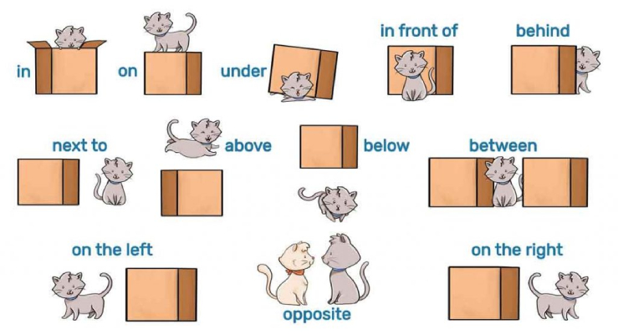

**Figure 4.2 Example of preposition**

Then the researcher asked the students to memorize it for about 10 minutes. After that the researcher prepared a picture of the different geometric shapes along with the prepositions and adjectives. Examples of images such as: a small star in a large circle, a triangle on the top of a square, a small circle below the rectangle, etc.

|  |  |
| --- | --- |
| **Picture for group 1** | **Picture for group 2** |
|  |  |

**Figure 4. 3 Picture for the test**

Then one student from each group becomes a representative to stand in front of the whiteboard which has been outlined into two parts while holding a marker which will be used to draw the command from the student of their group that stand behind. Meanwhile, other students from each group that stand behind were tasked with elaborating on the images arranged by the researcher for the students standing in front of the whiteboard. Example: the researcher shows a picture of a small star in a large circle, then the student who is stand behind must describe to the student in front of the whiteboard what shape they should draw. Example command: "please draw a small star in a big circle", Then the next student just needs to said the continuation of the given picture until all the given pictures are accurately and correctly drawn. So the student that in front of the whiteboard who guesses and draw the command quickly and correctly according to the picture given by the researcher is the winner.

During the third meeting, the researcher conducted another treatment using the Guessing Game Technique on April 14th, 2022. This activity mirrored the initial treatment, with the researcher providing images pertaining to shapes of geometric objects in the description text "my house" that was given yesterday such as triangles, squares, stars, circles, ovals, and rounds. Then the researcher also gave the adjective word like small and big, also preposition picture like under, above, inside, outside, on the right side, and on the left side. Then the researcher asked the students to memorize it for about 10 minutes. After that the researcher prepared a picture of the different geometric shapes along with the prepositions and adjectives. Examples of images such as: a small star in a large circle, a triangle on the top of a square, a rectangle on the right of an oval, etc. Then one student from each group becomes a representative to stand in front of the whiteboard which has been outlined into two parts while holding a marker which will be used to draw the command from the student of their group that stand behind. Meanwhile, other students from each group that stand behind were tasked with describing the pictures that the researcher had prepared for the students standing in front of the whiteboard. Example: the researcher shows a picture of a small star in a large circle, then the student who is stand behind must describe to the student in front of the whiteboard what shape they should draw. Example command: "please draw a small star in a big circle", So the student that in front of the whiteboard who guesses and draw the command quickly and correctly according to the picture given by the researcher is the winner.

During the fourth meeting, the researcher administered a post-test related to the guessing game played previously, which took place on April 19th, 2022. This assessment aimed to determine the effectiveness of the Guessing Game Technique in teaching speaking skills.

### The Control Class Procedure

The procedures for the control group same with those of the experimental group, encompassing a pre-test, first treatment, second treatment, and post-test.. In the control group, the researcher employs conventional teaching methods. But, it is not a new technique within the learning framework. This technique centers on student engagement, with the teacher directing students to consult their peers for insights on the "my house" descriptive text material subsequently students are directed to communicate the outcomes of their results with the researcher.

During the first session, students underwent a pre-test as a precursor to commencing the research, which took place on April 7th, 2022. The assessment comprised seven tests, each lasting 30 minutes.

During the second session, scheduled for April 12th, 2022, students received the first treatment in the control class. However, the researcher only provided explanation on descriptive text to the class, followed by feedback on the material.

During the third meeting on April 14th, 2022, the control class received the second treatment, where the conventional approach of reading and explaining the descriptive text "My house" was employed, mirroring the activities of the first treatment.

The final meeting, conducted on April 19th, 2022, comprised the post-test aimed at determining the ultimate score in the control class.

### The Outcomes of Students’ Pre-Test and Post-Test in the Experimental Class

The table presented below illustrates the pre-test and post-test outcomes in the experimental class for students instructed through the Guessing Game technique.

Table 4.1 The outcomes of students’ pre-test and post-test in experiment class

| **No** | **Name** | **Pre-test** | **Post-test** |
| --- | --- | --- | --- |
| 1 | AMA | 80 | 100 |
| 2 | AS | 70 | 90 |
| 3 | ARR | 70 | 80 |
| 4 | ALF | 50 | 90 |
| 5 | AFEA | 60 | 90 |
| 6 | AP | 40 | 80 |
| 7 | AAD | 80 | 100 |
| 8 | ALS | 50 | 80 |
| 9 | BAD | 70 | 90 |
| 10 | DHL | 50 | 100 |
| 11 | DAD | 70 | 90 |
| 12 | DAA | 80 | 100 |
| 13 | ES | 50 | 90 |
| 14 | FKP | 90 | 100 |
| 15 | FZS | 60 | 80 |
| 16 | HAPP | 50 | 100 |
| 17 | IS | 80 | 100 |
| 18 | JES | 70 | 90 |
| 19 | MH | 40 | 90 |
| 20 | MAR | 50 | 80 |
| 21 | MAM | 40 | 90 |
| 22 | MAM | 90 | 100 |
| 23 | MAF | 50 | 90 |
| 24 | MBS | 40 | 90 |
| 25 | RDA | 50 | 80 |
| 26 | RAJ | 70 | 90 |
| 27 | RA | 60 | 80 |
| 28 | RNA | 60 | 90 |
| 29 | RWAK | 40 | 100 |
| 30 | RA | 50 | 70 |
| 31 | SK | 70 | 100 |
| 32 | TA | 40 | 90 |
|  | **TOTAL** | 1920 | 2890 |
|  | **MEAN** | 60 | 90.31 |

The data table above displays the highest and lowest pre-test scores achieved by students in the experimental class. Notably, the highest pre-test score recorded was 90, while the lowest was 40, with a cumulative pre-test score of 1920. In contrast, the highest post-test score for the experimental class was 100, and the lowest was 70, resulting in a total experimental class score of 2890.

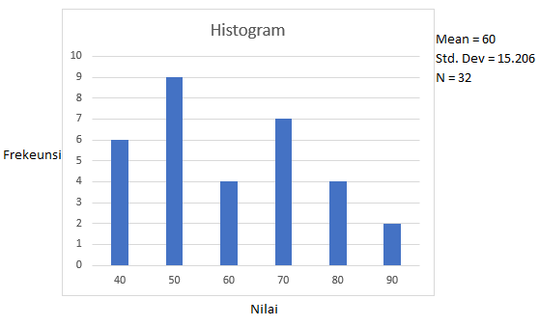

**Figure 4. 4 Histogram of pre-test in experimental class**

In the provided histogram, it is indicated that the mean (M) is 60 and the standard deviation (SD) is 15.206. In order to categorize students' speaking skills as either good, medium, or low, the researcher utilized the following standard classification based on scores:

* 1. Scores exceeding M+1SD (60+15.206 = 75) were classified as "good".
  2. Scores between M-1SD (60-15.206 = 44) were categorized as "medium".
  3. Scores below M-1SD (60-15.206 = 44) were labeled as "low".

This categorization is clearly depicted in the subsequent table.

Table 4.2 The categorization students’ pre-test in experiment class

|  |  |  |  |  |
| --- | --- | --- | --- | --- |
| **No** | **Score** | **Frequency** | **Percentage** | **Category** |
| 1 | More than 75 | 6 | 18,8% | Good |
| 2 | Between 44-75 | 20 | 62,5% | Medium |
| 3 | Below 44 | 6 | 18,8% | Low |

Source: researcher 2023

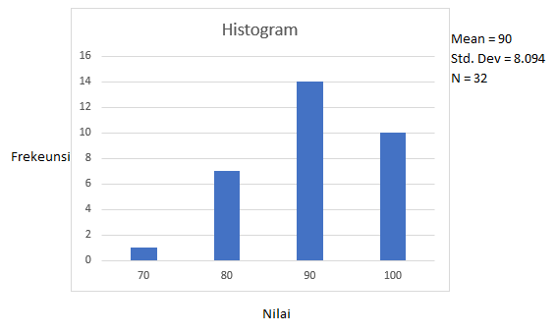

**Figure 4. 5 Histogram of post-test in experimental class**

Based on the table above, it is outlined that the mean (M) is 90.31 and the standard deviation (SD) is 8.094. To determine the classification of students' speaking mastery as good, medium, or low, the researcher applied the following standardization criteria:

* 1. Scores exceeding M+1SD (90.31+8.094 = 98) were classified as "good".
  2. Scores between M-1SD (90.31-8.094= 82) were categorized as "medium".
  3. Scores below M-1SD (90.31-8.094= 82) were labeled as "low".

The classification is visually presented in the subsequent table:

Table 4.3 The categorization of students’ post-test in experimental class

|  |  |  |  |  |
| --- | --- | --- | --- | --- |
| **No** | **Score** | **Frequency** | **Percentage** | **Category** |
| 1 | More than 98 | 10 | 31,3% | Good |
| 2 | Between 98-82 | 14 | 43,8% | Medium |
| 3 | Below 82 | 8 | 25% | Low |

### 4. The Result of Students’ Pre-test and Post-test in Control Class

The table presented below illustrates the outcomes of students' speaking skills, comparing those taught through discussion or conventional techniques (control class) with those not exposed to the Guessing Game Technique. The table displays both pre-test and post-test scores.

Table 4.4 The result of Students’ Pre-test and Post-test in Control Class

| **No** | **Name** | **Pre-test** | **Post-test** |
| --- | --- | --- | --- |
| 1 | AHPP | 60 | 60 |
| 2 | AS | 50 | 70 |
| 3 | APL | 80 | 90 |
| 4 | ARK | 70 | 70 |
| 5 | EJPT | 50 | 50 |
| 6 | FAS | 40 | 50 |
| 7 | HDP` | 70 | 70 |
| 8 | IDM | 60 | 70 |
| 9 | Kevin | 50 | 60 |
| 10 | Khairana | 40 | 60 |
| 11 | LEA | 60 | 70 |
| 12 | MZA | 50 | 80 |
| 13 | MAFR | 50 | 60 |
| 14 | MNH | 60 | 70 |
| 15 | MFA | 50 | 60 |
| 16 | MZK | 30 | 40 |
| 17 | NZA | 40 | 50 |
| 18 | NPP | 40 | 50 |
| 19 | NAPFS | 50 | 60 |
| 20 | NS | 80 | 80 |
| 21 | NAM | 90 | 90 |
| 22 | N | 100 | 80 |
| 23 | PD | 50 | 60 |
| 24 | PM | 50 | 70 |
| 25 | RJF | 40 | 40 |
| 26 | RRR | 90 | 90 |
| 27 | RV | 50 | 60 |
| 28 | SDNDA | 60 | 70 |
| 29 | SADI | 60 | 50 |
| 30 | VNC | 70 | 70 |
| 31 | WDPP | 60 | 70 |
| 32 | YS | 50 | 60 |
|  | **TOTAL** | 1850 | 2080 |
|  | **MEAN** | 57.81 | 65 |

The table above illustrates the highest and lowest pre-test scores among students in the control class. Notably, the highest pre-test score recorded was 100, while the lowest was 40, resulting in a total pre-test score of 1850. Similarly, in the post-test scores for the control class, the highest score achieved was 90, and the lowest was 40, with a total score of 2080.

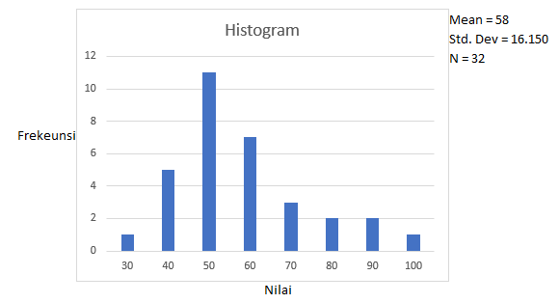

**Figure 4. 6 histogram of pre-test in control class**

Based on the provided histogram, it is indicated that the mean (M) is 58 and the standard deviation (SD) is 16.150. To categorize students' speaking skills as good, medium, or low, the researcher established classification criteria as follows:

* 1. More than M+1SD (58+16.150= 74) were classified as "good".
  2. Scores between M-1SD (58-16.150= 41) were categorized as "medium".
  3. Scores below M-1SD (58-16.150=41) were labeled as "low".

Table 4.5 The categorization of students’ pre-test in control class

|  |  |  |  |  |
| --- | --- | --- | --- | --- |
| **No** | **Score** | **Frequency** | **Percentage** | **Category** |
| 1 | More than 74 | 6 | 9,3% | Good |
| 2 | Between 41-74 | 21 | 65,6% | Medium |
| 3 | Below 41 | 5 | 15,6% | Low |

Source: researcher 2023

Mean = 65

Std.Dev = 13.199

N = 32

**Figure 4.7 Histogram of post-test in control class**

Based on the histogram above, it is evident that the mean (M) is 65 and the standard deviation (SD) is 13.199. To categorize students' Speaking skills as good, medium, or low, the researcher applied the following classification criteria:

* 1. More than M+1SD (65+13.199= 78) were classified as "good".
  2. Between M-1SD (65-13.199= 51) were categorized as "medium".
  3. Less than M-1SD (65-13.199=51) were labeled as "low".

Table 4.6 The categorization of students’ post-test in control class

|  |  |  |  |  |
| --- | --- | --- | --- | --- |
| **No** | **Score** | **Frequency** | **Percentage** | **Category** |
| 1 | More than 78 | 7 | 21.87% | Good |
| 2 | Between 51-78 | 19 | 59.38% | Medium |
| 3 | Below 51 | 6 | 18.75% | Low |

Source: researcher 2023

## B. Inferential Statistic

1. **Assumption Test**

Conducting assumption tests is an essential preliminary step in statistical research, required before hypothesis testing. This study will assess assumptions through normality and homogeneity tests, ensuring that data meet the necessary criteria before hypothesis testing commences.

1. **Normality**

The normality test assesses whether the distribution of responses to the instrument conforms to a normal distribution. Theoretically, if the statistical value exceeds 5%, the data is considered normal. However, if it falls below 5%, the data is deemed non-normally distributed. In this study, the researcher employed the Kolmogorov-Smirnov formula, and the computations were performed using SPSS as outlined below:

1. **The normality Test of Experimental Class**

Table 4.7 One-Sample Kolmogorov-Smirnov Test experimental class

|  |  |  |
| --- | --- | --- |
| **One-Sample Kolmogorov-Smirnov Test** | | |
|  | | Unstandardized Residual |
| N | | 32 |
| Normal Parametersa,b | Mean | .0000000 |
| Std. Deviation | 5.99782390 |
| Most Extreme Differences | Absolute | .177 |
| Positive | .087 |
| Negative | -.177 |
| Test Statistic | | .177 |
| Asymp. Sig. (2-tailed) | | .012c |
| a. Test distribution is Normal. | | |

According to Table 4.7, the asymptotic significance (2-tailed) value of 0.12 is greater than 0.05. This indicates that the data for the experimental class is normal.

1. **The Normality Test of Control class**

Table 4.8 One-Sample Kolmogorov-Smirnov Test Control Class

|  |  |  |
| --- | --- | --- |
| **One-Sample Kolmogorov-Smirnov Test** | | |
|  | | Unstandardized Residual |
| N | | 32 |
| Normal Parametersa,b | Mean | .0000000 |
| Std. Deviation | 5.11742958 |
| Most Extreme Differences | Absolute | .123 |
| Positive | .123 |
| Negative | -.081 |
| Test Statistic | | .123 |
| Asymp. Sig. (2-tailed) | | .200c,d |
| a. Test distribution is Normal. | | |

According to the displayed table, the asymptotic significance (2-tailed) value of 0.200 exceeds 0.05, indicating that the data for the class is normal.

1. **Homogeneity Test**

The homogeneity test aims to determine whether the dataset under examination exhibits uniform characteristics. In this study, data calculations were conducted using SPSS version.

Table 4.9 Homogeneity of variances

|  |  |  |  |  |  |
| --- | --- | --- | --- | --- | --- |
| **Test of Homogeneity of Variance** | | | | | |
|  | | Levene Statistic | df1 | df2 | Sig. |
| Score | Based on Mean | 2.112 | 1 | 62 | .151 |
| Based on Median | 1.097 | 1 | 62 | .299 |
| Based on Median and with adjusted df | 1.097 | 1 | 52.959 | .300 |
| Based on trimmed mean | 2.131 | 1 | 62 | .149 |

Based on the aforementioned calculation, it is evident that the significance value of 0.149 surpasses 0.05. Thus, indicating homogeneity within the data.

1. **Testing Hypothesis**

Following the assessment of normality and homogeneity, the researcher proceeded to test the hypothesis. Subsequently, T-test calculations were performed using the SPSS program, yielding the following results:

Table 4.10 The mean of score of experimental and control class

|  |  |  |  |  |  |
| --- | --- | --- | --- | --- | --- |
| **Group Statistics** | | | | | |
|  | Group | N | Mean | Std. Deviation | Std. Error Mean |
| score | Experimental class | 32 | 90.31 | 8.225 | 1.453 |
| Control class | 32 | 65 | 13.199 | 2.333 |

Based on the data table above, the analysis revealed that the mean score for the experimental class was 90.31, whereas for the control class it was 65. Consequently, indicating that the experimental class obtained a higher mean score compared to the control class.

#### **Table 4.11 The calculation of T-test**

|  |  |  |  |  |  |  |  |  |  |  |
| --- | --- | --- | --- | --- | --- | --- | --- | --- | --- | --- |
| **Independent Samples Test** | | | | | | | | | | |
|  | | Levene's Test for Equality of Variances | | t-test for Equality of Means | | | | | | |
| F | Sig. | T | Df | Sig. (2-tailed) | Mean Difference | Std. Error Difference | 95% Confidence Interval of the Difference | |
| Lower | Upper |
| Score | Equal variances assumed | 7.642 | .151 | 9.208 | 62 | .000 | 25.313 | 2.749 | 19.817 | 30.808 |
| Equal variances not assumed |  |  | 9.208 | 51.921 | .000 | 25.313 | 2.749 | 19.796 | 30.829 |

Based on the T-test calculation table provided above, it can be inferred that the t-test value amounted to 9.208 with 62 degrees of freedom. Moreover, the significance value at 5% for T-table with 62 degrees of freedom is 2.042. To elucidate the data, the researcher formulated the hypothesis as follows:

Ha : There was significant effect of the use of Guessing Game Technique on students’ Speaking Skill.

Ho : There was no significant effect of the use of Guessing Game Technique on students’ speaking skill.

The research findings indicate that the T-test value exceeded the critical T-table value (9.208 > 2.042), leading to the acceptance of the alternative hypothesis (Ha) and the rejection of the null hypothesis (Ho). Thus, demonstrating a significant difference in the scores of Speaking Skill between those taught using the Guessing Game Technique and those who were not.

## C. Discussion

The aim of the independent sample t-test is to evaluate whether the means of two distinct groups, depicted by independent samples, are statistically comparable or not. According to the research outcomes, it was established that students who underwent instruction through the Guessing Game Technique witnessed significant enhancements in their speaking abilities. This could potentially be linked to the heightened engagement of students in the speaking process facilitated by the Guessing Game Technique, which encouraged them to actively explore and apply their speaking skills in their everyday interactions.

Considering the findings of past research, aimed at enhancing students' speaking abilities, the researcher seeks a technique or method applicable in the teaching and learning process to foster enjoyable engagement and effective involvement among students. Ceyda Yalçin in “Cutting-Edge Topics and Approaches in Education and Applied Linguistics” said that games, including guessing games, should be used as a teaching method in learning. Because guessing games can be a very effective tool in improving students' abilities, including speaking skill. Sri Yuliani, in "Teaching English by Using Guessing Games," similarly states that Guessing Games involve a playful approach aimed at guessing various information, including words, titles, pictures, body parts, and objects. Within the guessing system, each student is allotted time and opportunities to engage in speaking practice and provide clues to others until the correct answer is guessed. Consequently, when implementing the game, students feel more confident in articulating their thoughts. It is evident that guessing games have the potential to enhance students' motivation in English learning and refine their speaking skills.

Based on the preceding explanation, it is evident that the disparity in scores between students instructed with the Guessing Game Technique and those without it amounts to 9.208. The hypothesis test (t0) value of 9.208 obtained from the calculation will be juxtaposed with the "t" index (tt), under the conditions outlined below:

1. If the t**0 >** t**t.** Ha was accepted. It means that there was a significance between two variables.
2. If the t**0** > t**t** Ha was refused. It means that there was no significance difference between two variables.

In determining the value of t0, the researcher examined the degrees of freedom and referenced the tt score:

= (n1+n2)-2

= (32+32)-2

= 62

With a significance level of 5%, the tt value was determined to be 2.042. Given that the t0 value is 9.208, the outcome indicates t0 > tt, thereby leading to the acceptance of Ha and the rejection of H0.

Based on the aforementioned calculation, it is evident that there was a significant difference between students instructed using the Guessing Game technique and those who were not. This suggests that students taught with the Guessing Game technique achieved higher scores in Speaking Skill, indicating the effectiveness of this technique in the learning process. In essence, the employment of the Guessing Game Technique had a notable influence on students' Speaking skill.

# 

# CHAPTER V

# CLOSING

## 1. Conclusion

Data analysis demonstrates the effectiveness of the Guessing Game Technique in enhancing the speaking proficiency of seventh-grade students at SMPN 3 Ngronggot Nganjuk during the academic year 2021/2022. With a calculated t-value of 9.208 compared to the t-table value of 2.042 at a 5% significance level, it is clear that the t-value exceeds the t-table value. As a result, the null hypothesis (Ho) is rejected, and the alternative hypothesis (Ha) is accepted, indicating that the Guessing Game Technique serves as an effective strategy for improving the speaking skills of seventh-grade students at SMPN 3 Ngronggot Nganjuk.

## 2. Suggestion

From the explanation above, the researcher proposes the following suggestion:

1. For teachers

Given the observed improvement in students' learning abilities, particularly in English, teachers are advised to cultivate an enjoyable classroom environment through various creative methods and techniques tailored to suit their students. This approach ensures that students feel content and engaged during lessons, fostering a deeper understanding of the subject matter. Additionally, teachers should empathize with students' learning challenges to provide effective support.

1. For students

It is crucial for students to maintain focus and enthusiasm throughout the lesson. By actively engaging with the material, students can better comprehend concepts and achieve satisfactory outcomes in their studies.

1. For the readers

The researcher hopes that the outcomes of this study will be a valuable resource for upcoming research endeavors centered on speaking skills.

# BIBLIOGRAPHY

A. Aziz Alimul Hidayat Musrifatul Uliyah. Pengantar Kebutuhan Dasar Manusia. 2nd edn. Edited by Tri Utami. Jakarta Selatan: Salemba Medik, 2015

Andrew Wright, David Betteridge and Michael Buckby. Games for Learning, Third Edition. New York: Cambridge University Press, 2006

Arikunto, Suharsimi, Prosedur Penelitian, (Jakarta: Rineka Cipta, 2010), 136

Arsjad, Maidar G & Mukti U.S. Pembinaan Kemampuan Berbicara.Jakarta: Erlangga, 2001.

Brown dan Yule. Strategi Pembelajaran Bahasa.Bandung: Remaja Rosdakarya, 2006

Brown, H, Douglas. Teaching by Principles, an Interactive Approach to Language Pedagogy.( New York: Addison Wesley Longman,2001) ,p. 406-407

Burns, Christine, Teaching Speaking: A Holistic Approach (New York: Cambridge University Press, 2012), 37.

Ceyda Yalçin. Cutting-Edge Topics and Approaches in Education and Applied Linguistics. ISBN(10): 1-5275-0804-8 ISBN (13): 978-1-5275-0804-0 Britania Raya: Cambridge Scholars Publishing ,p.169-171, 2018

Dewi, RS,Kulsum, U, and Armadi. Using Communicative Games inImprovingStudents’ SpeakingSkills EnglishLanguage Teaching. Vol. 10, No. 1;2017. ISSN 1916-4742 E-ISSN 1916-4750 Published by Canadian, 2017

Ersoz, A. Six games for the EFL/ESL classroom. The Internet TESL Journal, 6, 2000

Fradd, S. Irmayanti, “Applying Matching Puzzle Game in Teaching Translation at Second grade students of SMPN 8 Pinrang” (Skripsi Sarjana; Tarbiyah dan Adab: Parepare, 2015), p. 19-20.

Fulcher, G. Testing Second Language (Britain : Pearson Education Limited, 2003), 51.

Geoffrey Broughton, et.al., Teaching English as a Foreign Language (2th Ed.) (New York: Routledge, 1980), p.82

Hall Houston, “Playing Games,” Modern English Teacher vol. 18 no.1, p. 33. (accesed on 14th March 2018).

Iskandarwassid dan Dadang Sunendar, Strategi Pembelajaran Bahasa…, 257.

Kayi, H. Teaching Speaking: Activities to Promote Speaking in a Second Language, 2006

Klippel, F. Keep Talking. Communicative Fluency Activities for Language Teaching. Cambridge: Cambridge University Press, 1994

Kumalasari, Dwi Rahmawati. The Correlation Between Vocabulary Mastery and Listening Comprehension (of the second year student at SMP Muhammadiyah 1 Banyumas in academic year 2014/2015). Bachelor thesis, Universitas Muhammadiyah Purwokerto, 2016.

Lorraine R. Gay, Geoffrey E. Mills & Peter Airasian, Educational Research: Competencies for Analysis and Applications the eleventh Edition, (Boston: Pearson, 2012), 129

Maqfiroh, Y., Fitriani, & Chairina. The Use of Guessing Games toTeachSpeakingSkill Research in English and Education (READ), 3(1), 91-99, 2018

Mazidatuz Zahro, Bambang Suharjito, dan Sudarsono, “The Effect of Guessing Game on The Eight Year Students’ Vocabulary Achievement at SMPN 03 Balung Jember,” Pancaran, vol. 2 no.3 (August 2013), p. 116.

Nick Draeger, “Reasons You Need To Be Using Game For Corporate Training ,” elearning industry: A Journal of Elearning Industry.

Prabhat Pandey & Meenu Mishra Pandey, Research Methodology: Tools And Techniques. (Romania: Bridge Center, 2015), 41

Patricia A. Richard-Amato. Front cover image for Making it happen : interaction in the second language classroom : from. Print Book, English, 1988

Retno Widyaningrum, Statistika (Yogyakarta: Pustaka Felicha, 2015), 151

Richards, J. C. Teaching Listening and Speaking “From TheorytoPractice”.New York: CambridgeUniversityPress, 2008

Sri Yuliani, “Teaching English by Using Guessing Game” Universitas Muhammadiyah Palembang, vol. 1 no. 2 ( 2017), p. 124.

Sugiyono, Metode Penelitian Kuantitatif, Kualitatif, dan R&D (Bandung: Alfabeta, 2014), 108.

Suharsimi Arikunto, Prosedur Penelitian (Jakarta: Rineka Cipta, 2013), 211

Tarigan, Henry Guntur. 2008. Membaca sebagai Suatu Keterampilan Berbahasa. (Bandung:Angkasa)

Thornbury, Scott. How to Teach Speaking. Oxford:Longman, 2005

Virvou, M., & Papadimitriou Use ofdigital 'Guess Who Board Game' in teaching English Researchgate journal vol.10,2014

Webster, Merriam. Merriam Webster’s Collegiate Dictionary. United States of America: Merriam Webster Incorporated, 2004.

Wright, A., Batteridge, D., & Bucky, M. Games for Language Learning: Third Edition (NewYork: Cambridge University Press, 2005), 1.

Yusri. Developing speaking fluencyofgradeVII students through Guessing games at smp al-azhar palu.e-Jurnal Bahasantodea, 2013 1(1), 84-92

# APPENDICES

##### Appendix 1. 2 Research Metric

**RESEARCH PROPOSAL OUTLINE**

**“QUANTITATIVE RESEARCH”**

Name : Dea Faliha Rucita

Nim : 204180018

Semester : 7

Major : Tadris Bahasa Inggris

|  |  |
| --- | --- |
| Background of the Research | |
| * Identification of Phenomena | One of language skills that must be mastered by any foreign language learner is the ability to speak or communicate in the target language. In the 2013 Curriculum, it is clearly stated that one of the objectives of the English subject in Junior High School is developing the ability to communicate in English, either in written or oral form which covers listening, speaking, reading and writing. Unfortunately, the fact has shown that the students still face some difficulties to improve their speaking ability because they are accustomed to using their native language in daily life than using English. |
| * Description of the selected Phenomena | The author has obseryed,that the students had low scores in speaking. So, the researcher concluded the problem of students in junior high school was more about speaking. Sometimes the students' speaking scores do not reach the standard. It is influenced by some factors; that are, first, lack of teachers' technique in teaching speaking so that the goal of teaching speaking could not be achieved by students, while the goal of teaching speaking skill is to communicate efficiency. Second, they were shy and lazy to speak English because they were afraid of making mistakes. Based on the problem above, the researcher would apply shape guessing games technique as the solution to improve students' speaking skill. It is one of the communicative techniques in teaching speaking. It is also a kind of games in language teaching skill. This game can be applied to beginning level of the students in junior high school. |
| * Literature Review | Buku ajar Fun & Easy Speaking English! by : Rifka RN 2019  Speaking is one of the important skills to be mastered. Mastery of speaking is needed for communication efficiency. According to Brown, speaking is an interactive process of constructing meaning that involves producing and receiving and processing information (Brown, 1994: 253).  Games are activities that children naturally and universally engage in. „Game is played when one or more players compete or co-operate for pay-offs according to a set of rules‟ (Jones: 1986).  Andrew Wright, Betteridge and Buckby say,” Games can be found to give practice in all skills (reading,speaking, listening and writing) in all stages of teaching learning sequences” (Wright, Betteridge and Buckby, 1989). It is clear that games activity that can be applied in teaching all English skills.  Klippel argues that the basic rule of guessing game is eminently simple, one person knows something that another wants to find out (Klippel, 1994). While, Wright and Buck say, “Essentially, in guessing and speculating games, someone knows something and the others must find out what it is” (Wright and Buck, 1990).  Playing guessing game is one of the techniques that can be applied to develop speaking skill effectively. This assumption is supported by many experts. According to Richard – Amato, “Guessing game can be used to develop or reinforce concept, to add diversion to regular activities, or just to break the ice. |
| * Research Question and Objective | * **Research Question**   Do the students who are taught speaking using Guessing Game achieve score better than those who are not taught without using Guessing Game ?   * **Research Objectives**   Concerning with the problem statements, the objective of this research is to know whether the students who are taught speaking using guessing game will show better achievement than those who are taught without using guessing game. |
| * Previous Research | 1. There is a research that has been done by Angela Piu “*Simulation Games For Geometry Learning And The Development Of Mathematical Language”* University of Valle d’Aosta - University of Molise. The aim of the workshop is to present educational interventions based on collaborative simulation games targeting geometry learning among primary school pupils. These games have been conceptualized,developed, and tested as part of Simulandia, a research project. 2. Second previous research is *Improving The Speaking Skills Through Guessing Games Of The Seventh Grade Students Of Smp Muhammadiyah 1 Seyegan Yogyakarta In The Academic Year Of 2012/2013* By Dian Fitriana. The result of this study showed that the implementation of guessing games in the speaking class is believed effective to improve students’ skills to learn speaking English, maximizes students’ participation during the speaking activities, and reduces the students’ boredom on learning. This implies that the implementation of guessing games gives the positive effects on improving students’ skills in speaking English. 3. The third previous research is *Using Guessing Game To Improve Speaking Ability Of The Seventh Grade Students Of SMP Negeri 3 Balusu By Dr. Ammang Latifa, Dr. Rafi’ah Nur, Nurmiati.* the result of this study is it shows that the speaking ability of the seventh grade students of SMPN 3 Balusu improve through guessing game technique. Moreover, the response to questionnaire also shows that most of the students’ interest to the teaching guessing game uses in the classroom. In short, using guessing game in speaking is effective to improve the speaking ability of the seventh grade students of SMPN 3 Balusu. 4. The fourth previous study is *Using Games To Improve Students’ Speaking Skills (A Classroom Action Research) By Annisa Damayanti S.Pd Universitas Negeri Medan, 2016*. This thesis describe about Three cycles were done in this study until the desirable result was achieved.The result of the study showed that after making some changes on how the ‘Who am I’ game was presented and played, it was able to improve the teaching and learning activity. The game provided a fun activity that allowed all students to equally practice speaking and helped improving students’ speaking skills as well as their motivation and confidence. 5. The last previous study is *Aims For Using Fun Games To Improve The Esl Students’ Speaking Ability By Maisarah Unipdu – Jombang*, This study reveals the reasons why fun games are effective to help the students improve their vocabularies and use the language actively. The use of games can be a good language learning tool. During the games, a student not only competes with other students to achieve the learning goal but also collaborates with the others. This process makes the students do the game as good as possible for the sake of winning. When the games are applied, the students are forced to speak and they will try to use vocabularies related to the theme of the game. |
| * Title | The Effectiveness of using guessing games on students speaking skill at seventh grade of SMPN 3 Ngronggot Nganjuk in Academic year 2021/2022 |
| * Keyword | Speaking, Games, SmpN 3 Ngronggot. |

Disetujui sebagai pijakan membuat proposal

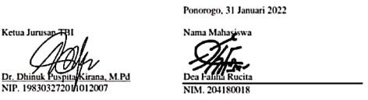

##### Appendix 1. 3 Lesson Plan For Experimental Class

|  |  |  |  |
| --- | --- | --- | --- |
| **Nama Sekolah** | **: SMPN 3 Ngronggot** | **Kelas/Semester** | **: VII / 2** |
| **Mata**  **Pelajaran** | **: Bahasa Inggris** | **Alokasi waktu** | **: 4 X Pertemuan** |
| **Aspek/Skill** | **: Speaking** | **Oleh** | **: Dea Faliha Rucita** |

1. **Standar Kompetensi**

**3.4** Membandingkan fungsi sosial,struktur teks, dan unsur kebahasaan beberapa teks deskriptif lisan dan tulis dengan memberi dan meminta informasi terkait dengan deskripsi orang, binatang, dan benda, sangat pendek dan sederhana, sesuai dengan konteks penggunaannya

**B. Kompetensi Dasar**

**4.4.1** Mengungkapkan makna secara konstekstual terkait fungsi sosial,struktur teks,dan unsur kebahasaan teks deskriptif lisan dan tulis,sangat pendek dan sederhana,terkait orang,binatang dan benda

**C. Indikator**

* Mampu bertanya dan menjawab berbagai informasi secara lisan dalam teks berbentuk descriptive
* Mampu mengidentifikasi informasi utama dalam teks deskriptif.
* Mampu menggambarkan objek atau tempat yang dideskripsikan dalam teks

**D. Tujuan Pembelajaran**

Dengan Menggunakan Teknik “Guessing Game”, siswa diharapkan mampu menangkap makna dan merespon teks deskriptif sederhana tentang benda dengan menggunakan unsur kebahasaan,struktur teks, dan fungsi social teks deskriptif dengan baik dan benar.

**E. Metode Pembelajaran**

Guessing Game

**F. Media/Alat Bahan dan Sumber Belajar**

Media :Worksheet (lembar kerja siswa) dan Lembar penilaian

Alat/Bahan :Spidol, Papan Tulis, dan Kertas.

Sumber Belajar : internet, Buku lks, Lingkungan sekitar

**G. Kegiatan Pembelajaran**

|  |  |
| --- | --- |
| **Kegiatan** | **Deskripsi Kegiatan** |
| **Pertemuan 1** | |
| **Pendahuluan**  (10 menit) | * Memulai pembelajaran dengan salam pembuka dan berdo’a, memeriksa kehadiran peserta didik sebagai sikap disiplin. * Mengaitkan materi/tema/kegiatan pembelajaran yang akan dilakukan dengan pengalaman peserta didik dengan materi/tema/kegiatan sebelumnya serta mengajukan pertanyaan untuk mengingat dan menghubungkan dengan materi selanjutnya. * Menyampaikan motivasi tentang pentingya materi yang akan   dipelajari berikut kompetensi yang harus dikuasai peserta didik |
| **Inti**  (15 menit) | **Eksplorasi:**   * Melibatkan peserta didik mencari informasi yang luas dan dalam tentang topik/tema materi yang akan dipelajari dengan menerapkan prinsip alam takambang jadi guru dan belajar dari aneka sumber. * Mengenalkan metode pembelajaran *Guessing Game*   yang menarik untuk peserta didik.   * Guru menerangkan tujuan pembelajaran teks deskriptif * Memfasilitasi terjadinya interaksi antar peserta didik serta antara peserta didik dengan guru, lingkungan, dan sumber belajar lainnya. * Melibatkan peserta didik secara aktif dalam setiap kegiatan pembelajaran.   **Elaborasi:**   * Guru memberikan lembar soal speaking kepada peserta didik * Guru memfasilitasi peserta didik untuk menyajikan hasil kerja secara individual.   **Konfirmasi:** |

|  |  |
| --- | --- |
|  | * Guru memberikan umpan balik positif dan penguatan dalam bentuk lisan, tulisan, isyarat, maupun hadiah terhadap keberhasilan peserta didik. * Guru memfasilitasi peserta didik melakukan refleksi untuk memperoleh pengalaman belajar yang telah dilakukan. * Guru memfasilitasi peserta didik untuk memperoleh pengalaman yang bermakna dalam mencapai kompetensi dasar. * Guru berfungsi sebagai narasumber dan fasilitator dalam menjawab pertanyaan peserta didik yang menghadapi kesulitan, dengan menggunakan bahasa yang baku dan benar. * Guru memberikan motivasi kepada peserta didik yang kurang atau belum berpartisipasi aktif. * Guru bertanya jawab tentang hal-hal yang belum diketahui siswa. * Guru bersama siswa bertanya jawab meluruskan kesalahan pemahaman, memberikan penguatan dan penyimpulan. |
| **Penutup**  (5 menit) | * Guru bersama-sama dengan peserta didik membuat rangkuman/simpulan pelajaran. * Guru melakukan penilaian dan refleksi terhadap kegiatan yang sudah dilaksanakan secara konsisten dan terprogram. * Guru merencanakan kegiatan tindak lanjut dalam bentuk treatmen pembelajaran dengan menggunakan metode yang menarik. * Guru menyampaikan rencana pembelajaran pada pertemuan berikutnya. * Menugaskan peserta didik untuk terus mencari informasi dimana saja yang berkaitan dengan materi/pelajaran yang sedang atau yang akan pelajari. * Guru menyampaikan materi pembelajaran berikutnya. |

|  |  |
| --- | --- |
|  | * Guru menutup kegiatan pembelajaran dengan mengucapkan salam dan doa. |
| **Pertemuan 2&3** | |
| **Pendahuluan**  (10 menit) | * Memulai pembelajaran dengan salam pembuka dan berdo’a, memeriksa kehadiran peserta didik sebagai sikap disiplin. * Mengaitkan materi/tema/kegiatan pembelajaran yang akan dilakukan dengan pengalaman peserta didik dengan materi/tema/kegiatan sebelumnya serta mengajukan pertanyaan untuk mengingat dan menghubungkan dengan materi selanjutnya. * Menyampaikan motivasi tentang pentingya materi yang akan   dipelajari berikut kompetensi yang harus dikuasai peserta didik |
| **Inti**  (15 menit) | **Eksplorasi:**   * Melibatkan peserta didik mencari informasi yang luas dan dalam tentang topik/tema materi yang akan dipelajari. * Menggunakan metode pembelajaran *Guessing Game*   untuk mempelajari teks deskriptif *My House.*   * Membaca dan mengerjakan bersama teks deskriptif * Memperhatikan pengerjaan peserta didik. * Memfasilitasi terjadinya interaksi antar peserta didik serta antara peserta didik dengan guru, lingkungan, dan sumber belajar lainnya. * Melibatkan peserta didik secara aktif dalam setiap kegiatan pembelajaran.   **Elaborasi:**   * Guru membiasakan peserta didik memahami tentang isi bacaan teks deskriptif. * Guru memfasilitasi peserta didik melalui pemberian tugas, diskusi, dan lain-lain untuk memunculkan gagasan baru baik   secara lisan maupun tertulis. |

|  |  |
| --- | --- |
|  | * Guru memfasilitasi peserta didik untuk menyajikan hasil kerja individual.   **Konfirmasi:**   * Guru memberikan umpan balik positif dan penguatan dalam bentuk lisan, tulisan, isyarat, maupun hadiah terhadap keberhasilan peserta didik. * Guru memfasilitasi peserta didik melakukan refleksi untuk memperoleh pengalaman belajar yang telah dilakukan. * Guru memfasilitasi peserta didik untuk memperoleh pengalaman yang bermakna dalam mencapai kompetensi dasar. * Guru berfungsi sebagai narasumber dan fasilitator dalam menjawab pertanyaan peserta didik yang menghadapi kesulitan, dengan menggunakan bahasa yang baku dan benar. * Guru memberikan motivasi kepada peserta didik yang kurang atau belum berpartisipasi aktif. * Guru bertanya jawab tentang hal-hal yang belum diktahui siswa. * Guru bersama siswa bertanya jawab meluruskan kesalahan pemahaman, memberikan penguatan dan penyimpulan. |
| **Penutup**  (5 menit) | * Guru bersama-sama dengan peserta didik membuat rangkuman/simpulan pelajaran. * Guru melakukan penilaian dan refleksi terhadap kegiatan yang sudah dilaksanakan secara konsisten dan terprogram. * Guru merencanakan kegiatan tindak lanjut dalam bentuk treatmen pembelajaran dengan menggunakan metode yang menarik. * Guru menyampaikan rencana pembelajaran pada pertemuan berikutnya. * Menugaskan Peserta didik untuk terus mencari informasi dimana saja yang berkaitan dengan materi/pelajaran yang sedang atau yang akan pelajari. * Guru menyampaikan materi pembelajaran berikutnya. |

|  |  |
| --- | --- |
|  | * Guru menutup kegiatan pembelajaran dengan mengucapkan salam dan doa. |
| **Pertemuan 4** | |
| **Pendahuluan**  (10 menit) | * Memulai pembelajaran dengan salam pembuka dan berdo’a, memeriksa kehadiran peserta didik sebagai sikap disiplin. * Mengaitkan materi/tema/kegiatan pembelajaran yang akan dilakukan dengan pengalaman peserta didik dengan materi/tema/kegiatan sebelumnya serta mengajukan pertanyaan   untuk mengingat dan menghubungkan dengan materi selanjutnya. |
| **Inti**  (15 menit) | **Eksplorasi:**   * Guru menginstruksikan peserta didik untuk menggunakan metode pembelajaran *Guessing Game*. * Guru membantu siswa untuk membentuk kelompok. * Memfasilitasi terjadinya interaksi antar peserta didik serta antara peserta didik dengan guru, lingkungan, dan sumber belajar lainnya.   **Elaborasi:**   * Guru memberikan lembar soal speaking kepada peserta didik. * Guru memfasilitasi peserta didik untuk menyajikan hasil kerja secara individual.   **Konfirmasi:**   * Guru memberikan umpan balik positif dan penguatan dalam bentuk lisan, tulisan, isyarat, maupun hadiah terhadap keberhasilan peserta didik. * Guru memfasilitasi peserta didik melakukan refleksi untuk memperoleh pengalaman belajar yang telah dilakukan. * Guru memfasilitasi peserta didik untuk memperoleh pengalaman yang bermakna dalam mencapai kompetensi dasar. * Guru berfungsi sebagai narasumber dan fasilitator |

|  |  |
| --- | --- |
|  | * dalam menjawab pertanyaan peserta didik yang menghadapi kesulitan, dengan menggunakan bahasa yang baku dan benar. * Guru memberikan motivasi kepada peserta didik yang kurang atau belum berpartisipasi aktif. * Guru bertanya jawab tentang hal-hal yang belum diketahui siswa. * Guru bersama siswa bertanya jawab meluruskan kesalahan   pemahaman, memberikan penguatan dan penyimpulan. |
| **Penutup**  (5 menit) | * Guru bersama-sama dengan peserta didik membuat rangkuman/simpulan pelajaran. * Guru melakukan penilaian dan refleksi terhadap kegiatan yang sudah dilaksanakan secara konsisten dan terprogram. * Menugaskan Peserta didik untuk terus mencari informasi dimana saja yang berkaitan dengan materi/pelajaran yang sedang atau yang akan pelajari. * Guru menutup kegiatan pembelajaran dengan mengucapkan salam dan doa. |

* + - 1. **Penilaian (Assesment)**

Penilaiain terhadap materi ini dapat dilakukan sesuai kebutuhan guru yaitu dari tes dengan rubrik penilaian sebagai nilai keterampilan. (*Terlampir)*

|  |  |
| --- | --- |
| Mengetahui, | Nganjuk, 1 April 2022 |

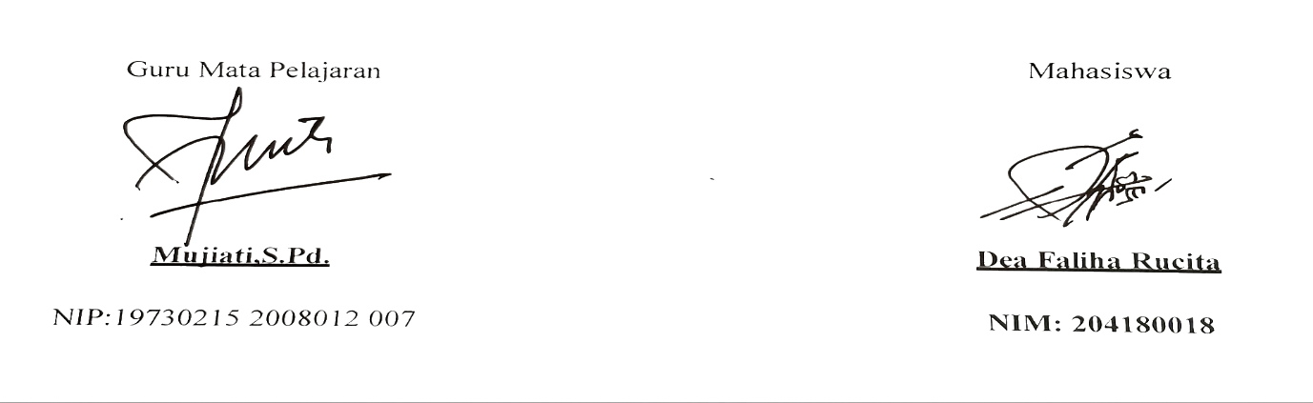

##### Lampiran 1

**ASSESSING RUBRIC OF SPEAKING**

|  |  |  |  |
| --- | --- | --- | --- |
| **Indicator** | **Level** | **Description** |  |
| **Grammar** | 1 | Errors in grammar are frequent, but speaker can be understood by a native speaker used to dealing with foreigners attempting to speak his language | **20** |
| 2 | Can usually handle elementary constructions quite accurately but does not have thorough or confident control of the grammar. |
| 3 | Control of grammar is good. Able to speak the language with sufficient structural accuracy to participate effectively in most formal and informal conversations on practical, social, and professional topics |
| 4 | Able to use the language accurately on all levels normally pertinent to professional needs. Errors in grammar are quite rare. 5 Equivalent to that of an educated native speaker. |
| 5 | Equivalent to that of an educated native speaker |
| **Vocabulary** | 1 | Speaking vocabulary inadequate to express anything but the most elementary needs | **20** |
| 2 | Has speaking vocabulary sufficient to express himself simply with some circumlocutions |
| 3 | Able to speak the language with sufficient vocabulary to participate effectively in most formal and informal conversations on practical, social and professional topics. Vocabulary is broad enough that he rarely has to grope for a word. |
| 4 | Can understand and participate in any conversation within the range of his experience with a high degree of precision of vocabulary. |
| 5 | Speech on all level is sufficiently accepted by educated native speakers in all its features including breadth of vocabulary and idioms, colloquialisms, and pertinentcultural references |
| **Fluency** | 1 | No specific fluency description. Refer to other four language areas for implied level of fluency. | **20** |
| 2 | Can handle with confidence but not with facility most social situations, including introductions and casual conversations about current events, as well as work, family and autobiographical information. |
| 3 | Can discuss particular interests of competence with reasonable ease. Rarely has to grope for words |
| 4 | Able to use the language fluently on all levels normally pertinent to professional needs. Can participate in any conversation with a high degree of fluency. |
| 5 | Has complete fluency in the language such that his speech is fully accepted by educated native speakers |
| **Pronunciation** | 1 | Errors in pronunciation are frequent but can be understood by a native speaker used to dealing with foreigners attempting to speak his language | **20** |
| 2 | Accent is intelligible though often quite faulty |
| 3 | Errors never interfere with understanding and rarely disturb the native speaker. Accent may be obviously foreign. |
| 4 | Errors in pronunciation are quite rare. |
| 5 | Equivalent to and fully accepted by educated native speakers. |
| **Comprehension** | 1 | Within the scope of his very limited language experience, can understand simple questions and statements if delivered with slowed speech, repetition, or paraphrase | **20** |
| 2 | Can get the gist of most conversations of non-technical subjects (i.e., topics that requite no specialized knowledge). |
| 3 | Comprehension is quite complete at a normal rate of speech. |
| 4 | Can understand any conversation within the range of his experience. |
| 5 | Equivalent to that of an educated native speaker |
| **Total Score** | | | **100** |

**Scoring Standards and Range in Speaking Assesments**

|  |  |
| --- | --- |
| **Standards of Scoring** | **Range of Score** |
| Very good | 80-100 |
| Good | 73-79 |
| Average | 60-64 |
| Poor | 55-59 |
| Very Poor | <55 |

##### Appendix 1. 4 Lesson Plan For Control Class

|  |  |  |  |
| --- | --- | --- | --- |
| **Nama Sekolah** | **: SMPN 3 Ngronggot** | **Kelas/Semester** | **: VII / 2** |
| **Mata**  **Pelajaran** | **: Bahasa Inggris** | **Alokasi waktu** | **: 4 X Pertemuan** |
| **Aspek/Skill** | **: Speaking** | **Oleh** | **: Dea Faliha Rucita** |

1. **Standar Kompetensi**

**3.4**  Membandingkan fungsi sosial,struktur teks, dan unsur kebahasaan beberapa teks deskriptif lisan dan tulis dengan memberi dan meminta informasi terkait dengan deskripsi orang, binatang, dan benda, sangat pendek dan sederhana, sesuai dengan konteks penggunaannya.

**B. Kompetensi Dasar**

**4.4.1** Mengungkapkan makna secara kontekstual terkait fungsi sosial, struktur teks, dan unsur kebahasaan teks deskriptif lisan dan tulis, sangat pendek dan sederhana, terkait orang, binatang,dan benda.

**C. Indikator**

* Mampu bertanya dan menjawab berbagai informasi secara lisan dalam teks berbentuk descriptive
* Mampu mengidentifikasi informasi utama dalam teks deskriptif.
* Mampu menggambarkan objek atau tempat yang dideskripsikan dalam teks

**D. Tujuan Pembelajaran**

Setelah mengikuti kegiatan pembelajaran, siswa diharapkan mampu menangkap makna dan merespon teks deskriptif sederhana tentang benda dengan menggunakan unsur kebahasaan,struktur teks, dan fungsi social teks deskriptif dengan baik dan benar.

**E. Metode Pembelajaran**

Diskusi, tanya jawab.

**F. Media/Alat Bahan dan Sumber Belajar**

Media :Worksheet (lembar kerja siswa) dan Lembar penilaian

Alat/Bahan :Spidol, Papan Tulis, dan Kertas.

Sumber Belajar : internet, Buku Lks, Lingkungan sekitar

**G. Kegiatan Pembelajaran**

|  |  |  |
| --- | --- | --- |
| **Kegiatan** | **Deskripsi Kegiatan** | **Durasi** |
|  | **Pertemuan 1** | |
| **Pendahuluan** | * Memulai pembelajaran dengan salam pembuka dan berdo’a, memeriksa kehadiran peserta didik sebagai sikap disiplin. * Mengaitkan materi/tema/kegiatan pembelajaran yang akan dilakukan dengan pengalaman peserta didik dengan materi/tema/kegiatan sebelumnya serta mengajukan pertanyaan untuk mengingat dan menghubungkan dengan materi selanjutnya * Menyampaikan motivasi tentang pentingya materi yang akan dipelajari berikut kompetensi yang harus dikuasai peserta didik | 10 menit |
| **Inti** | **Eksplorasi:**   * Melibatkan peserta didik mencari informasi yang luas dan dalam tentang topik/tema materi yang akan dipelajari. * Guru memfasilitasi peserta didik untuk memahami fungsi teks descriptive. * Memfasilitasi terjadinya interaksi antar peserta didik serta antara peserta didik dengan guru, lingkungan, dan sumber belajar lainnya. * Melibatkan peserta didik secara aktif dalam setiap kegiatan pembelajaran.   **Elaborasi:**   * Guru memberikan lembar soal speaking kepada peserta didik. * Guru memfasilitasi peserta didik untuk menyajikan hasil kerja secara individual.   **Konfirmasi:**   * Guru memberikan umpan balik positif dan penguatan dalam bentuk lisan, tulisan, isyarat, maupun hadiah terhadap keberhasilan peserta didik. * Guru memfasilitasi peserta didik melakukan refleksi untuk memperoleh pengalaman belajar yang telah dilakukan. * Guru memfasilitasi peserta didik untuk memperoleh pengalaman yang bermakna dalam mencapai kompetensi dasar. * Guru berfungsi sebagai narasumber dan fasilitator dalam menjawab pertanyaan peserta didik yang menghadapi kesulitan, dengan menggunakan bahasa yang baku dan benar. * Guru memberikan motivasi kepada peserta didik yang kurang atau belum berpartisipasi aktif. * Guru bertanya jawab tentang hal-hal yang belum diketahui siswa. * Guru bersama siswa bertanya jawab meluruskan kesalahan pemahaman, memberikan penguatan dan penyimpulan. | 15 menit |
| **Penutup** | * Guru bersama-sama dengan peserta didik membuat rangkuman/simpulan pelajaran. * Guru melakukan penilaian dan refleksi terhadap kegiatan yang sudah dilaksanakan secara konsisten dan terprogram. * Guru menyampaikan rencana pembelajaran pada pertemuan berikutnya. * Menugaskan peserta didik untuk terus mencari informasi dimana saja yang berkaitan dengan materi/pelajaran yang sedang atau yang akan pelajari. * Guru menyampaikan materi pembelajaran berikutnya. * Guru menutup kegiatan pembelajaran dengan mengucapkan salam dan doa. | 5 menit |
|  | **Pertemuan 2 & 3** |  |
| **Pendahuluan** | * Memulai pembelajaran dengan salam pembuka dan berdo’a, memeriksa kehadiran peserta didik sebagai sikap disiplin. * Mengaitkan materi/tema/kegiatan pembelajaran yang akan dilakukan dengan pengalaman peserta didik dengan materi/tema/kegiatan sebelumnya serta mengajukan pertanyaan untuk mengingat dan menghubungkan dengan materi selanjutnya. * Menyampaikan motivasi tentang pentingya materi yang akan dipelajari berikut kompetensi yang harus dikuasai peserta didik | 10 menit |
| **Inti** | **Eksplorasi:**   * Melibatkan peserta didik mencari informasi yang luas dan dalam tentang topik/tema materi yang akan dipelajari. * Memfasilitasi terjadinya interaksi antar peserta didik serta antara peserta didik dengan guru, lingkungan, dan sumber belajar lainnya. * Guru memfasilitasi peserta didik untuk memahami teks descriptive. * Melibatkan peserta didik secara aktif dalam setiap kegiatan pembelajaran.   **Elaborasi:**   * Guru memfasilitasi peserta didik melalui pemberian tugas, diskusi, dan lain-lain untuk memunculkan gagasan baru baik secara lisan maupun tertulis. * Guru memfasilitasi peserta didik untuk menyajikan hasil kerja individual.   **Konfirmasi:**   * Guru memberikan umpan balik positif dan penguatan dalam bentuk lisan, tulisan, isyarat, maupun hadiah terhadap keberhasilan peserta didik. * Guru memfasilitasi peserta didik melakukan refleksi untuk memperoleh pengalaman belajar yang telah dilakukan. * Guru memfasilitasi peserta didik untuk memperoleh pengalaman yang bermakna dalam mencapai kompetensi dasar. * Guru berfungsi sebagai narasumber dan fasilitator dalam menjawab pertanyaan peserta didik yang menghadapi kesulitan, dengan menggunakan bahasa yang baku dan benar. * Guru memberikan motivasi kepada peserta didik yang kurang atau belum berpartisipasi aktif. * Guru bertanya jawab tentang hal-hal yang belum diketahui siswa. * Guru bersama siswa bertanya jawab meluruskan kesalahan pemahaman, memberikan penguatan dan penyimpulan. | 15 menit |
| **Penutup** | * Guru bersama-sama dengan peserta didik membuat rangkuman/simpulan pelajaran. * Guru melakukan penilaian dan refleksi terhadap kegiatan yang sudah dilaksanakan secara konsisten dan terprogram. * Guru menyampaikan rencana pembelajaran pada pertemuan berikutnya. * Menugaskan Peserta didik untuk terus mencari informasi dimana saja yang berkaitan dengan materi/pelajaran yang sedang atau yang akan pelajari. * Guru menyampaikan materi pembelajaran berikutnya. * Guru menutup kegiatan pembelajaran dengan mengucapkan salam dan doa. | 5 menit |
|  | **Pertemuan 4** |  |
| **Pendahuluan** | * Memulai pembelajaran dengan salam pembuka dan berdo’a, memeriksa kehadiran peserta didik sebagai sikap disiplin. * Mengaitkan materi/tema/kegiatan pembelajaran yang akan dilakukan dengan pengalaman peserta didik dengan materi/tema/kegiatan sebelumnya serta mengajukan pertanyaan untuk mengingat dan menghubungkan dengan materi selanjutnya. * Menyampaikan motivasi tentang pentingya materi yang akan dipelajari berikut kompetensi yang harus dikuasai peserta didik | 10 menit |
| **Inti** | **Eksplorasi:**   * Guru memfasilitasi terjadinya interaksi antar peserta didik serta antara peserta didik dengan guru, lingkungan, dan sumber belajar lainnya. * Guru memfasilitasi peserta didik untuk mendengarkan lagu bahasa inggris.   **Elaborasi:**   * Guru memberikan lembar soal speaking kepada peserta didik. * Guru memfasilitasi peserta didik untuk menyajikan hasil kerja secara individual.   **Konfirmasi:**   * Guru memberikan umpan balik positif dan penguatan dalam bentuk lisan, tulisan, isyarat, maupun hadiah terhadap keberhasilan peserta didik. * Guru memfasilitasi peserta didik melakukan refleksi untuk memperoleh pengalaman belajar yang telah dilakukan. * Guru memfasilitasi peserta didik untuk memperoleh pengalaman yang bermakna dalam mencapai kompetensi dasar. * Guru berfungsi sebagai narasumber dan fasilitator * dalam menjawab pertanyaan peserta didik yang menghadapi kesulitan, dengan menggunakan bahasa yang baku dan benar. * Guru memberikan motivasi kepada peserta didik yang kurang atau belum berpartisipasi aktif. * Guru bertanya jawab tentang hal-hal yang belum diketahui siswa. * Guru bersama siswa bertanya jawab meluruskan kesalahan pemahaman, memberikan penguatan dan penyimpulan. | 15 menit |
| **Penutup** | * Guru bersama-sama dengan peserta didik membuat rangkuman/simpulan pelajaran. * Guru melakukan penilaian dan refleksi terhadap kegiatan yang sudah dilaksanakan secara konsisten dan terprogram. * Menugaskan Peserta didik untuk terus mencari informasi dimana saja yang berkaitan dengan materi/pelajaran yang sedang atau yang akan pelajari. * Guru menutup kegiatan pembelajaran dengan mengucapkan salam dan doa. | 5 menit |

**H. Penilaian**

1. Penilaiain terhadap materi ini dapat dilakukan sesuai kebutuhan guru yaitu dari tes dengan rubrik penilaian sebagai nilai keterampilan. (*lampiran 1)*
2. Instruments (*lampiran 2*)

|  |  |
| --- | --- |
| Mengetahui, | Nganjuk, 1 April 2022 |
| Guru Mata Pelajaran | Mahasiswa |
|  | **Dea Faliha Rucita**  204180018 |

##### Lampiran 1

**ASSESING RUBRIC OF SPEAKING**

|  |  |  |  |
| --- | --- | --- | --- |
| **Indicator** | **Level** | **Description** |  |
| **Grammar** | 1 | Errors in grammar are frequent, but speaker can be understood by a native speaker used to dealing with foreigners attempting to speak his language | **20** |
| 2 | Can usually handle elementary constructions quite accurately but does not have thorough or confident control of the grammar. |
| 3 | Control of grammar is good. Able to speak the language with sufficient structural accuracy to participate effectively in most formal and informal conversations on practical, social, and professional topics |
| 4 | Able to use the language accurately on all levels normally pertinent to professional needs. Errors in grammar are quite rare. 5 Equivalent to that of an educated native speaker. |
| 5 | Equivalent to that of an educated native speaker |
| **Vocabulary** | 1 | Speaking vocabulary inadequate to express anything but the most elementary needs | **20** |
| 2 | Has speaking vocabulary sufficient to express himself simply with some circumlocutions |
| 3 | Able to speak the language with sufficient vocabulary to participate effectively in most formal and informal conversations on practical, social and professional topics. Vocabulary is broad enough that he rarely has to grope for a word. |
| 4 | Can understand and participate in any conversation within the range of his experience with a high degree of precision of vocabulary. |
| 5 | Speech on all level is sufficiently accepted by educated native speakers in all its features including breadth of vocabulary and idioms, colloquialisms, and pertinentcultural references |
| **Fluency** | 1 | No specific fluency description. Refer to other four language areas for implied level of fluency. | **20** |
| 2 | Can handle with confidence but not with facility most social situations, including introductions and casual conversations about current events, as well as work, family and autobiographical information. |
| 3 | Can discuss particular interests of competence with reasonable ease. Rarely has to grope for words |
| 4 | Able to use the language fluently on all levels normally pertinent to professional needs. Can participate in any conversation with a high degree of fluency. |
| 5 | Has complete fluency in the language such that his speech is fully accepted by educated native speakers |
| **Pronunciation** | 1 | Errors in pronunciation are frequent but can be understood by a native speaker used to dealing with foreigners attempting to speak his language | **20** |
| 2 | Accent is intelligible though often quite faulty |
| 3 | Errors never interfere with understanding and rarely disturb the native speaker. Accent may be obviously foreign. |
| 4 | Errors in pronunciation are quite rare. |
| 5 | Equivalent to and fully accepted by educated native speakers. |
| **Comprehension** | 1 | Within the scope of his very limited language experience, can understand simple questions and statements if delivered with slowed speech, repetition, or paraphrase | **20** |
| 2 | Can get the gist of most conversations of non-technical subjects (i.e., topics that requite no specialized knowledge). |
| 3 | Comprehension is quite complete at a normal rate of speech. |
| 4 | Can understand any conversation within the range of his experience. |
| 5 | Equivalent to that of an educated native speaker |
| **Total Score** | | | **100** |

**Scoring Standards and Range in Speaking Assesments**

|  |  |
| --- | --- |
| **Standards of Scoring** | **Range of Score** |
| Very good | 80-100 |
| Good | 73-79 |
| Average | 60-64 |
| Poor | 55-59 |
| Very Poor | <55 |

##### Appendix 1. 5 Item Validity Calculation

|  |  |  |  |  |  |  |  |  |  |  |  |
| --- | --- | --- | --- | --- | --- | --- | --- | --- | --- | --- | --- |
|  | s1 | s2 | s3 | s4 | s5 | s6 | s7 | s8 | s9 | s10 | Total |
| 1 | 5 | 5 | 5 | 3 | 2 | 4 | 2 | 5 | 3 | 5 | 39 |
| 2 | 4 | 4 | 5 | 3 | 2 | 4 | 3 | 3 | 5 | 4 | 37 |
| 3 | 4 | 4 | 4 | 2 | 3 | 3 | 3 | 5 | 4 | 5 | 37 |
| 4 | 3 | 4 | 4 | 2 | 3 | 4 | 4 | 5 | 5 | 5 | 39 |
| 5 | 2 | 3 | 4 | 3 | 4 | 4 | 5 | 5 | 5 | 4 | 39 |
| 6 | 3 | 3 | 3 | 3 | 3 | 4 | 3 | 5 | 5 | 5 | 37 |
| 7 | 1 | 3 | 3 | 2 | 5 | 5 | 4 | 4 | 4 | 5 | 36 |
| 8 | 4 | 5 | 4 | 2 | 5 | 4 | 3 | 5 | 4 | 5 | 41 |
| 9 | 3 | 5 | 5 | 3 | 3 | 4 | 4 | 3 | 3 | 5 | 38 |
| 10 | 3 | 3 | 4 | 3 | 5 | 5 | 3 | 4 | 5 | 5 | 40 |
| 11 | 3 | 3 | 5 | 4 | 3 | 4 | 2 | 5 | 4 | 4 | 37 |
| 12 | 2 | 4 | 2 | 3 | 3 | 4 | 1 | 5 | 5 | 5 | 34 |
| 13 | 2 | 5 | 5 | 4 | 4 | 3 | 4 | 4 | 5 | 5 | 41 |
| 14 | 5 | 3 | 4 | 3 | 3 | 4 | 4 | 5 | 5 | 5 | 41 |
| 15 | 4 | 2 | 5 | 2 | 4 | 4 | 5 | 3 | 4 | 3 | 36 |
| 16 | 3 | 1 | 3 | 2 | 5 | 5 | 3 | 4 | 4 | 4 | 34 |
| 17 | 3 | 1 | 5 | 3 | 4 | 4 | 3 | 5 | 5 | 4 | 37 |
| 18 | 2 | 2 | 3 | 5 | 4 | 4 | 3 | 5 | 5 | 3 | 36 |
| 19 | 2 | 3 | 4 | 5 | 3 | 4 | 3 | 3 | 5 | 4 | 36 |
| 20 | 4 | 3 | 4 | 4 | 3 | 5 | 2 | 4 | 4 | 5 | 38 |
| 21 | 5 | 4 | 5 | 4 | 5 | 5 | 1 | 4 | 4 | 4 | 41 |
| 22 | 5 | 3 | 3 | 3 | 2 | 3 | 1 | 2 | 3 | 5 | 30 |
| 23 | 3 | 4 | 3 | 3 | 5 | 3 | 2 | 1 | 2 | 3 | 29 |
| 24 | 2 | 3 | 4 | 2 | 2 | 3 | 2 | 2 | 2 | 2 | 24 |
| 25 | 1 | 2 | 5 | 2 | 3 | 2 | 3 | 3 | 3 | 3 | 27 |
| 26 | 4 | 3 | 2 | 3 | 2 | 4 | 2 | 2 | 3 | 3 | 28 |
| 27 | 3 | 3 | 2 | 4 | 3 | 2 | 2 | 4 | 2 | 2 | 27 |
| 28 | 3 | 4 | 4 | 5 | 2 | 1 | 2 | 3 | 4 | 4 | 32 |
| 29 | 3 | 3 | 3 | 4 | 5 | 3 | 2 | 2 | 3 | 4 | 32 |
| 30 | 3 | 3 | 2 | 4 | 3 | 3 | 2 | 3 | 4 | 3 | 30 |
| 31 | 5 | 2 | 3 | 3 | 2 | 4 | 3 | 2 | 4 | 3 | 31 |
| 32 | 5 | 1 | 3 | 2 | 3 | 3 | 4 | 2 | 3 | 1 | 27 |
|  | 104 | 101 | 120 | 100 | 108 | 118 | 90 | 117 | 126 | 127 | 1111 |
| R Pearson | 0.120498 | 0.40069 | 0.524583 | 0.098985 | 0.3  53879 | 0.58261 | 0.337979 | 0.705431 | 0.708905 | 0.759853 |  |

##### Appendix 1. 6 Test Paper

**TEST INSTRUMENT FOR PRE TEST**

Subject : English

Sub Matter : Speaking

Sub Subject Matter : Descriptive Text

Class/Semester : VII/2

Time Allocation : 1x 30 menit

**Direction**

* + - Use your time efficiently and wisely
    - Work individually.

**Instruction :** Describe the text

|  |  |  |
| --- | --- | --- |
| **No** | **Topic** | **Text** |
| 1 | Descriptive text ( My Class) | My Classroom is not very big but it’s neat and clean so we are comfortable while studying. In my class there are many tables and chairs, in front of the class there is a big rectangle whiteboard and on the right of the whiteboard there is a large bookshelf containing stationary including a small ruler, triangle compass, and big circle globe and there is a door and square windows that are always open, so we can enjoy the fresh air from outside. |

**Please, answer this question orally!**

1. Is the class big?
2. What is the shape of the whiteboard?
3. Are there many tables and chairs?
4. What in front of the class?
5. Mention the windows shape!
6. What is in the right side of the whiteboard?
7. Why the windows are always open?

**TEST INSTRUMENT FOR POST TEST**

Subject : English

Sub Matter : Speaking

Sub Subject Matter : Descriptive Text

Class/Semester : VII/2

Time Allocation : 1x 30 menit

**Direction**

- Use your time efficienctly and effectively

- Work individually.

**Instruction :** Describe the text

|  |  |  |
| --- | --- | --- |
| **No** | **Topic** | **Text** |
| 1 | Descriptive text ( My House) | I have a house, it is square and big one in my village. The roof is so high and it is a triangle, you can see many stars there. Under the roof there is a table, it has square and long shape.My mother also has circle mirror beside the table. In front of the living room, there is a rack that contains my toys. Andy is my favorite car toys, it has long and round shape but not too big. My grand mother likes to plants many vegetables and flower in the backyard garden, one of my favorite is potato plants, because it has small and oval shapes, but  sometimes it is round absolutely it is delicious. |

**Please, answer this question orally!**

1. Is the house big?
2. What is the shape of the roof?
3. Are we can see many stars in the roof?
4. What name of the car?
5. Mention the Andy’s car shape!
6. What is the mirror shape?
7. Why the writer like potato?

##### Appendix 1. 7 Documentations

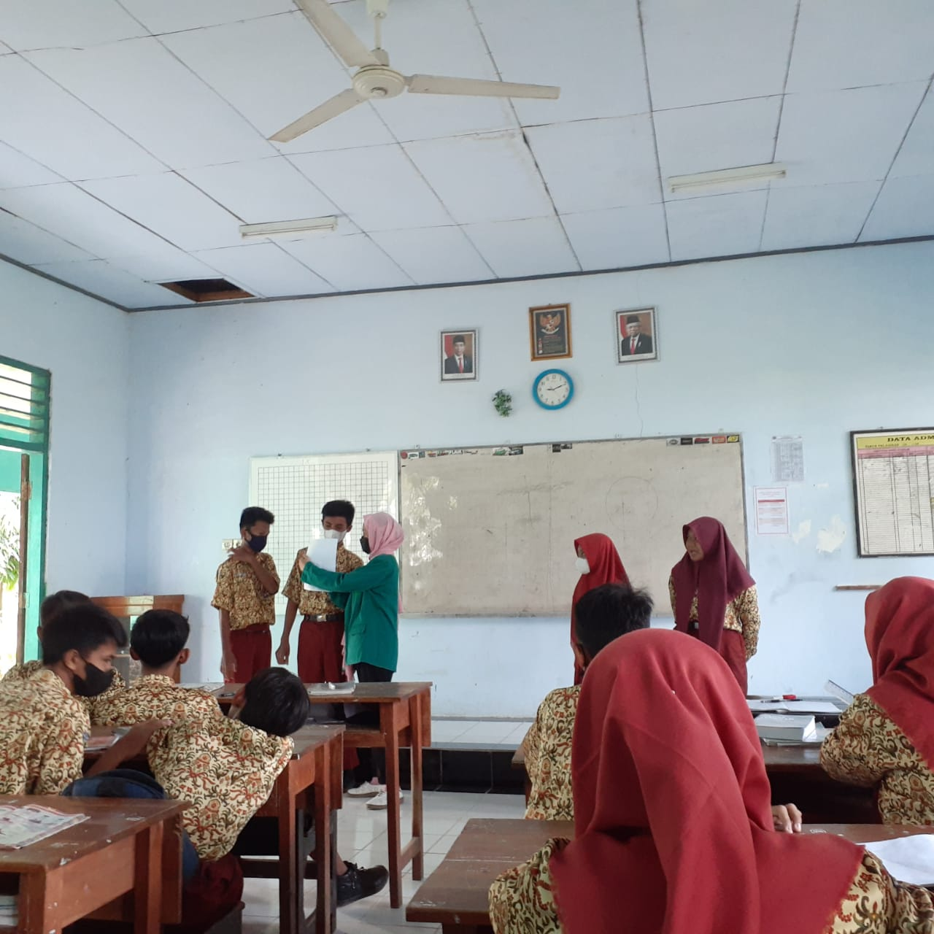

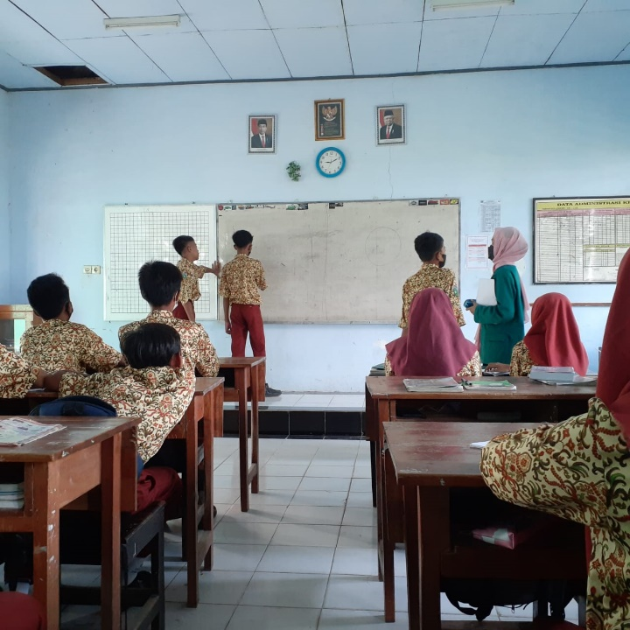

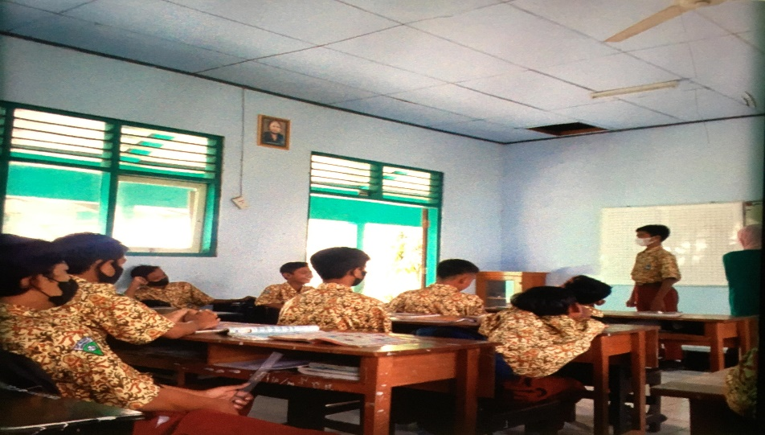

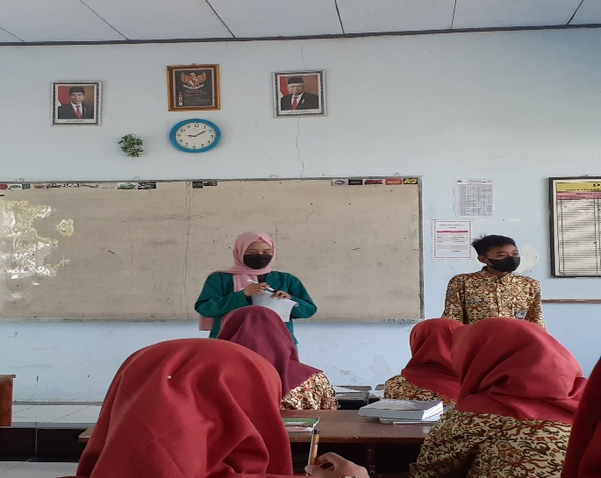

##### Appendix 1. 8 Form Construct Validity

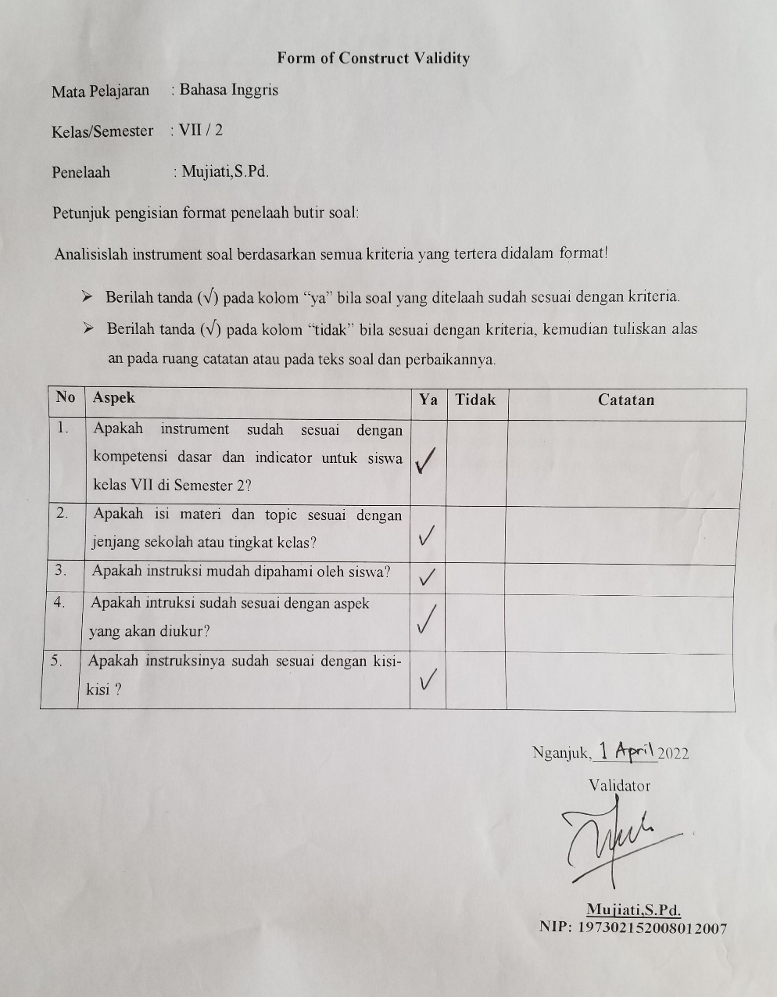

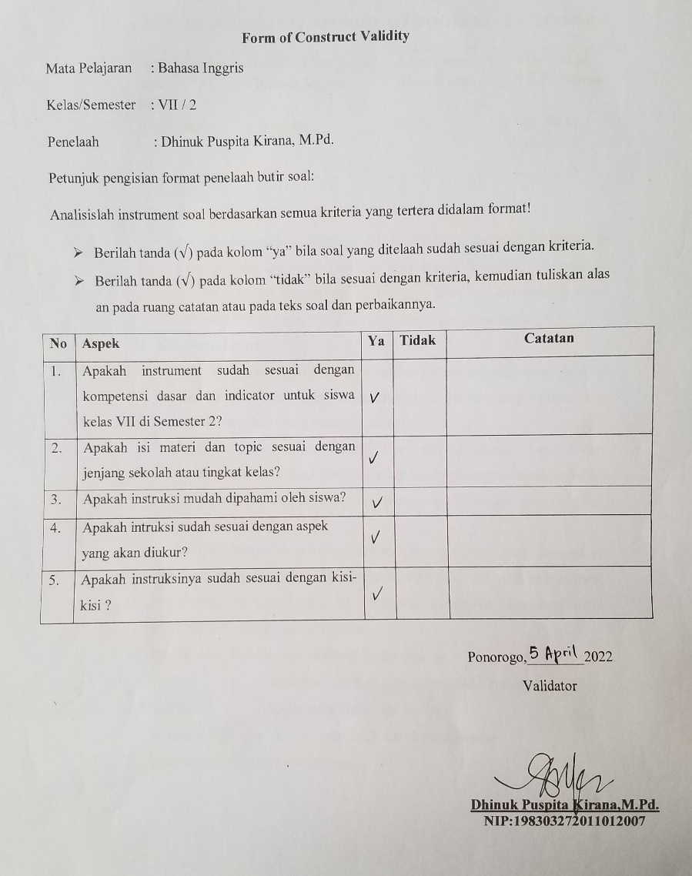

##### LETTER CONDUCTED RESEARCH

##### Appendix 1.9 Surat Izin Penelitian

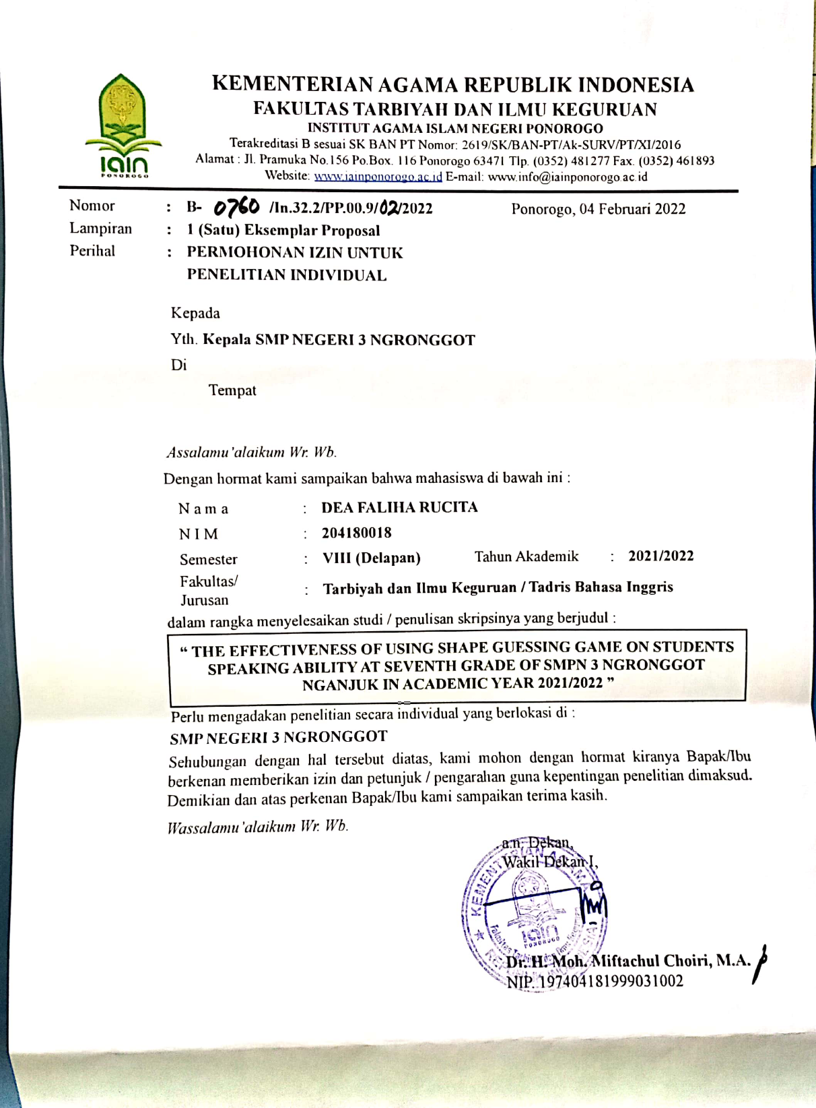

##### Appendix 1.10 Surat Keterangan Sudah Melakukan Penelitian

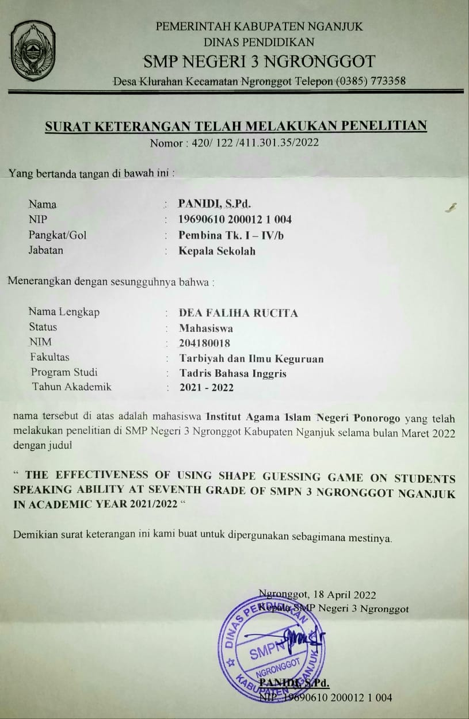

# CURRICULUM VITAE

**Dea Faliha Rucita** was born in Wonogiri, July,09,2000. She was so thankfull for living on earth as a daughter of Mr.Hery Santoso and Mrs. Evi Wahyuningsih and a sister of one lovely Ms. Ruaz Inaya Fausta. In 2012, she was graduated from SDN Harapan Jaya 2, Bekasi and she went to SMPN 1 Jatisrono, Wonogiri. Then she studied in SMAN 1 Jatisrono and graduated in 2015. In addition, she went to SMAN 1 Jatisrono taking Science (IPA) as her focus of study and graduated in 2018. Then, 2019 she continued to IAIN Ponorogo at English Department.

1. Al-Bukhari, Abu Abdullah Muhammad bin Ismail, *Ensiklopedia Hadits*; Shahih al-Bukhari, Terj. Masyhar dan Muhammad Suhadi, Jakarta: Almahira, Cet. I, 2011
2. S. Thornbury. How to Teach Speaking. (London: Longman Press, 2007). 1
3. Christine Burns, Teaching Speaking: A Holistic Approach (New York: Cambridge University Press, 2012), 37.
4. Richards, J. C. Teaching Listening and Speaking “From TheorytoPractice”.New York: CambridgeUniversityPress (2008).
5. Maqfiroh, Y., Fitriani, & Chairina. The Use of Guessing Games toTeachSpeakingSkill Research in English and Education (READ), 3(1), 91-99 (2018).
6. Dewi, RS,Kulsum, U, andArmadi. Using Communicative Games inImprovingStudents’ SpeakingSkills EnglishLanguage Teaching. Vol. 10, No. 1;2017. ISSN 1916-4742 E-ISSN 1916-4750 Published by Canadian.(2017).
7. Anggreyni, D. Improving stuedents speaking skill through guessing game technique at grade x-1 of SMAN1 Angkola Jurnal Pendidikan Bahasa, Sastra, dan SeniVolumeXVNomor1Maret2014 Hal. 1-15 (2014)
8. Yusri Developing speaking fluencyofgradeVII students through Guessing games at smp al-azhar palu.e-Jurnal Bahasantodea, 1(1), 84-92 (2013).
9. Virvou, M., &Papadimitriou Use ofdigital 'Guess Who Board Game'inteaching English Researchgate journal vol.10,2014
10. G. Fulcher, Testing Second Language (Britain : Pearson Education Limited, 2003), 51.
11. Klippel, F. Keep Talking. Communicative Fluency Activities for Language Teaching. Cambridge: Cambridge University Press. 1994
12. Webster, Merriam. Merriam Webster’s Collegiate Dictionary. United States of America: Merriam Webster Incorporated 2004.
13. A. Wright, D. Batteridge, & M. Bucky, Games for Language Learning: Third Edition (NewYork: Cambridge University Press, 2005), 1.
14. Thornbury, Scott. How to Teach Speaking. Oxford:Longman 2005
15. A. Wright, D. Batteridge, & M. Bucky, Games for Language Learning: Third Edition (NewYork: Cambridge University Press, 2005), 1.
16. Iskandarwassid dan Dadang Sunendar, *Strategi Pembelajaran Bahasa*…, 257.
17. Arsjad, Maidar G & Mukti U.S. *Pembinaan Kemampuan Berbicara*.Jakarta: Erlangga 2001.
18. Tarigan, Henry Guntur. *Membaca sebagai Suatu Keterampilan Berbahasa*. (Bandung:Angkasa) 2008.
19. Brown dan Yule. *Strategi Pembelajaran Bahasa.*Bandung: Remaja Rosdakarya. 2006
20. Soetjiningsih. *Tumbuh kembang anak*. Jakarta: EGC. 2005
21. Kayi, H. *Teaching Speaking*: Activities to Promote Speaking in a SecondLanguage. 2006
22. Harmer, Jeremy. *The Practice of English Language Teaching.* (Edinburgh Gate: Pearson Education Limited 2001.
23. Ibid . p.270
24. Ibid. p.271
25. Ibid.p.272
26. Ibid, p.128
27. Caloline T. Linse, *Practical English Language Teaching: Young Learners,* ( New York, McGraw-Hill, 2005), p.46
28. Geoffrey Broughton, et.al*., Teaching English as a Foreign Language* (2th Ed.) (New York: Routledge, 1980), p.82
29. Ibid.p. 172-173
30. Samhis setiawan, “*Pengertian Rubrik-Tujuan, Jenis, Isi, Macam, Langkah, Manfaat, Contoh, Para Ahli”* (https://www.gurupendidikan.co.id/pengertian-rubrik/. Accessed on 1th desember 2020, 14.00)
31. Brown, H, Douglas. *Teaching by Principles, an Interactive Approach to Language Pedagogy*.( New York: Addison Wesley Longman,2001) ,p. 406-407
32. Andrew Wright, David Betteridge, And Michael Buckby, Games for Language Learning (United Kingdom: Cambridge University Press, 2006), p. 1.
33. Virginia French Allen, techniques in teaching vocabulary (New York: Oxford University Press, 1983), p. 52
34. Mazidatuz Zahro, Bambang Suharjito, dan Sudarsono, “The Effect of Guessing Game on The Eight Year Students’ Vocabulary Achievement at SMPN 03 Balung Jember,” Pancaran, vol. 2 no.3 (August 2013), p. 116. https://jurnal.unej.ac.id/index.php/pancaran/article/download/707/525 (accessed on 5th December 2022).
35. Andrew Wright, David Betteridge and Michael Buckby. Games for Learning, Third Edition. New York: Cambridge University Press 2006
36. Ersoz, A. Six games for the EFL/ESL classroom. The Internet TESL Journal, 6. Fradd, S. 2000
37. Hadfield further uses ‘linguistic’ and ‘communicative’ classifications of games to refer to accuracy-focused in the former, while in the latter referring to fluency-focused 1999
38. Ceyda Yalçin. Cutting-Edge Topics and Approaches in Education and Applied Linguistics. (2018). ISBN(10): 1-5275-0804-8 ISBN (13): 978-1-5275-0804-0 Britania Raya: Cambridge Scholars Publishing ,p.169-171
39. Nick Draeger, “Reasons You Need To Be Using Game For Corporate Training ,” elearning industry: A Journal of Elearning Industry. http://www.google.co.id/amp/s/elearningindustry.com/5-reasons-you-need-to-be-using-games-for-corporate-training/amp (accessed on 5th 2022).
40. Klippel, F. Keep Talking. Communicative Fluency Activities for Language Teaching Cambridge: Cambridge University Press.1994
41. G. Fulcher, Testing Second Language (Britain : Pearson Education Limited, 2003), 51.
42. Sri Yuliani, “Teaching English by Using Guessing Game” Universitas Muhammadiyah Palembang, vol. 1 no. 2 ( 2017), p. 124. http://eprints.umk.ac.id/7007/24/The-2ndTEYLIN-ilovepdf-compressed-201-209.pdf (accessed on 8th December 2022).
43. Hall Houston, “Playing Games,” Modern English Teacher vol. 18 no.1, (accesed on 14th March 2018). p.33
44. Patricia A. Richard-Amato. Front cover image for Making it happen : interaction in the second language classroom : from. Print Book, English, 1988.
45. A. Aziz Alimul Hidayat Musrifatul Uliyah. *Pengantar Kebutuhan Dasar*. Manusia. 2nd edn. Edited by Tri Utami. Jakarta Selatan: Salemba Medika. 2015
46. Kumalasari, Dwi Rahmawati. *The Correlation Between Vocabulary Mastery and Listening Comprehension (of the second year student at SMP Muhammadiyah 1 Banyumas in academic year 2014/2015).* Bachelor thesis, Universitas Muhammadiyah Purwokerto, 2016.
47. Dwi Rahmawati, “*The Effectiveness of Using Guessing Game Technique Toward The Eight*

    *Grade Students’ Speaking Skill at MTs Negeri Bandung*”, (Published Thesis. IAIN Tulungagung,2016), 27
48. Sugiyono, Metode Penelitian Kuantitatif, Kualitatif, dan R&D (Bandung: Alfabeta, 2014), 108.
49. Retno Widyaningrum, *Statistika* (Yogyakarta: Pustaka Felicha, 2015), 151.
50. Jack R. Fraenkel and Norman E. Wallen, *How to Design and Evaluate Research in Education 7th Ed,* (New York, McGraw-Hill, 2009), p. 90
51. Lorraine R. Gay, Geoffrey E. Mills & Peter Airasian, *Educational Research: Competencies for Analysis and Applications the eleventh Edition*, (Boston: Pearson, 2012), 129
52. Prabhat Pandey & Meenu Mishra Pandey, *Research Methodology: Tools And Techniques*. (Romania: Bridge Center, 2015), 41
53. Ibid., 143.
54. Ibid., 143.
55. Mujiati. English Teaching and Learning Process. Nganjuk: SMPN 3 Ngronggot 2022
56. Ibid. p. 151
57. Arikunto, Suharsimi, Prosedur Penelitian, (Jakarta: Rineka Cipta, 2010), 136
58. Ibid.p.3.
59. Suharsimi Arikunto, *Prosedur Penelitian* (Jakarta: Rineka Cipta, 2013), 211
60. Ibid p.22
61. James Dean Brown, *Testing in Language Program* (New York: McGraw-Hill ELS/ELT, 2005), 232
62. Donald Ary, et *al Introduction to Research in Education* Eight EDITION, (Wadsworth: Compage Learning, 2010). 236
63. Ibid p.20
64. Budiyono, *Statistika Untuk Penelitian*, (Surakarta: Sebelas Maret University Press, 2004), p.170
65. Retno Widyanigrum, *Statistika.* (Yogyakarta: Pustaka Felicha, 2017), 151.