**THE EFFECTIVENESS OF HOPSCOTCH GAME IN TEACHING SPEAKING AT SMPN 1 BABADAN PONOROGO**

**THESIS**



**BY**

**LILIS SETYO ASIH**

**NIM. 210916026**

**ENGLISH EDUCATION DEPARTMENT**

**FACULTY OF TARBIYAH AND TEACHER TRAINING**

**STATE INSTITUTE OF ISLAMIC STUDIES PONOROGO**

**FEBRUARY 2021**

**ABSTRACT**

**Asih, Setyo Lilis. 2021.** The Effectiveness of Hopscotch Game in Teaching Speaking at SMPN 1 Babadan. Thesis, English Education Department, Tarbiyah and Teacher Training Faculty, State Institute for Islamic Studies of Ponorogo (IAIN). Advisor Aries Fitriani.

**Key words: Speaking Skill, Hopscotch Game, Descriptive Text.**

Speaking is considered as an important skill to be talented by students. The students got difficulties in finding ideas to speak. Hopscotch game is also one of traditional games in Indonesia. Hopscotch games can used as an auxiliary tool for the children’s education purpose to attract the eyes to concentrate their learning. This game can solved students difficulties at seventh grade at SMPN 1 Babadan.

The aim of this research was to find out whether there is a significant difference in students speaking skill who are taught by using hopscotch game and those who are not.

This research applied quantitative approach and used the quasi experimental design. The population of this research was all of the seventh grade students of SMPN 1 Babadan in academic year 2020/2021. The total number of sample were 58 students from class VII E and VII F. The technique of data collection were interview, test and documentation. To analize the data, the researcher used normality test, homogenity test and t-test formula to know whether there was significcant difference on students’ speaking skill who are taught by using hopscotch game and who are not taught.

The result of the research shows that the value of t-test is 125,31. The result computation using t-test formula of 5% significance level is 2,00. It means that 125,31 > 2,00. So, that Ha is accepted and Ho is rejected. From the explanation above the researcher concluded that hopscotch game is effective games in improving students speaking skill at seventh grade at SMPN 1 Babadan in academic year 2020/2021.

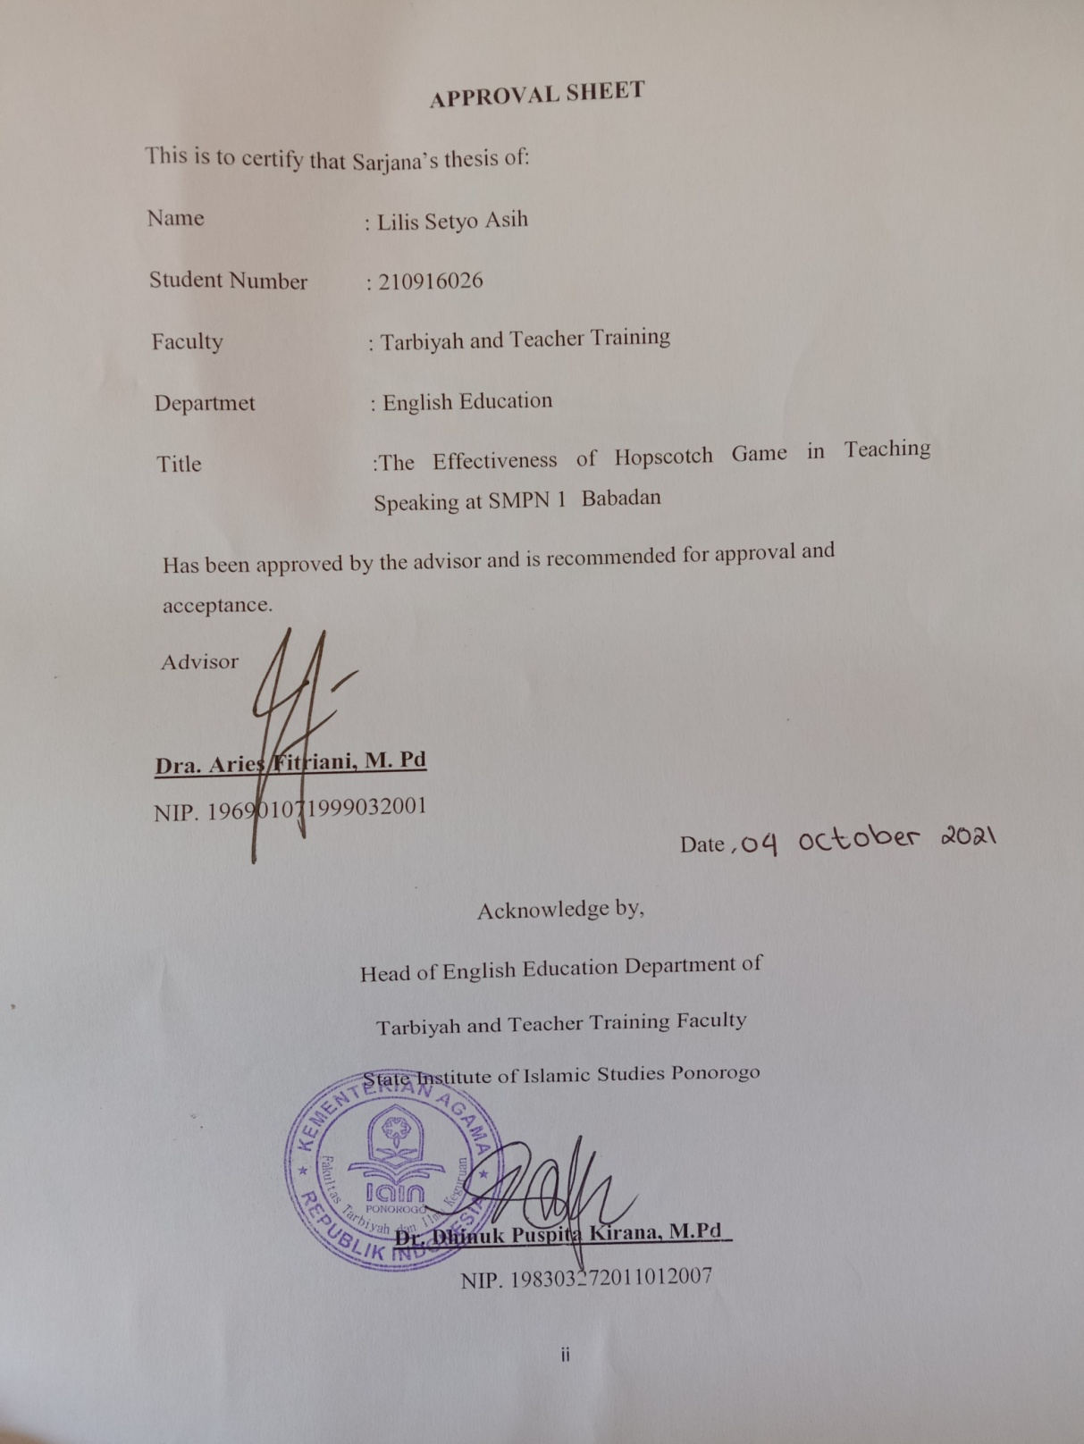



**SURAT PERSETUJUAN PUBLIKASI**

Yang bertanda tangan dibawah ini:

Nama : Lilis Setyo Asih

NIM : 210916026

Fakultas : Tarbiyah dan Ilmu Keguruan

Progam Studi : Tadris Bahasa Inggris

Judul Skripsi : The Effectiveness of Hopscotch Game in Teaching Speaking at SMPN 1 Babadan

Dengan ini menyatakan bahwa naskah skripsi/thesis telah diperiksa dan disahkan oleh dosen pembimbing. Selanjutnya saya bersedia naskah tersebut dipublikasikan oleh perpustakaan IAIN Ponorogo yang dapat diakses di ethesis.iainponorogo.ac.id. Adapun isi dari keseluruhan tulisan tersebut sepenuhnya menjadi tanggung jawab dari penulisan.

Demikian pernyataan ini saya buat untuk digunakan semestinya.

Ponorogo, 31 Oktober 2021

Penulis



Lilis Setyo Asih

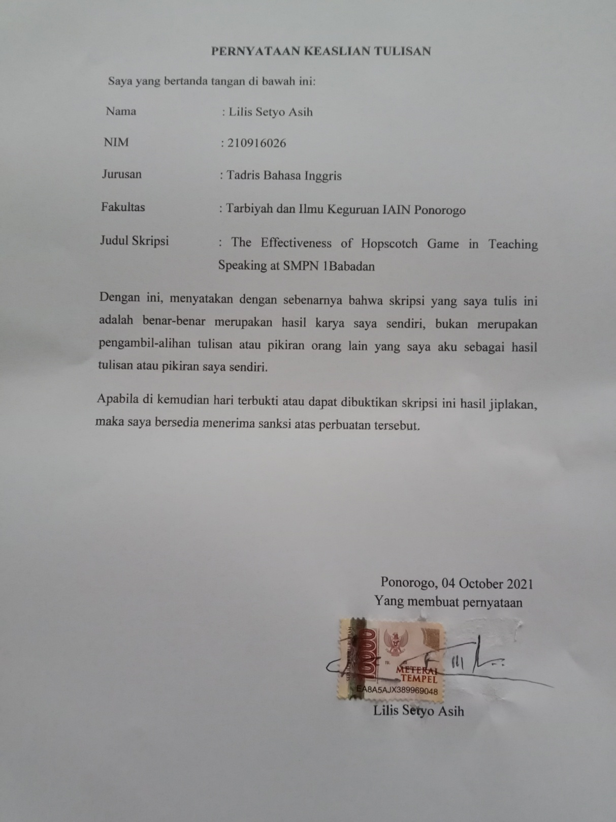

**CHAPTER I**

**INTRODUCTION**

1. Background of the study

Traditionally, language is an expression that contains the intention to convey something to the others. Something intended by the speaker can be understood by the listener or interlocutors through the language expressed. And the function of language is governed by the conventional rules shared by the speaker to the listener of language. Also, language is a sytem, the point of language is that language was formed by several constituents that are permanently patterned and can be learned.

Language has an important role an establishment of social, intellectual and emotional learners. It support the english study to be success. Studying english is supposed to help the learners to get information about their culture, and other cultures of english language. Now, studying language also helps learners to state ideas and feelings, partake in society, and use an analytical and imaginative skill that was in theirs[1].

English be a most of important language in the world, because english is a language international. English as a medium of communication and it is simple to make interactions and communication who people come from another countries by using English. In fact, in the globalization’s era, many areas including economics, politics, culture, communication and education, English appear a key role in it. Therefore, in Indonesia, English is very important to be learned.

English is one of the required subjects that taught in junior high school. Listening, speaking, reading, and writing are the four skill that be dominated. Speaking is well-thought-of as an important skill to be talented by students.

It’s contributed by O’Malley and Pierce, finding that is in the four skills, speaking show to be an important skill that a learner should obtaine since one of the major responsibilities of any teacher working with english language learners is to enable students to communicate effectively through oral language[2].

Either productive or active skill are kind one of speaking. Speaking becomes the most important instrument to communicate that needs to be completed, although the four skills are evenly important. Its mean that the goal of language is communication and the purpose of speaking in a language context is to encourage communicative efficiency.

In the English teaching and learning, only speaking activities that contrast to the other English skills during English classes so make the students don’t have any opportunities to expanded their communication skills. The students are study about grammar, structure and written communication are studied about by the students, while the oral one is put aside. The students have limite to study speaking because they answer the question through writing and reading in the semester exam. Consequently, the students do not have self-confidence even to speak a simple word and they the can’t produce sentences because have limited vocabulary and parts of speech’s knowledge.

According to Tri Murti, one of teacher in SMPN 1 Babadan Ponorogo, many students got difficulties on speaking english. The first problem is the related to the term of content. The students got difficulties in finding ideas to speak. They just had a little words to speak and only from the question of the teacher what they should speak. So, it can be said that the students lack in idea.

The second problem is related to organization and vocabulary. The students difficulty in organizing what they say. They could not organize their ideas within their minds when they were speaking. The students also got difficulties in finding vocabulary that related when they were speaking.

The third problem is related to the teacher is the english teacher just take a little role in the teaching and rarely developing learning activities in students’ speaking skill performance. The english teacher has taught about speaking skill and the media is still monoton. The teacher use LKS to teaching speaking because LKS which did not provide the students with adequate speaking practices. And the teacher only use direct method when teaching english.

The last problem is related to teaching and learning process. The problem is the students were not enthusiast and low participate to attend the learning process. The classroom were less motivated the students learning activities. The class were less fun and not interest because the teaching methods not appropriate on activities to practice speaking in english that’s why the students have low speaking skill in english[3].

Based on the explanation above, the researcher need to find the solution to solve the students’ speaking problem. There are several alternatives that can be used by teachers to improve students’ speaking skill. One of that is the use of game, such as hopscotch game.

The researcher chooses the game for this research because nowadays many modern games or online games in gadget. In the fact, children are as the object of many games on gadget. Student spend much of their time to play online game. It causes another problem that is students tend to be more familiar with modern and online games from gadget than traditional game. And than thera are two problems of the students’ junior high school are not exposed with english especially speaking and tradtional games. Exposing students with english can help them require target languages better.

Through traditional games, students are provided with they real-life that encourage interaction and communication with their friends. Those things are important because children love in playing game. A worry that children is not ready with the global demand and the sift of good values, the researcher conducted a research on teaching english through traditional games in Ponorogo, that is hopscotch game. [4]

There are several definitions of hopscotch games. In general, hopscotch game have meaning Hop (jumping) and Scotch (the lines that are in the game). Based on the definition from the free dictionary by Farlex, hopscotch game is a young”s game in which players throw a small thing into the numbered spots of a pattern of rectangle outlined on the land and then hops pass the spaces to retriev the object[5].

Hopscotch game also one of traditional game in Indonesia. This game can help the students more interested to their learning.Tzeng and Huang said that hopscotch is one of the most well known traditional games played by the children or students all around the word. Hopscotch game can be used as an auxiliary tool for children’s education purpose to attract the eyes to concentrate their learning. it means that hopscotch has different version in the word.

In teaching speaking by using hopscotch game makes students enjoy learning english. They can speak up naturally with their friend in teaching and learning process. Venkateswaran said that there are some advantages study with hopscotch game. Hopscotch game is a good activity for students study, especially for junior high school[6].

The research conducted by Thanh and Nga, shows that are Through games the students can be more relax and enjoy the learning. Games also involve friendly competition and still keep their interest to learn. It encourages the students to be involved and participate actively in learning activities. Speaking games can provide real-life into the class context and improve the use of English communicatively.

Azar investigated about effects of games toward strategies for teaching speaking for English students in Iran. Other research was conducted by Arif about the implementation of Contextual Teaching and Learning (CTL) in Teaching Science through Traditional Games. The result shows that there is a significant difference on the implementation of CTL through traditional games in science activities on the experimental group in which traditional games were implemented.[7]

The traditional games can be used too as a modul of educating, training, out bond and recreation function for student. Traditional game that writer means is the innovation game from “ hopscotch game” as one of the indonesian traditional games. This game brings many advantages for many people, especially for students in junior high school. Hopscotch games brings many advantages for students. They need fun to learning english, so the researcher has given the idea from hopscotch game to innovation in learning english.

In this case, teacher needs simple material that can be gotten in the class like chalk, colored stone and patch. Nevertheless, it is better played out door comparing to indoor playing. Here the members of each group can discuss the way of winning the game, thus students can be more active in speaking.

Based on the explanation above the researcher interest in conducting the research with the tittle **“ THE EFFECTIVENESS OF HOPSCOTCH GAME IN TEACHING SPEAKING AT SMPN 1 BABADAN”**

1. Limitation of the study

In this research, to avoid the amount speaking material used in the research. The researcher would like to limit in the teaching speaking using Hopscotch Game at SMPN 1 Babadan Ponorogo in Academic Year 2020/2021.

1. Statement of the problem

The statement problem of this study was formulated as follows : Is there any different students’ speaking achievement who are taught using hopscotch game and the students who are not?

1. Objective of the study

The objective of the research is to find out whether there is a significant difference in students speaking achievement by using hopscotch game and those who are not.

1. Significance of the study

This research study has significance are:

1. Theoritical significance
2. For English Department of IAIN Ponorogo, it’s intended that the research findings can increase the theories of the use of games in improving students’ speaking skills.
3. The research findings can be references for the next researchers who establish of same studies.
4. Practical significance
5. The result of the research can be useful for the English teachers, especially in SMPN 1 Babadan Ponorogo, to get more the knowledge in teaching and learning to improve the speaking skill of the students..
6. The research can improve the speaking skills of the SMPN 1 Babadan Ponorogo students.
7. The researcher is also expected to increase knowledge and experiences from the process of teaching and learning English speaking skill.
8. Organization of the study

The researcher writes this study into five chapters, it has related to each other. The purpose is to organize the study easily. The organization of the study are:

The first chapter is an introduction that involves of the background of the study, limitation of the study, statement of the problem, objective of the study, significance of the study and organization of the study.

The second chapter is a review of related study, review of literature that describes theories related to the variable of the study, conceptual framework and the hypothesis that show the answer of the study.

The third chapter is a research method that consists of research object, research setting and subject, reserahc variable and research procedure.

The fourth chapter is the result of the research that consists of brief description of the research location, data explanation of the cycle, data analysis process of the cycle, and discussion.

The fifth chapter is closing that consists of a conclusion and suggestion. This is make the reader easier to take the essence of the study.

**CHAPTER II**

**REVIEW OF RELATED LITERATURE**

1. Previous Research Findings

In this research, the researcher takes some review literature from several previous studies that related to the title this research and conducted by other research. There are some previous studies that are found by researcher.

The first previous research was conducted on thesis by Evinia Susandi about the implementation of hopscotch technique to improve the students’ speaking performance among the eight graders at SMP TMI Roudhlatul Qur’an Metro In The Academic Year Of 2019/2020. The purpose of this study is to improve students’ speaking skill by hopscocth technique at The Eight Graders At SMP TMI Roudhlatul Qur’an Metro In The Academic Year Of 2019/2020. In this research, the researcher conducted a classroom action research (CAR) which was done in two cycles. The result of this research show that Hopscotch Technique have positive result in improving the students’ speaking performance among the eighth graders of SMP TMI Roudhlatul Qur’an Metro. It can be proven by the students average score from pre test to post test. The average score in pre-test was 50, post-test I was 68 and become 77 in post-test II. In addition, the students’ learning activites were improved from the 51% in cycle 1 to 76% in cycle 2. It means that the using Hopscotch Technique can improve the students’ speaking performance[8].

The second previous research was conducted on thesis by Fitra Pinandita with the title “ the use of hopscotch game in teaching speaking to the first grade students of english department of IKIP PGRI Madiun in the academic year of 2013/2014”. This research was done at IKIP PGRI Madiun from September-December 2013. The result of the research shows that: 1) there are some procedures of using hopscotch, 2) hopscotch game makes students have fun in speaking class, and it can be a media to motivate students in the teaching-learning process. 3) the disadvantage of hopscotch game is spending much time.

Based on the result of this research, some suggestions are presented to the lecturer, and the students. The lecturer is expected to apply various kinds of approach or method such as hopscotch game in teaching speaking in order to make the teaching learning process more interesting and fun. The students are expected to practice speaking English actively without being afraid of making mistakes, because the lecturer will rectify and help them to be better in speaking English[9].

And the third previous research on paper by Dian Amelia Sekarini with the title Teaching Speaking Through Hopscotch Game ( A Game For Young Learners). This paper discusses the application of hopscotch game as one of the techniques in the teaching aspect of speaking English which focused on Elementary School students. The aim of this paper is to describe the implementation of hopscotch game in teaching speaking. This paper will explain: 1) The procedure for applying hopscotch game in teaching speaking. 2) The advantages of using hopscotch game in teaching speaking. The writer will explain the teaching materials, teaching media, and procedures in implementing hopscotch game in teaching speaking.

The conclusion shows that: 1) There is an example of teaching procedure in speaking English using hopscotch game, 2) Hopscotch game makes students enjoy the learning to talk, and it can be a way to motivate students in teaching and learning English. Therefore it is expected that the teachers can implement a variety of techniques such as hopscotch game in the teaching speaking to make the learning process more interested and enjoyable. The students are expected to be active in practicing speaking English without fear of making mistakes because the teachers will improve and help them better in speaking English[10].

From the previous research, the researcher found the difference and the similarity between previous research findings above with this research. The difference is in the research methodology. From previous research findings above were conducted qualitative method, and the researcher use quantitative quasi experimental method. Meanwhile, the similarity is the strategy. The previous research findings above use corrective feedback as their strategy to improve students’ speaking skill.

1. Theoritical Background
2. Teaching speaking
3. Definition of speaking

Speaking is the productive skill. speaking is an activity of producing words or sentences orally. People can convey their ideas, thought and opinion about the world, by the speaking skill and they can communicative with others directly or indirectly[11].

Brown and Yale said that speaking shows need-request, information, service, etc. Brown & Yule in Nunan also stated that spoken language suddenly stand up of short, often partial utterances in a range of pronunciation. That have to be pronounced, It deals with the ability to convey meaning through words. Between one speaker and another, there is often a great deal of repetition and negotiation of meaning[12].

Accordingly from Spratt, Pulverness, & Williams, Speaking is a productive skill. To express meanings to other people, it involves the speaker to use speech[13].

They need to be able to pronounce phonemes correctly, use appropriate stress and intonation patterns and speak in connected speech if they want to be able to speak fluently in English that are some people think. However, speaking is more than that. The skill that is used by learners to produce language is the productive skill. In this case the speaker performance can be directly observed and empirically measured in the speaking process. This situation involving two people who are engaged in talking to each share information the understanding with each other[14].

1. Component of Speaking Skill

The component of speaking can be classified into four, as follows:

1. Grammar

Grammar is a description of the structure of a language and way in which units such as words and phrases are combined to produce sentence in language.

1. Vocabulary

Vocabulary can be defined, roughly as the words we teach in foreign language. Vocabulary is one of the important aspects in speaking. Without sufficient vocabulary, we cannot communicate with others effectively and automatically we find

1. Pronunciation

One key to succes in learning to speak a foreign language is having good pronunciation. Pronunciation is the way to utter a word. It deals with stress, intonation, sounds, rhythm when we speak word.

1. Fluency

Fluency is the capacity to speak fluidly, confidently, and at a rate consistent with the norms of the relevant native speech comunity. So, it means that fluency not only the ability to speak fast but also it is relevant with the norms of native speech.

1. Type of Speaking

Before assessing speaking, we need to acknowledge basic types of speaking. According to brwn, there are five type of speaking:

1. Imitative

At one end of a continuum of types of speaking performance is the ability to simply parrot back a word of phrase os possibly a sentence. The purpose of imitative activities is obviously is not focus on students’ meaningfulinteraction but for focusing on the element of language form.

1. Intensive

A second type of speaking frequently employed in assessment contexts is the productio of short stretches of oral language designed to demonstrate competence in a narrow hand of grammatical, phrasa, lexical, or phonological relationship. This activity intended to practice some phonological or grammatical aspect but it is one step beyond imitative activities. Intensive speaking can be done through pair work activities.

1. Responsive

Responsive assessment task include interaction and test comprehension but the somewhat limited level very short convertations, standard, greetings and small talk, simple request and comments. In responsive activites, the students focused on how to reply the question shortly. The reply is usually sufficient and no need to be extended. As in example:

Teacher : “ how are you today?”

Student : “ i’m fine, and you?”

1. Interactive

The difference between responsive and interactive speaking is in the lenght and complexity of the interaction, which sometimes includes multiple exchanges or multiple participants.

1. Extensive

Extensive oral production tasks include speeches, oral presentation, and story telling, during which the opportunity for oral interaction from listeners is either highly limited or ruled out together. It is given for intermediate to advanced students who can explore the ability in extending monologue in the form of oral reports, summaries or short speeches[15].

1. The measurement of speaking performance

According to h. Douglas Brown, here is the measurement of speaking performance[16]:

|  |  |  |  |  |
| --- | --- | --- | --- | --- |
| No | Scoring aspect | Scale | Criteria | Indicators |
| 1 | Pronunciation | 17-20 | Very good | It was few traces of the foreign accent. |
|  |  | 13-16 | Good | Always intelligible though one is conscius of definitive. |
|  |  | 9-12 | Fair | Pronunciation problem necessitate concentrated. |
|  |  | 5-8 | Poor | Very hard to understand because of pronunciation, must frequently is asks to repeat. |
|  |  | 0-4 | Very poor | Pronunciation problem so ever as to make speech virtually unintelligible |
| 2 | Accent | 17-20 | Very good | Native pronunciation with no trace of foreign accent |
|  |  | 13-16 | Good | There is no conspicuous mispronunciation, but would not be taken from native speaker |
|  |  | 9-12 | Fair | Marked foreign accent and occational |
|  |  | 5-8 | Poor | Mispronunciation that do not interface with understanding foreign accent requires concentrated listening and mispronunciation lead to occational misunderstanding and apparent errors in grammar as vocabulary. |
|  |  | 0-4 | Very poor | Frequently gross errors and very heavy accent make understanding difficult requires frequent repetition |
| 3 | Grammar | 17-20 | Very good | Make few (in any noticeable) errors of grammar word order |
|  |  | 13-16 | Good | Ocationally make grammatically and/or word order errors, which do not, however obscure meaning |
|  |  | 9-12 | Fair | Makes frequent errors of grammar word order which occationally obscure meaning |
|  |  | 5-8 | Poor | Grammar and word order errors make comprehension difficult. Most of tent reprase sentence and or restrict him to basic pattern |
|  |  | 0-4 | Very poor | Errors in grammar and word order as severe as to make speech virtually intelligible. |
| 4 | Vocabulary | 17-20 | Very good | Use of vocabulary and idioms is virtually that native speaker |
|  |  | 13-16 | Good | Sometimes uses inappropriate terms and/or must rephrase ideas because of lexical inadequate vocabulary |
|  |  | 9-12 | Fair | Frequently uses the wrong word conversation some what limited because of in adequate vocabulary |
|  |  | 5-8 | Poor | Misuese of word and limited vocabulary make |
|  |  | 0-4 | Very poor | Vocabulary limitation so extreme as to make conversation virtually imposible |
| 5 | Fluency | 17-20 | Very good | Speech as fluent and effort less as that of native speaker |
|  |  | 13-16 | Good | Speed of speech seem to be slightly affected by language problem |
|  |  | 9-12 | Fair | Speed and fluency are rather strongly by language problem |
|  |  | 5-8 | Poor | Usually hestitant aften forced into silence by language limitation |
|  |  | 0-4 | Very poor | Speech is a halting and fragmentary as make conversation virtually impossible. |

1. Principles in designing speaking teaching technique.

Some principles for designing speaking technique according to Brown . They are presented as follows:

1. Use techniques that cover the spectrum of learner needs, from language-based focus on accuracy to message-based focus on interaction, meaning, and fluency.
2. Provide intrinsically motivating techniques.
3. Encourage the use authentic language in meaningful contexts.
4. Provide appropriate feedback and correction.
5. Capitalize on the natural link between speaking and listening.
6. Give students opportunities to initiate oral communication.
7. Encourage the development of speaking strategies, such as:

* Asking for clarification (What?)
* Asking someone to repeat something (Excuse me?)
* Using fillers (I mean, well)
* Using conversation maintenance cues (Right, Yeah, Okay)
* Getting someone’s attention (Hey, Say, So)
* Using paraphrases for structures one can’t produce
* Appealing for assistance from the interlocutor (to get a word or phrases, for example)
* Using formula expressions (at the survival stage) (How much does ___ cost? How do you get to the __?)
* Using mime and nonverbal expressions to convey meaning.[17]

1. Hopscotch game
2. Definition

Newman Barbara said that hopscotch is the game symbolized of early shilhood as students try to move ahead in their live without stopping on lines, going outside the boxes, the player must balance and carefully to avoid lines or stopping in forbidden area[18].

Hopscotch is a really simple game. The students play with it reat success all the time according to the game rule the objective is to jump and place the foot safely within the marked border of the 8 to 12 chalk square while avoiding the square that has been marked as no landing spot[19]. Hopscotch game’s technique is move and jump in this situation in which students, so the students will be active and beneficial to body health and the last closing game in every grid the students will convey their idea to speaking.

Player of hopscotch technique includes cooperative interaction. Hopscotch game also can be viewed as form of aituated activity system. A particular social organization of attention is required to construct a point of common focus. The part of hopscotch if the player throwing one’s or stepping on or outside lines as a consequential event, an “ out” in which the haples player its loses. Therefore its means hopscotch is technique that make the students easier to delivery their opinion or idea and also help for student i process oral activity then make all student contribute in the task. One of the most commonly every player must concentrate and carefully archieve to the square to play an important role in the group and benefit from the group.

In other words, hopscotch is an especially good way for participant to observe and interprate behaviour, and involved in the process of learning about each other and refer to physical game world is clearly defined for rules simple enough. It means that hopscotch game can helps the students create in learning and to motivate student to speak up[20].

1. The Purpose of Hopscotch Game

The purpose of hopscotch game is:

1. To get amusement for students, speading spare time, and to be sociable in personal of students.
2. The students can interact with each other in teaching speaking.
3. To make enjoy and relax in process teaching.
4. It encourages the students to be involved and participate actively in learning activities[21].
5. The Procedure of Implementation Hopscotch Game
6. The teacher explain will be discuss.
7. The teacher divides the student into some group. The teacher or student draw the square on the ground or floor. In every square the teacher give text paper.
8. Every player of the group is given the stone.
9. The first player throw the stone into the square. If the stone is inside the ground, then the player put the text paper and speak the text on the paper.
10. The player turns back from the last square and takes the stone with one foot stand
11. The player turns back from the last square when the player takes the stone that he may step in the square and takes the stone with one-foot stand.
12. Finishing the hopscotch game, the teacher gives some suggestion, criticism, and conclusion about the students perfomance[22].
13. The advantage and disadvantage of Hopscotch Game
14. The advantage of hopscotch game:
15. The students enjoy to follow english oral activity.
16. This game can motivate students in teaching speaking[23].
17. Involving physical action that encourages children to be mentally active[24].
18. This technique help the student in possitive effect on developing young learners.
19. The impact this technique for the student will health of body.
20. Physical activities can contribute physocomotor development, foster cooperation, and development positive attitude towards learning.[25]
21. The disadvantage of hopscotch game:

Hopscotch games also has several disadvantage in teaching process how to the teacher manage the classroom activity:

a. Spending much time in learning its mean the teacher must manage time in process learning.

b. The class is big enough, the student can’t concentrate because hopscotch dominant use in outdoor or classroom[26].

1. Conceptual Framework

When the students speaking, the elements of speaking that must be mastered were the idea, grammar, vocabulary, comprehension, fluency, pronounciation. The students difficulties to speak because they had lack of some elements of speaking and no motivation from students’ self to speaking.

In the previous chapter, the researcher limited the identified problems and considers one main problem. The main problem is the students lack of speaking skills. Therefore, the researcher had to improve the students speaking skills. The researcher try to use speaking with hopscotch game to teach speaking. The researcher will implement the use of speaking during the teaching and learning of speaking.

Using hopscotch game can support the students to speak and to express their ideas also make the students enjoy to speak. the researcher will also observer the activity on the class during the implementation the game and find some improvement after implementing the hopscotch game in teaching and learning speaking process.

The researcher will give the students activities to support them to speak english and make them able to speak english.

1. Hypothesis

Based on the statement of the problem above, the hypothesis of the study is Hopscotch Game is:

Ha: there is a significant difference in speaking achievement between students who are taught by using Hopscotch Game and those who are not.

Ho: there is no significant difference in speaking achievement between students who are taught by using Hopscotch Game and those who are not.

The hypothesis criterion states that: if t0>tt = ha is accepted and h0 is rejected, and if t0<tt = ha is rejected and h0 is accepted t0 is t observation, and tt is t test.

**CHAPTER III**

**RESEARCH METHODS**

1. Research Design

In this research, the researcher applied a quantitative research design. The researcher used experimental design that was quasi experimental. The researcher used quasi experimental research because the researcher could oly assign randomly different treatments to two classes that is a control class and experimental class. The experimental class was taught by using hopscotch game and the control class was taught by ordinary method.

The researcher used non-equivalent (pre-test and post-test) control group design. This is a popular approach involved control class and experimental class. Both classes received pre-test and post-test but only the experimental class received the treatment.[27]

The process of this research included pre-test, experimental treatment, and post-test. The researcher taught th students in experimental class by using hopscotch game, while for the control class, the researhcer taught by using traditional teaching, explained the material and asked the students to speak in front of the class. Pre-test was given before the treatment to measure their confidence in speaking, while for the post-test was given after the researcher gave the treatment.

Table 3.1

Design of study

|  |  |  |
| --- | --- | --- |
| Experimental class VII F | Step pre-test | Step post-test |
| Treatment by using hopscoth game method | 1. The researcher give the descriptive text to the students. 2. The researcher ask to the students to open the descriptive text. 3. The reseacher ask to the students to practice it in front of the class. | 1. The researcher writing the topics in board or tell to the students about the topics. 2. The researcher divides the student into some group. The researcher or student draw the square on the ground or floor. In every square the teacher give text paper. 3. Every player of the group is given the stone. The first player throw the stone into the square. If the stone is inside the ground, then the player put the text paper and speak the text on the paper. 4. The player turns back from the last square and takes the stone with one foot stand. 5. The player turns back from the last square when the player takes the stone that he may step in the square and takes the stone with one-foot stand. 6. Finishing the hopscotch game, the teacher gives some suggestion, criticism, and conclusion about the students perfomance. |
| Treatment by using conventional method. | 1. The researcher give the descriptive text to the students. 2. The researcher ask to the students to open the descriptive text.   The reseacher ask to the students to practice it in front of the class. | 1. The researcher give the descriptive text to the students. 2. The researcher ask to the students to open the descriptive text. 3. The reseacher ask to the students to practice it in front of the class. |

1. Population and Sample
2. Population

Population is a large group about which generalization that made. A population is defined as all members of any well-defined class of people, event or objects[28]

The population of this research is all of the seventh grade students of SMPN 1 Babadan Ponorogo in Academic Year 2020/2021. The total number of the population is 201 students. It can be shown at the following table:

Table 3.2

The population of students

|  |  |  |
| --- | --- | --- |
| No | Class | Students |
| 1 | VII A | 29 |
| 2 | VII B | 29 |
| 3 | VII C | 29 |
| 4 | VII D | 28 |
| 5 | VII E | 29 |
| 6 | VII F | 29 |
| 7 | VII G | 28 |
| TOTAL | | 201 |

1. Sample

Sample is a subgroup of the target population that the researcher plans to study for generalizing about the target populations[29]. It is stated that sample is a small group of people selected to represent the much larger entire population from which it is drawn[30]. There are two kind of sample, probability and non probability sample. In this research, the researcher used probability sample. The total number of sample were 58 students. The samples were taken randomly. The two classes were the class VII E as control class and VII F as experimental class.

1. Data Collecting Instrument

Instrument is tool that used the researcher in collecting data in order researcher works easier, the result is better, accurate, complete, and systematic, so the data are easy to be processed.

Table 3.3

Data collecting instrument

|  |  |  |  |  |
| --- | --- | --- | --- | --- |
| Tittle | Variable | Indicator | Instrument | Subject |
| The effectiveness of hopscotch game in teaching speaking at SMPN 1 Babadan | Independent variable X1: hopscotch game | 1. Students get new experiences in learning speaking. 2. The researcher can collaboration among students. 3. Increase the tolerance between students and researcher. 4. Students are able to tell about descriptive text through hopscotch game. | Oral test | Seventh grade students |
| Dependent variable Y1: students speaking skill | Students are able to use grammar, pronunciation and vocabulary in speaking.  Students also are able to speak fluently. | Oral test | Seventh grade students |

The research instrument that is used to collect data was the test. The test will be done into two part that is pre-test and post test. Pre-test was given to know the results of the value and the condition from the students before getting the treatment. While the post-test was given to know the results of the students value and condition after getting the treatment by using hopscotch game.

Before the instrument used in this research, the researcher test the instrument with two test, the first is validity test and the second is reliability test.

1. Validity

Validity is the process of gathering evidence to support a particular interpretation of reffer the test score. Need evidence to establish that inference, appropriate make on the basic of the result test. Numerous studies may be required to build body of the evidence about the validity of these score based interpretation[31].

Validity is an important key to measure effective instrument research. Validity is the excent to which inferences made from assessment result are appropriate, meaningful and useful in the terms of the purpose of the assessment[32].

To calculate the validity, the researcher used SPSS program os use the formula as follows:

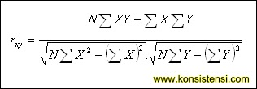

rxy = digit of index product moment correlation

$εx$ = the total score X

$εy$ = the total score Y

$εXY$ = the total score of result multiplication between X and Y

$N=$ Total of responden[33]

In this research, the researcher used to SPSS program to measure the validity. After finding rxy, it was equal to or greater than the value of rtable, in indicated that items was valid. According to the rtable value for N=27 on the 5 % of significance level, it lasted 0,444. So the result of the test were valid and the test validity as follows:

Table 3.4

The result test validity of speaking

|  |  |  |  |
| --- | --- | --- | --- |
| Item | Itable | Ixy | Criteria |
| Grammar | 0,381 | 0,381 | Valid |
| Fluency | 0,381 | 0,465 | Valid |
| Pronunciation | 0,381 | 0,478 | Valid |
| Vocabulary | 0,381 | 0,575 | Valid |
| Accent | 0,381 | 0,465 | Valid |

To test validity of the item, the researcher takes sample 27 respondents from VII C, the researcher gave 1 text for this class and with the speaking scoring rubric. So, the researcher calculated the validity test from 5 scoring speaking rubrics and the item is valid.

1. Reliability

Reliability test is consistent and dependable[34]. Reliability of a measuring instrument is the degree of consistency with which it measures whatever it is measuring. Reliabilty of a test may best adrresed by considering a number of factors that may contribute to unreliability of a test. Consider the following possibilities[35]. The researcher employe SPSS program to measure reliability.

The instruments is reliable if alpha is more than r table, if alpha is under the r table the instrument is unreliable. The sample is seventh grade students, n= 29 and the significance the price of r table is 0,819. so, the result of reliability instruments calculate is as follow:

Table 3.5

Reliability of speaking test

|  |  |
| --- | --- |
| Conbrach’s alpha | N of item |
| .819 | 5 |

The value of reliability of speaking test is 0,819. All of the value reliability is high reliability. The test called to be reliable if the responden answer are consistent.

1. Data Collecting Technique

In this researh, researcher collected the data by the some techniques as the following:

1. Test

Test is method of measuring a person’s ability, knowledge, or performance in a given domain[36]. In this research, the test was used to test speaking skill, the test in this research are pre-test and post test. Pre-test used to know the students’ previous level of the speaking skill. And the post-test used to know the students’ level of their speaking ability after the researcher give the treatment of hopscotch game in teaching speaking. The researcher chose the test by conducting oral test. There are five indicator to be assessing in speaking skill test, such as the students are able to use appropriate grammar and vocabulary, students are able to speak fluently and good pronunciation.

According to h. Douglas Brown, here is the measurement of speaking performance[37]:

|  |  |  |  |  |
| --- | --- | --- | --- | --- |
| No | Scoring aspect | Scale | Criteria | Indicators |
| 1 | Pronunciation | 17-20 | Very good | It was few traces of the foreign accent. |
|  |  | 13-16 | Good | Always intelligible though one is conscius of definitive. |
|  |  | 9-12 | Fair | Pronunciation problem necessitate concentrated. |
|  |  | 5-8 | Poor | Very hard to understand because of pronunciation, must frequently is asks to repeat. |
|  |  | 0-4 | Very poor | Pronunciation problem so ever as to make speech virtually unintelligible |
| 2 | Accent | 17-20 | Very good | Native pronunciation with no trace of foreign accent |
|  |  | 13-16 | Good | There is no conspicuous mispronunciation, but would not be taken from native speaker |
|  |  | 9-12 | Fair | Marked foreign accent and occational |
|  |  | 5-8 | Poor | Mispronunciation that do not interface with understanding foreign accent requires concentrated listening and mispronunciation lead to occational misunderstanding and apparent errors in grammar as vocabulary. |
|  |  | 0-4 | Very poor | Frequently gross errors and very heavy accent make understanding difficult requires frequent repetition |
| 3 | Grammar | 17-20 | Very good | Make few (in any noticeable) errors of grammar word order |
|  |  | 13-16 | Good | Ocationally make grammatically and/or word order errors, which do not, however obscure meaning |
|  |  | 9-12 | Fair | Makes frequent errors of grammar word order which occationally obscure meaning |
|  |  | 5-8 | Poor | Grammar and word order errors make comprehension difficult. Most of tent reprase sentence and or restrict him to basic pattern |
|  |  | 0-4 | Very poor | Errors in grammar and word order as severe as to make speech virtually intelligible. |
| 4 | Vocabulary | 17-20 | Very good | Use of vocabulary and idioms is virtually that native speaker |
|  |  | 13-16 | Good | Sometimes uses inappropriate terms and/or must rephrase ideas because of lexical inadequate vocabulary |
|  |  | 9-12 | Fair | Frequently uses the wrong word conversation some what limited because of in adequate vocabulary |
|  |  | 5-8 | Poor | Misuese of word and limited vocabulary make |
|  |  | 0-4 | Very poor | Vocabulary limitation so extreme as to make conversation virtually imposible |
| 5 | Fluency | 17-20 | Very good | Speech as fluent and effort less as that of native speaker |
|  |  | 13-16 | Good | Speed of speech seem to be slightly affected by language problem |
|  |  | 9-12 | Fair | Speed and fluency are rather strongly by language problem |
|  |  | 5-8 | Poor | Usually hestitant aften forced into silence by language limitation |
|  |  | 0-4 | Very poor | Speech is a halting and fragmentary as make conversation virtually impossible. |

1. Interview
2. Documentation

Documentation technique is the way to collect data by photos,ancient and video,etc[38]. In this research, the researcher used the documentation method to analyze students on using hopscotch games at seventh grade of SMPN 1 Babadan in academic year 2020/2021. The documentation were constructed based on the standarized procedures of applying the documentation method.

1. Data Analysis Technique

After collecting data by giving test ( pre-test and post-test), the researcher analyzed the data. The result of the test ( pre-test and post-test) were analyzed by using T test. Before it, the data were analyzed by using normality and homogenity test.

1. Normality test

Normality test was used to know whether the data come the distribution or not. There are many ways to conducting normality test. In this research, the researcher used SPSS with Kolmogorov Smirnov formula. The steps to find out the normality test as follows:

1. Open the SPSS 23 version program.
2. Input the data to the data view. After that change ta variable view with the class name.
3. Click analyze after that click non-parametric and then click sample K-S (Kolmogorov Smirnov)
4. Drag the data to test variable
5. Klik OK
6. After calculate the data, to determine the data is normal or not can be seen if the t-value was lower than t-table or the t-value was higher than t-table.
7. Homogenity test

Homogenity test means the similarity variance of each groups, so the researcher will face with groups that have same condition from the begining[39]. In quasi-experimental research, homogenity was used to know whether experimental and control that are taken from population have same variant or not. The researcher used SPSS program to calculate homogenity test. The steps of homogenity test as follows:

1. Open the SPSS 23 version program.
2. Input the data to the data view. After that, change the variable view with X as pre-test score and Y as post-test score.
3. Click analyze, after that click compare means and then click one way anova.
4. Click option, after that check list homogenity of variance and then click OK.

After calculate the data, to determine the data is homogen or not it can be seen if the t-value was lower than t-table or the t-value was higher than t-table.

1. T-tes

After testing of normality and homogenity, the researcher analyzed the data by using T-test is to determine whether the mean of two groups are statiscally different from one another. Researcher analyze the data by comparing the score between experimental class and control class in test (pre-test and post- test). The researcher used SPSS 23 version to analyze the t-test. The step to calculatedt-test as follows:

1. Open SPSS 23 version program
2. Input the data yo the data view. After that change the value in variable view, and then change the measure, name, decimals and value.
3. Click analyze, after that click compare means and then independent sample t-test.
4. In the independent sample t-test box dialogue, input the variable X for test varable and variable Y for grouping varable.
5. Click define groups, then in the group 1 write down and in the group 2. After that click continue and OK.

The result of the calculation will show whether Hopscotch games given effective in teaching speaking or not.

Ho : if Ttest <Ttable in significant degree 5%

Ha : if Ttest > Ttable in significant degree 5%

**CHAPTER IV**

**RESEARCH RESULT**

1. General Findings
2. The Geographical Location of SMPN 1 Babadan Ponorogo

SMPN 1 Babadan located on Jl. Teuku Umar , Babadan village, Babadan street , Ponorogo district. Zip code 14391, number phone (o352) 483723.

1. Vision, Mission and Motto of SMPN 1 Babadan
2. Vision

Excellent in achievement, knowledge and technological, culture, and care about the environment based on faith and taqwa.

1. Mission
2. Development active, creative, innovative and fun learning programs.
3. Cultivate the students’ potential through ICT- based learning.
4. Cultivate the potential of students in sports and arts.
5. Creating discipline, orderliness, cleanliness, virtous character and good attitude.
6. Creating a clean, healthy, green leafy, beautiful, comfortable and safe environment.
7. Establish good and synergistic, cooperative relationships between school residents, institutions and the community.
8. Motto

Build togetherness to create a school that is condusive, aspirational and innovative.

1. Teacher Data of SMPN 1 Babadan

There are the data of SMPN 1 Babadan teachers and staff can be seen as follows:

Table 4.1

Teachers data of SMPN 1 Babadan

|  |  |  |  |
| --- | --- | --- | --- |
| No | Name | Gender | Position stucture |
| 1 | Imam Saifudin, S.Pd., M.Or | Male | Headmaster |
| 2 | Tri Woelan S.Pd | Female | Indonesian teacher |
| 3 | Sumini S.Pd | Female | Indonesian teacher |
| 4 | Slamet S.Pd | Male | Art and culture teacher |
| 5 | Budi Wiyono S.Pd | Male | Sport teacher |
| 6 | Sriati S.Pd | Female | Sosial teachers |
| 7 | Marwati S.Pd | Female | Sosial teacher |
| 8 | Subagyo S.Pd | Male | Mathematic teacher |
| 9 | Husnul Chotimah S.Pd | Female | Art and culture teacher |
| 10 | Tri murtiningsih, M.Pd | Female | English teacher |
| 11 | Wiwin Mantoningsih, S.Pd | Female | English teacher |
| 12 | Edi Widodo, S.Pd | Male | Science teacher |
| 13 | Tjahjani Budi Astuti, S.Pd | Female | Matematics teacher |
| 14 | Nunik Nurhidayati, S.Pd | Female | Science teacher |
| 15 | Bambang, S.Pd., S.Kom | Male | Counseling and technology information (BKTI) |
| 16 | Setyorini, M.Pd | Female | Sosial teacher |
| 17 | Titik Sulisyowati, S.Pd | Female | Locals teacher |
| 18 | R. Purnomo Edi S., S.Pd | Male | Sosial teacher |
| 19 | Lestari Indah, S.Pd | Female | Mathematic teacher |
| 20 | Mulyono, S.Pd | Male | Science teacher |
| 21 | Nanik Sri Isdiyanti, S.Pd | Female | Mathematic teacher |
| 22 | Siti Mutmainah, S.Pd | Female | English teacher |
| 23 | Tri Sulistiani, S.Pd | Female | English teacher |
| 24 | Emy Wahyuningsih, S.Pd | Female | Science teacher |
| 25 | Drs. Ikhwan, M.Si | Male | Science teacher |
| 26 | Dra. Sri Purwanti, M.Pd | Female | Indonesian teacher |
| 27 | Sigid Setya Purnama, S.Pd | Male | Sport teacher |
| 28 | Drs. Misbah | Male | Religion teacher |
| 29 | Anik Sri Martanti, S.Pd | Female | Indonesian teacher |
| 30 | Thoyyibah, BA | Female | Head of administration |
| 31 | Sri Mulyani, S.Pd | Female | Art and culture teacher |
| 32 | Puguh Murbuono, S.Psi | Male | Counseling |
| 33 | Didit Ifa Wibisono, S.Pd.I | Male | Religion teacher |
| 34 | Handari Endah P., M.Psi | Female | Counseling |
| 35 | Bekti Hidayati, S.Pd | Female | Indonesian teacher |
| 36 | Susana Kusumastuti | Female | Staff of administration |
| 37 | Yayuk Hartini | Female | Staff of administration |
| 38 | Karyono | Male | Staff of discipline |
| 39 | Faruk Amirulloh | Male | Staff of administration |
| 40 | Soimin | Male | Helper |
| 41 | Yoko Gayuh Susilo, S.S | Female | Local teacher |
| 42 | Satria Agung A. P., S.Pd | Male | Civics teacher |
| 43 | Dwi Ayu Novita A., S.Pd | Female | Prakarya teacher |
| 44 | Yuliana Tri Maya, S.Pd | Female | Sport teacher |
| 45 | Hantoro Nur Setiawan | Male | Operators |
| 46 | Agung Puji Astoto | Male | Staff of administration |
| 47 | A.F. Kusuma, S.Kom | Male | Staff of administration |
| 48 | Edi Prayitno | Male | Helper |
| 49 | Suryadi | Male | Helper |
| 50 | Aryuda Bagus W., S.Kom | Male | Staff of administration |
| 51 | Pravita Yonika Aulia, S.Sos | Female | Staff of administration |
| 52 | Nidya Lutfi Ekasari, S.Pd | Female | Counseling |

1. Student Data of SMPN 1 Babadan

The data of students in SMPN 1 Babadan Ponorogo at academic year 2020/2021 as follows:

Table 4.2

Student Data of SMPN 1 Babadan Ponorogo in Academic Year 2020/2021

|  |  |  |
| --- | --- | --- |
| **No** | **Class** | **Sum** |
| 1 | Class VII A | 29 |
| 2 | Class VII B | 29 |
| 3 | Class VII C | 29 |
| 4 | Class VII D | 28 |
| 5 | Class VII E | 29 |
| 6 | Class VII F | 29 |
| 7 | Class VII G | 28 |
| 8 | Class VIII A | 29 |
| 9 | Class VIII B | 29 |
| 10 | Class VIII C | 28 |
| 11 | Class VIII D | 28 |
| 12 | Class VIII E | 29 |
| 13 | Class VIII F | 29 |
| 15 | Class IX A | 32 |
| 16 | Class IX B | 32 |
| 17 | Class IX C | 32 |
| 18 | Class IX D | 32 |
| 19 | Class IX E | 32 |
| 20 | Class IX F | 32 |

1. Data Description

The researcher used quasi experimental research on this research. The researcher took two different groups of the students’ sample and taught by using different treatment to find the effectiveness of certain treatment. The researcher used two class as a sample, class VII E as an control class and class VII F as an experimental class.

In experimental class, the researcher taught the students by using hopscotch game, while in the control class the researcher not taught the students by using hopscotch game. So, the researcher wanted to know the result of the test between the students who are taught by using hopscotch game and the students who are not taught.

1. Research schedule in Experimental and Control Class

The researcher divided the sample into two class. The first class is VII F was an experimental class. The researcher conducted four meetings in the experimental class. The first and the second meeting was pre-test, the third and the fourth meeting was treatment by using hopscotch game and the last meeting was post-test. On the other hand, the control class also consisted four meeting.the first and the second meeting was pre-test, the third and the fourth meeting was treatment by using conventional method, and the last was post-test. This is the table schedule of the research as below

Table 4.3

Research Schedule in Experimental Class

|  |  |  |  |  |
| --- | --- | --- | --- | --- |
| No | Date | Activities | Subject | Meeting |
| 1 | 05-04-2021 | Pre-test (1) | Descriptive text | 1st |
| 2 | 06-04-2021 | Pre-test (2) | Descriptive text | 2nd |
| 3 | 09-04-2021 | Treatment using hopscotch game | Descriptive text | 3rd |
| 4 | 10-04-2021 | Treatment using hopscotch game | Descriptive text | 4th |
| 5 | 16-04-2021 | Post-test | Descriptive text | 5th |

Table 4.4

Research Schedule in Control Class

|  |  |  |  |  |
| --- | --- | --- | --- | --- |
| No | Date | Activities | Subject | Meeting |
| 1 | 07-04-2021 | Pre-test (1) | Descriptive text | 1st |
| 2 | 08-04-2021 | Pre-test (2) | Descriptive text | 2nd |
| 3 | 14-04-2021 | Treatment by conventional method | Descriptive text | 3nd |
| 4 | 15-04-2021 | Treatment by conventional method | Descriptive text | 4th |
| 5 | 17-04-2021 | Post-test | Descriptive text | 5th |

1. Research Teaching Procedure
2. Teaching Procedure in Experimental Class

The research procedure in experimental class was four step. The first meeting was pre-test. The researcher gave the pre-test to examine the students speaking skill. The researcher ask to the students to speak about the descriptive text, in this treatment the students get the descriptive text from the researcher. The students speaking in front of the class and the researcher assess the students score of speaking. The researcher use five aspects: grammar, vocabulary, pronunciation, fluency, and task.

The second and third meeting is the researcher give the treatment to the students. The researcher explain about the hopscotch game and the steps playing the game. The first step is the researcher divides the student into some group. The researcher or the student draw the square on the ground or floor. After draw the square, the researcher give text paper in every square. In this step, every player of the group is given the stone. The second steps is action, every player or student ready to play the game. The first player throw the stone into square. If the stone is inside the ground, the player must put the text paper and speak the text on the paper. After that, the player turns back from the last square and takes the stone with one foot stand. And the last of the hopscotch game is the teacher gives some suggestion, criticism, and conclusion about the students performance.

The fourth step is give the post test with the oral test. The test were used towards the effect of hopscotch game in students speaking skill

1. Teaching Procedure in Control Class

In the control class, the researcher give four meeting too in the class. The first meeting is pre-test. In pre-test, the researcher ask to the students speak the text in front of the class and the researcher write the score of the students speaking test. The second steps is treatment, the researcher give the treatment to the students by conventional method. The researcher give the example how to speak or tell the descriptive text. The last step, the rearcher give the post test

1. Description of Students’ Score In Experimental and Control Class

In this part, the researcher give the information the data of speaking test. the result of the students’ pre-test and post-test in experimental class and control class as follows:

1. The Result of Students’ Score in Experimental Class

There are the result of pre-test and post-test in experimental class. The pre-test on April 5th 2021 until April 06th 2021 and the post-test on April 16th 2021. This table below showed the results score of the speaking skill who were taught by using “hopscotch game”. This table indicate the pre-test and post-test score for experimental class.

Table 4.5

The students pre-test and post-test score in experimental class

|  |  |  |  |
| --- | --- | --- | --- |
| No | Name | Pre-test Score | Post-test Score |
| 1 | ASS | 52 | 70 |
| 2 | AAW | 53 | 75 |
| 3 | ABA | 52 | 75 |
| 4 | AM | 47 | 74 |
| 5 | AAS | 49 | 72 |
| 6 | AP | 48 | 72 |
| 7 | AZ | 49 | 70 |
| 8 | BHA | 50 | 72 |
| 9 | BDW | 49 | 75 |
| 10 | DONA | 50 | 77 |
| 11 | EDM | 49 | 70 |
| 12 | FZS | 49 | 71 |
| 13 | FP | 51 | 74 |
| 14 | GAPH | 51 | 71 |
| 15 | GAZ | 51 | 70 |
| 16 | GAD | 52 | 74 |
| 17 | LVA | 51 | 75 |
| 18 | MAA | 52 | 80 |
| 19 | MA | 53 | 75 |
| 20 | NZPJ | 52 | 77 |
| 21 | NBS | 53 | 73 |
| 22 | RH | 52 | 72 |
| 23 | RAP | 55 | 72 |
| 24 | RAPU | 56 | 70 |
| 25 | WS | 56 | 74 |
| 26 | WAN | 52 | 77 |
| 27 | WAN | 56 | 73 |
| 28 | ZKD | 52 | 73 |
| 29 | ZAK | 52 | 73 |

Based on the table, it can be seen that the highest score of students speaking in pre-test is 54 and the lowest score is 46. Meanwhile, the result of the post-test can be seen that the highest score of students speaking is 80 and the lowest score is 70.

So, the researcher conclude that the students’ post-test who were taught using hopscotch game was better than pre-test. For more detail, the statistic description of the students speaking score, can be seen as follows:

1. Pre-Test Score of Experimental Class

After getting the data of pre-test score in experimental class, the researcher formulated the frequency distribution as follows.

Table 4.6

Frequency Distribution of Pre-test in Experimental Class

|  |  |  |  |  |  |
| --- | --- | --- | --- | --- | --- |
|  | | | | | |
|  | | Frequency | Percent | Valid Percent | Cumulative Percent |
| Valid | 47 | 1 | 3,4 | 3,4 | 3,4 |
| 48 | 1 | 3,4 | 3,4 | 6,9 |
| 49 | 5 | 17,2 | 17,2 | 24,1 |
| 50 | 2 | 6,9 | 6,9 | 31,0 |
| 51 | 5 | 17,2 | 17,2 | 48,3 |
| 52 | 7 | 24,1 | 24,1 | 72,4 |
| 53 | 2 | 6,9 | 6,9 | 79,3 |
| 54 | 2 | 6,9 | 6,9 | 86,2 |
| 55 | 1 | 3,4 | 3,4 | 89,7 |
| 56 | 3 | 10,3 | 10,3 | 100,0 |
| Total | 29 | 100,0 | 100,0 |  |

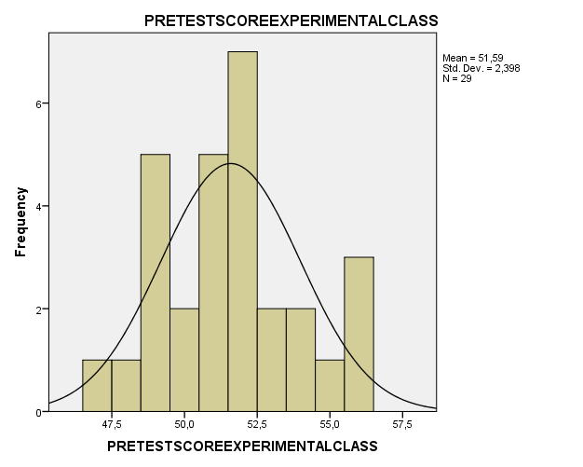

Figure 4.1

Histogram of speaking

Based on the histogram above, the the pretest of the experimental class gets mean 51,59 and the standard deviation is 2,398 to determine the catwgory of students’ speaking. The researcher divided them into three categories of pre-test score for the experimental class. The categories of the students’ speaking was good, medium and low. The researcher grouped the data as follows:

1. More than M+SD is classified as good
2. Between M-SD until M+SD is classified as medium
3. Less than M1 SD is classified as low
4. Post-test Score of Experimental Class

After getting the data of the students’ score of experimental class, the researcher formulated the frequency distribution as follows :

Table 4.7

Frequency Distribution of The Post-test in Experimental Class

|  |  |  |  |  |  |
| --- | --- | --- | --- | --- | --- |
|  | | Frequency | Percent | Valid Percent | Cumulative Percent |
| Valid | 71 | 2 | 6,9 | 6,9 | 6,9 |
| 72 | 8 | 27,6 | 27,6 | 34,5 |
| 73 | 6 | 20,7 | 20,7 | 55,2 |
| 74 | 4 | 13,8 | 13,8 | 69,0 |
| 75 | 5 | 17,2 | 17,2 | 86,2 |
| 77 | 3 | 10,3 | 10,3 | 96,6 |
| 80 | 1 | 3,4 | 3,4 | 100,0 |
| Total | 29 | 100,0 | 100,0 |  |

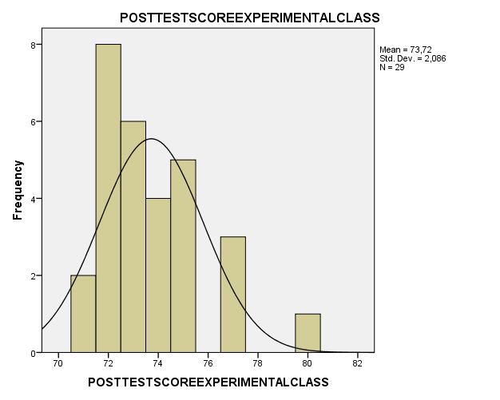

Figure 4.2

Histogram Of Post-test in Experimental Class

Based on the histogram above, the experimental class gets mean 73,72 and the standard deviastion is 2,086. The researcher divided them into three categories of post-test score for the experimental class is low, medium and good. The researcher group the data as follows:

1. More than M+SD is classified as good
2. More than M-SD until M+SD is classified as medium
3. Less than M-SD is classified as low
4. The Result of Students’ Score in Control Class

There re the result of pre-test and post-test in control class. The pre-test on April 7th 2021 until April 8th 2021, and the post-test on April 17th 2021. This table indicate the pre-test and post-test score for control class.

Table 4.8

The pre-test and post-test score in control class

|  |  |  |  |
| --- | --- | --- | --- |
| No | Name | Pre-test Score | Post-test Score |
| 1 | AZAF | 49 | 62 |
| 2 | AS | 52 | 58 |
| 3 | ADC | 49 | 62 |
| 4 | ARV | 49 | 60 |
| 5 | APD | 52 | 62 |
| 6 | AM | 52 | 65 |
| 7 | AC | 51 | 60 |
| 8 | BSN | 50 | 61 |
| 9 | DAPM | 49 | 66 |
| 10 | ENS | 48 | 64 |
| 11 | FAF | 49 | 59 |
| 12 | FWS | 49 | 61 |
| 13 | GS | 49 | 61 |
| 14 | GSBP | 55 | 65 |
| 15 | HDP | 53 | 62 |
| 16 | JYS | 52 | 61 |
| 17 | KRB | 52 | 57 |
| 18 | MNAS | 53 | 63 |
| 19 | MAH | 52 | 63 |
| 20 | NPA | 46 | 61 |
| 21 | NAB | 47 | 62 |
| 22 | RDS | 50 | 65 |
| 23 | RSAR | 50 | 59 |
| 24 | RA | 51 | 63 |
| 25 | STKJ | 51 | 64 |
| 26 | SAP | 52 | 61 |
| 27 | WDR | 51 | 62 |
| 28 | ZM | 50 | 62 |
| 29 | ZD | 52 | 63 |

Based on the table, it can be seen that the highest score in students pre-test is 53 and the lowest score is 46. Meanwhile, the result of post-test can be seen that the highest score os students speaking is 65 and the lowest score is 57. For more detail of students’ speaking score statictic description as follows:

1. Pre-Test Score of Control Class

After getting the data of pre-test score in control class, the researcher formulated the frequency distribution as follows:

Table 4.9

Frequency Distribution of Pre-test in Experimental Class

|  |  |  |  |  |  |
| --- | --- | --- | --- | --- | --- |
|  | | Frequency | Percent | Valid Percent | Cumulative Percent |
| Valid | 46 | 1 | 3,4 | 3,4 | 3,4 |
| 47 | 1 | 3,4 | 3,4 | 6,9 |
| 48 | 1 | 3,4 | 3,4 | 10,3 |
| 49 | 7 | 24,1 | 24,1 | 34,5 |
| 50 | 4 | 13,8 | 13,8 | 48,3 |
| 51 | 4 | 13,8 | 13,8 | 62,1 |
| 52 | 8 | 27,6 | 27,6 | 89,7 |
| 53 | 2 | 6,9 | 6,9 | 96,6 |
| 55 | 1 | 3,4 | 3,4 | 100,0 |
| Total | 29 | 100,0 | 100,0 |  |

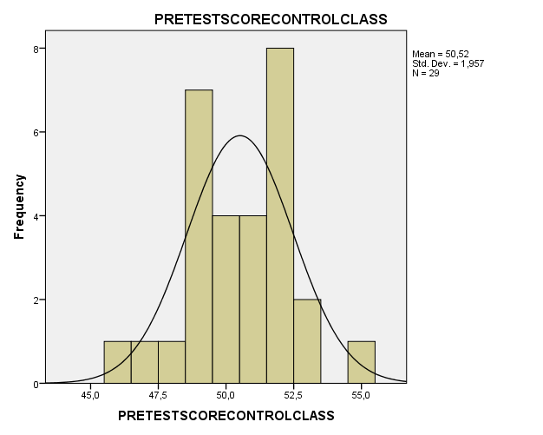

Figure 4.3

Histogram of pre-test in Control Class

Based on the histogram above, the control class gets mean 50,52 and the standard deviation is 2,086. The researcher divided them into three categories of pre-test score for the control class is low, medium and good.

The researcher group the data as follows:

1. More than M+SD is classified
2. More than M-SD until M+SD is calssified as medium
3. Less than M-SD is classified as low
4. Post-test Score of Control Class

After getting the students’ scores of control class, the reseacher formulated the frequency distribution as follows:

Table 4.10

Frequency Distribution of Post-test in Control Class

|  |  |  |  |  |  |
| --- | --- | --- | --- | --- | --- |
|  | | Frequency | Percent | Valid Percent | Cumulative Percent |
| Valid | 57 | 1 | 3,4 | 3,4 | 3,4 |
| 58 | 1 | 3,4 | 3,4 | 6,9 |
| 59 | 2 | 6,9 | 6,9 | 13,8 |
| 60 | 2 | 6,9 | 6,9 | 20,7 |
| 61 | 6 | 20,7 | 20,7 | 41,4 |
| 62 | 7 | 24,1 | 24,1 | 65,5 |
| 63 | 4 | 13,8 | 13,8 | 79,3 |
| 64 | 2 | 6,9 | 6,9 | 86,2 |
| 65 | 3 | 10,3 | 10,3 | 96,6 |
| 66 | 1 | 3,4 | 3,4 | 100,0 |
| Total | 29 | 100,0 | 100,0 |  |

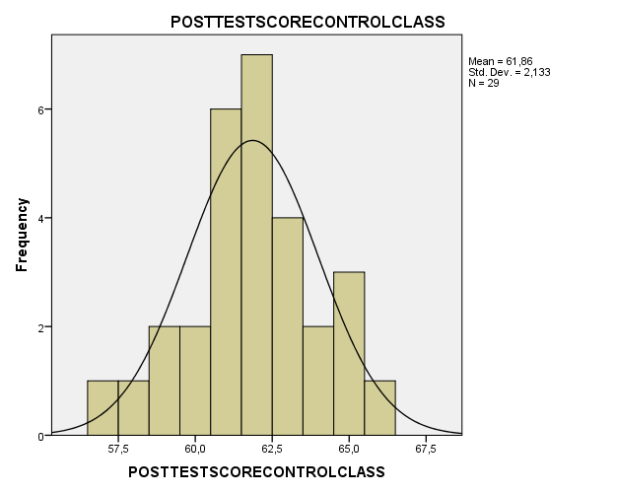

Figure 4.4

Histogram of Post-test in Control Class

Based on the histogram above, the control class gets mean 61,86 and the Standard Deviation is 2,133. Based on the histogram, several categories are divided below:

1. More than M+SD is classified
2. More than M-SD Until M+SD is classified as medium
3. Less than M-SD is classified as low
4. Data Analysis

In the data analysis, the researcher reports the analysis of students’ test of experimental class, the analysis students’ test of control class and testing hypothesis.

1. Assumption Test
2. Normality Test

Normality test is used to know the data from both group is normal or not, which examined comes from the population or distribution.[40] The researcher was used Kolomogorov –Smirnov by using SPSS 23 version program, in this research. With Kolomogorov Smirnov, it can be calculate the results to know of calculation is normal or not.

The calculation of normality test by using Kolmogorov Swirnov can be seen in the following table:

|  |  |  |  |  |  |  |
| --- | --- | --- | --- | --- | --- | --- |
| Table 4.11  Test of Normality | | | | | | |
|  | Kolmogorov-Smirnova | | | Shapiro-Wilk | | |
| Statistic | Df | Sig. | Statistic | Df | Sig. |
| Pretest Score Experimental Class | ,156 | 29 | ,070 | ,954 | 29 | ,228 |
| Posttest Score Experimental Class | ,188 | 29 | ,011 | ,887 | 29 | ,005 |
| Pretest Score Control Class | ,155 | 29 | ,073 | ,956 | 29 | ,264 |
| Posttest Score Control Class | ,136 | 29 | ,180 | ,971 | 29 | ,573 |
|  | | | | | | |

Based on the calculation above, it can be seen that the value significance of pre-test experimental class is 0,70 and the post-test of experimental class is 0,11. The value significance of pre-test control class is 0,73 and the post-test of control class is 0,180. It means that the value significance was higher than a (0,50). So, it can be conclude that the data was normal.

b. Homogenity Test

Homogenity test is used to know the quality of the populations with compare two group or more group. The calculation of homogenity test by using SPSS 23 version program can be seen in the table below:

Table 4.12

Test of Homogenity Variances

|  |  |  |  |
| --- | --- | --- | --- |
| Levene Statistic | df1 | df2 | Sig. |
| ,024 | 1 | 56 | ,877 |

Based on the table, it can be seen that the value significance was 0,877. It means that the value significance was higher than ᵅ (0,50). So, it can be seen conclude that the data was homogeneous.

1. Testing Hypothesis
2. The researcher testing the hypothesis with compare the value of test score in experimental class and control class after the researcher was testing the normality and homogenity. The researcher compared the score of students’ speaking taught by using hopscotch game and students’ speaking that were not taught. The researcher used T-test to analyze the data by using SPSS 23 program version.
3. T-Test Independent Samples

T-test is a type of statistical testing to used to test hypothese in the data. T-test used to compare the students’ speaking skill and it divided into two groups taught using different methods. The researcher compare the students’ speaking skill score taught by using the hopscotch game and not taught using hopscotch game. To answer this question, the independent sample t test was carried out on the post-test of experimental class and control class.

Table 4.13

Independent sample t test

|  |  |  |  |  |  |  |  |  |  |  |
| --- | --- | --- | --- | --- | --- | --- | --- | --- | --- | --- |
|  | | Levene's Test for Equality of Variances | | t-test for Equality of Means | | | | | | |
| F | Sig. | T | Df | Sig. (2-tailed) | Mean Difference | Std. Error Difference | 95% Confidence Interval of the Difference | |
| Lower | Upper |
| Score Speaking Test | Equal variances assumed | ,024 | ,877 | 15,641 | 56 | ,000 | 12,931 | ,827 | 11,275 | 14,587 |
| Equal variances not assumed |  |  | 15,641 | 55,747 | ,000 | 12,931 | ,827 | 11,275 | 14,587 |

Based on the table, the value significance (2 tailed) is 0,000 < 0,50 with an average difference of 12,931, this proves that there is a difference in students’ learning outcomes between those who use “hopscotch game “ than those who do not. Here are the difference in detail.

Table 4.14

Group statistic

|  |  |  |  |  |  |
| --- | --- | --- | --- | --- | --- |
| Class | | N | Mean | Std. Deviation | Std. Error Mean |
| Score Speaking Test | 1 | 29 | 125,31 | 3,253 | ,604 |
| 2 | 29 | 112,38 | 3,040 | ,565 |

From the descriptive table above, it is known that the post-test score of experimental class is higher than the control class with gain of 125,31 versus 112,38. This proves that teaching speaking by using hopscotch game is more effective than learning in conventional classrooms.

1. Paired Samples Statistics

The aim of this sample T test is to test whether or not there is a difference in the mean of the paired data. In this research, the paired sample T test was used to answer the problem formulation of Is there any different students’ speaking achievement who are taught using hopscotch game and the students who are not? So, the researcher conducted a paired sample t test experimental class data pre-test with post-test, and control class data pre-test with post-test.

|  |  |  |  |  |  |  |  |  |  |
| --- | --- | --- | --- | --- | --- | --- | --- | --- | --- |
|  | | Paired Differences | | | | | T | df | Sig. (2-tailed) |
| Mean | Std. Deviation | Std. Error Mean | 95% Confidence Interval of the Difference | |
| Lower | Upper |
| Pair 1 | Score Speaking Test – Class | 117,345 | 7,688 | 1,009 | 115,323 | 119,366 | 116,241 | 57 | ,000 |

Table 4.15

Paired sample test

Based on

Based on the table, it can be seen that the significance value (2-tailed) of this result of students pre-test and post-test was 0,000.<0,50. It is concluded that there is a difference between the pre-test and post-test in experimental class and control class.

Based on the pair, it concluded that there is a significance effect in effectiveness of students speaking skill by using hopscotch game.

1. Discussion and Interpretation

In english, there are four language skills in language teaching that are reading, listening, writing and speaking. English be a most of important language in the world, because its a international language. Therefore, in Indonesia, English is very impertant to be learned.

English is one of the required subjects that taught in junior high school. Speaking is well thought of as an important skill to be talented by the students. But in fact, students are still lacking in their speaking ability. Every students have different skill to speak english. They have their own problems for speaking.

Likewise condition at SMPN 1 Babadan, based on the obversation condition which conducted by the researcher that the seventh grade students have some problem in speaking such as the students lack in idea, the students were not enthusiast and low participate to attend the learning process. To solve the problem based on the researcher found, the reseacher attempt to use hopscotch game.

Hopscotch game have positive and negative effects on students’ learning. on the positive effects there are The students enjoy to follow english oral activity and this game can motivate students in teaching speaking[41]. Involving physical action that encourages children to be mentally active[42]. This technique help the student in possitive effect on developing young learners. The impact this technique for the student will health of body and physical activities can contribute physocomotor development, foster cooperation, and development positive attitude towards learning[43]. And the negative effects such as spending much time in learning its mean the teacher must manage time in process learning and the class is big enough, the student can’t concentrate because hopscotch dominant use in outdoor or classroom[44].

In this discussion the researcher answer the hypothesis that hopscotch game is effective in teaching speaking at seventh grade students at SMPN 1 Babadan in academic year 2020/2021. In this interpretation the researcher compared the result of t-test with t-table.

Based on the result of t-test independent samples it showed that the hopscotch game is effective method to improve students’ speaking skill. Based on the t-test result that shows the t-test value 15,641 and the t-table 2,043 with degree freedom (df)= 56. According to the formula if t-value more than t-table so the results of t-test indicated that the alternative hypothesis was accepted while the null hypothesis was rejected.

According to the paired samples test, we know that the significance value (2-tailed) of this students pre-test and post-test result was 0,000. The Ha is accepted if the results of t-test value more than t-table value and the Ho is rejected. Ho is accepted if the results of t-test value less than t-table value and Ha is rejected. From this formula, it can be seen that 0,000 less than 0,50. So, that the result of the test has significance different in speaking achievement between students who are taught by using hopscotch game and who are not.

**CHAPTER V**

**CLOSING**

1. **Conclusion**

Based on the data analysis, the researcher can conclude that mean score of experimental class get better than control class. It can be proved from the mean score of the experimental class (80) is higher than mean score of the control class (66). It is indicates that the students who are taught using hopscotch game had significant different achievement in speaking score those who are not taught. Based on t-test result the t-test value which is 2,040, it higher than t-table 1,671 at the level of significant 5% with df=56. It means that Ha is accepted while the Ho was rejected. So, teaching speaking skill using “hopscotch game” has effective achievement in improving students speaking skill at seventh grade of SMPN 1 Babadan Ponorogo in academic year 2020/2021.

1. **Recomendation**

From the conclusion above, the researcher would like to recomend:

1. For the teacher

The teacher sould be prepare and select appropriate technique and materials to produce the effective teaching ang learning process. Also the teacher should determine the target of the teaching which must be achieved and made english language interest in their learing process.

Furthermore, english teacher should be more understanding with class condition and suggested motivation to the students in order to be active in learning process. Inovation needed for the teacjer to made interest in english learning process.

So, the hopscotch game is better to use in english learning because it can improve students speaking skill.

1. For the students

The researcher hope that the students should have good motivation to learn english, especially in speaking. So, the students have consideration that they have to improve the speaking skill.

1. For the further reading

The researcher hopes for the next readers that the aim of this research can be a usefull for reference to the next research concerning english speaking.

**REFERENCES**

Arikunto, Suharsimi. *Procedur Penelitian* Suatu Pendekatan Praktik.

Ary, Donald., Lucy Cheeser Jacobs., and Chris sorensen. *Introduction to Research in Education 8th edition*. USA:wadsworth Cengage Learning, 2010.

Awaliyah, Titis. The Effectiveness of Instagram Vlog in Teaching Speaking. Ponorogo: IAIN Ponorogo, 2019.

Brown, Douglas H. *Language Assessment Principles and Classroom Practice*. California: Longman, 2003.

Brown, Douglas H. *Teaching by Principle an Interactive Approach to Language Pedagogy.* San Fransisco State University, New York: Longman,2001.

Creswell, John. *Educational Research : Planing, Conducting and Evaluating Quantitative and Qualitative Research. Fourth Edition.* Boston: Pearson Education: 2012.

Griva, Eleni. “Estimating the Effectiveness and Feasibility of a Game-basedP Project for Early Foreign Languange Learning”. Florina,Canadian Center of Science and Education, University of Wetern Macedonia. On Jurnal No 9/ July 2012 p. 34 Vol 5.

Hakim, Naufal Avansa. *Using English Mingling Games To Improve The Speaking Skill Of The Seventh Grade Students At SMP Muhammadiyah 2 Mlati In The Academic Year Of 2013/2014.* Yogyakarta State University, 2014.

Hatcher, Barbara. “*Children’s Games Resources for International Understanding.* Texas, Educational Resource Information Centre, San Marco University” on Jurnal No 6 April 1988 Vol 5.

Interviewed on Monday, 08 February 2021

Latief, Adnan Muhammad. *Research Methods on Language Learning an Introduction.* Malang: UM Press, 2013.

Newman, Barbara. *Developmment Through Life A Phsycosocial Approach*, New York:University of Rhode Island, 2010.

Nunan, David. *Designing Task for the Communicative Classroom*. Cambridge:Cambridge University Press, 1989.

O’Malley. J. M & Pierce. L. V . *Authentic Assessment for English Language Learners: Practical Approaches for Teachers*. New York: Addision-Wesley, 1996.

Pinandhita, Fitra. The Use of Hopscotch Game in Teaching Speaking to the First Grade Students of English Department of IKIP PGRI Madiun. Madiun: IKIP PGRI Madiun, 2013.

Rusiana & Nuraeningsih. *Teaching English to Young Learners through Traditional Games.* Language Circle: Journal of Language and Literature, 2016.

Sekarini,Amelia Dian. *Teaching Speaking Through Hopscotch Game ( A Game for Young Learners).* Padang : 3rd International Conference on Education 2018 Teachers in the Digital Age Batusangkar. 2018.

Spratt, Mary Et all. *The TKT Teaching Knowledge Course.* Crambidge: Cambridge University Press, 2005.

Susandi, Evinia. *The Implementation Technique to Improve the Students’ Speaking Performance Among the Eight Grades at SMP TMI Roudhotul Quran Metro.* Lampung : Institute of Islamic Studies Lampung 2019.

Thoma, Mathhia. *Hopscotch or Why Children are The Better Day Traders*. Canada:Trafford, 2010.

Widyaningrum, Retno. *Statistika*. Yogyakarta: Fecicha, 2014.

Wijaya, Toni. *Analisis Data Penelitian Menggunakan SPSS Untuk Skripsi, Tesis, dan Disertasi Disertai Contoh-Contoh Penelitian dan Interpretasi Output SPSS*. Yogyakarta:Universitas Atma Jaya, 2009.

Wulandari, Rian. *Improving Students’ Speaking Ability Through Communicative Language Games At SMPN 1 Prambanan Grade VIII A In The Academic Year Of 2013 / 2014*. Yogyakarta State University, 2014.

<https://www.konsistensi.com/2013/03/uji-validitas-data-dengan-rumus-pearson.html>

1. Dian Amelia Sekarini, *Thesis* ( Padang : 2018), 3rd *International Conference on Education 2018 Teachers in the Digital Age Batusangkar, September 12-13 2018*
2. J. M, O’Malley & L. V. Pierce, *Authentic Assessment for English Language Learners: Practical Approaches for Teachers* (New York:Addision-Wesley, 1996), 268.
3. Interviewed on Monday, 08 February 2021
4. Rusiana & Nuraeningsih. 2016. *Teaching English to Young Learners through Traditional Games.* (Language Circle: Journal of Language and Literature, X/2).
5. Rusiana & Nuraeningsih. 2016. *Teaching English to Young Learners through Traditional Games.* (Language Circle: Journal of Language and Literature, X/2)
6. Dian Amelia Sekarini, *Thesis* ( Padang : 2018), 3rd *International Conference on Education 2018 Teachers in the Digital Age Batusangkar, September 12-13 2018*
7. Rusiana & Nuraeningsih. 2016. *Teaching English to Young Learners through Traditional Games.* (Language Circle: Journal of Language and Literature, X/2)
8. Evinia Susandi, *Thesis* , ( Metro, Lampung : Institute of Islamic Studies Lampung )
9. Fitra Pinandhita, *Thesis*, (Madiun: IKIP PGRI Madiun)
10. Dian Amelia Sekarini, *Thesis* ( Padang : 2018), 3rd *International Conference on Education 2018 Teachers in the Digital Age Batusangkar, September 12-13 2018*
11. Rian Wulandari, *Improving Students’ Speaking Ability Through Communicative Language Games At SMPN 1 Prambanan Grade VIII A In The Academic Year Of 2013 / 2014*, ( Yogyakarta State University, 2014)
12. David Nunan, *Designing Task for the Communicative Classroom*, (Cambridge:Cambridge University Press, 1989).
13. Mary Spratt Et all, *The TKT Teaching Knowledge Course,* (Crambidge: Cambridge University Press, 2005)
14. Avansa Naufal Hakim, *Using English Mingling Games To Improve The Speaking Skill Of The Seventh Grade Students At SMP Muhammadiyah 2 Mlati In The Academic Year Of 2013/2014,* ( Yogyakarta State University, 2014).
15. H. Douglas Brown, *Language Assessment Principles and Classroom Practice*(Longman : California 2003) 141-142
16. H. Douglas Brown, *Teaching by Principle an Interactive Approach to Language Pedagogy ( San Fransisco State University,2001), 269* 
17. H. Douglas Brown, *Teaching by Principle and Interactive Approach to language pedagogy*, ( New York: Longman INC, 2001)P. 273-276
18. Barbara Newman, *Developmment Through Life A Phsycosocial Approach*, (New York:University of Rhode Island,2010)
19. Matthias Thoma,*Hopscotch or Why Children are The Better Day Traders*, (Canada:Trafford,2010)
20. Evinia Susandi, *Thesis* , ( Metro, Lampung : Institute of Islamic Studies Lampung )
21. Rusiana Nureaningsih, “*Teaching English Young Learners Through Traditional Games*”, (Jawa Tengah:lof Languange and Literature, School of post graduate Studies Universitas Muria Kudus, No.2/April 2016,p. 195, Vol 3.
22. Evinia Susandi, *Thesis* , ( Metro, Lampung : Institute of Islamic Studies Lampung )
23. Fitra Pinandhita, *Thesis*, (Madiun: IKIP PGRI Madiun)
24. Barbara Hatcher , “*Children’s Games Resources for International Understanding*”, (Texas,Educational Resource Information Centre, San Marco University) No 6 April 1988 p.4 Vol
25. Eleni Griva, “Estimating the Effectiveness and Feasibility of a Game-basedP Project for Early Foreign Languange Learning”, (Florina,Canadian Center of Science and Education, University of Wetern Macedonia) No 9/ July 2012 p. 34 Vol 5
26. Fitra Pinandhita, *Thesis*, (Madiun: IKIP PGRI Madiun)
27. Titis Awaliyah, Thesis (Ponorogo: IAIN Ponorogo)
28. Donald ARY, Lucy Cheeser Jacobs, and Chris sorensen, *Introduction to Research in Education 8th edition* (USA:wadsworth Cengage Learning, 2010),148.
29. John Creswell*, Educational Research : Planing, Conducting and Evaluating Quantitative and Qualitative Research. Fourth Edition* ( Boston: Pearson Education: 2012),143.
30. Muhammad Adnan Latief. *Research Methods on Language Learning an Introduction* (Malang: UM Press: 2013),181.
31. Donald ARY, Lucy Cheeser Jacobs, and Chris sorensen, *Introduction to Research in Education 8th edition* (USA:wadsworth Cengage Learning, 2010),226.
32. H. Douglas Brown, *Language Assessment Principles and Classroom Practice* (Longman : California 2003)22.
33. <https://www.konsistensi.com/2013/03/uji-validitas-data-dengan-rumus-pearson.html>
34. H. Douglas Brown, *Language Assessment Principles and Classroom Practice* (Longman : California 2003), 20.
35. Donald Ary,Et Al, *Introduction to Research in Evducation Eight Edition* (Canada: Wadsworth,2010)
36. H. Douglas Brown, *Language Assessment Principles and Classroom Practice* (Longman : California 2003).
37. H. Douglas Brown, *Teaching by Principle an Interactive Approach to Language Pedagogy ( San Fransisco State University,2001), 269* 
38. Suharsimi Arikunto, *Procedur Penelitian,* Suatu Pendekatan Praktik.
39. Retno widyaningrum,*Statistika*,(Yogyakarta: Fecicha,2014),203
40. Tony Wijaya, Analisis Data Penelitian Menggunakan SPSS Untuk Skripsi, Tesis, dan Disertasi Disertai Contoh-Contoh Penelitian dan Interpretasi Output SPSS, (Yogyakarta:Universitas Atma Jaya, 2009),126.
41. Fitra Pinandhita, *Thesis*, (Madiun: IKIP PGRI Madiun)
42. Barbara Hatcher , “*Children’s Games Resources for International Understanding*”, (Texas,Educational Resource Information Centre, San Marco University) No 6 April 1988 p.4 Vol
43. Eleni Griva, “Estimating the Effectiveness and Feasibility of a Game-basedP Project for Early Foreign Languange Learning”, (Florina,Canadian Center of Science and Education, University of Wetern Macedonia) No 9/ July 2012 p. 34 Vol 5
44. Fitra Pinandhita, *Thesis*, (Madiun: IKIP PGRI Madiun)