ENGLISH CORNER AS AN ENGLISH EXTRACURRICULAR PROGRAM FOR LEARNING ENGLISH AT SMAN 1 SAMBIT
PONOROGO

A THESIS

By:

NIKE ROHMAWATI
NIM. 210915022

ENGLISH EDUCATION DEPARTEMENT FACULTY OF
TARBIYAH AND TEACHER TRAINING STATE
INSTITUT OF ISLAMIC STUDIES PONOROGO
2021

ABSTRACT

Rohmawati, Nike. 2021. English Corner as an English Extracurricular Program for Learning English at SMAN 1 Sambit Ponorogo. Thesis, English Education Department, Tarbiyah and Tescher Training Faculty, state Institute of Islamic Studies of Ponorogo. Advisor Pryla Rochmahwati, M. Pd.

Key words: English Corner, Extracurricular Program, Learning English

English language is a compulsory subject that taught from all levels of school, especially senior high school. Being compulsory lesson, English language lesson often has less lesson hours. On the other hand learning is the main activity in all educational process at school. Its mean that success of failure of education goal attainment depend on how is students learning process. Because of that the teacher creates English corner as the solution of this problem. English corner is one of extracurricular program that characterized by ad-hoc, relatively unorganized gatherings of people who meet together on usually a weekly public in public place to practice English. Than extracurricular are those activities that fall outside the realm of the curricula or syllabi. Through the English corner students has more time to learning English. So English corner can be the guidance for students to add more knowledge in English.
This research was conducted for several purposes. They are: 1) To know the kind of activities in English Corner for learning English in SMAN 1 Sambit Ponorogo, 2) To know the factors influencing the successful of English Corner in SMAN Sambit Ponorogo, 3) To know students’ responses about English Corner in SMAN 1 Sambit Ponorogo.
This research was conducted at SMAN 1 Sambit Ponorogo. It applied case study qualitative research. The researcher used observation, documentation, and interview to collect the data. After getting the data the researcher analyzed the data through data reduction, data display, and conclusion English Corner.
The findings clarified that: 1) There are two kinds of activity in English Corner of SMAN 1 Sambit Ponorogo, namely explanation of the theory and playing game. 2) There are two factors that influencing learning, there are internal factor in terms of students’ motivation and external factor related to teachers’ support. 3) The students responded the implementation of English Corner positively.
In the end, the researcher concluded that the English Corner will give the students more knowledge. The teacher also gives a good offer to the students who follow English Corner so the students interest to follow it. The method that used by the teacher in English Corner also good, because the teacher used game to teach the students.

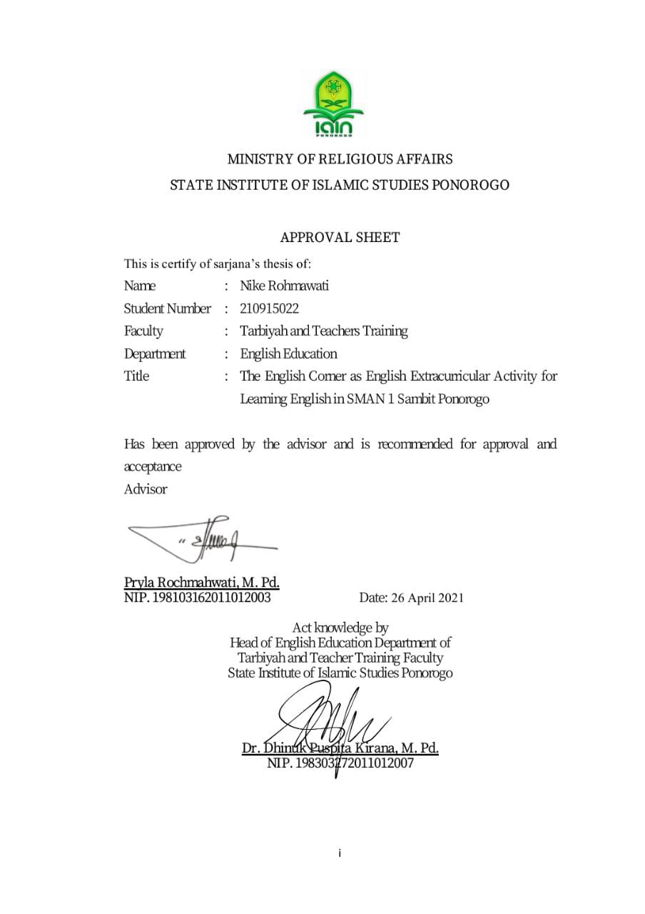

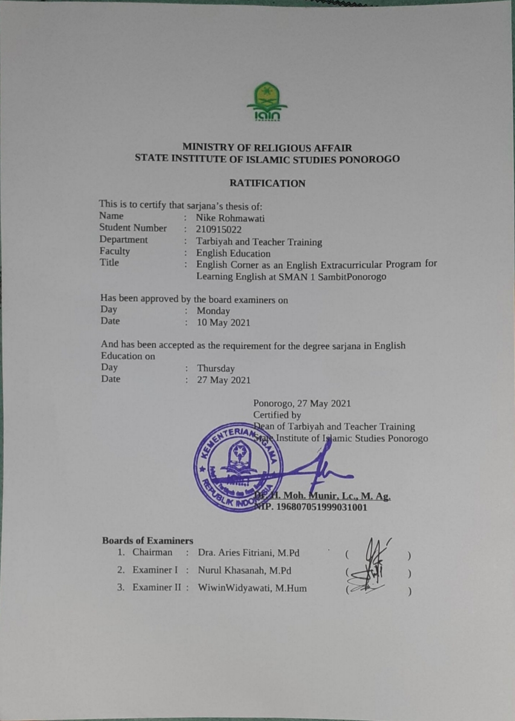
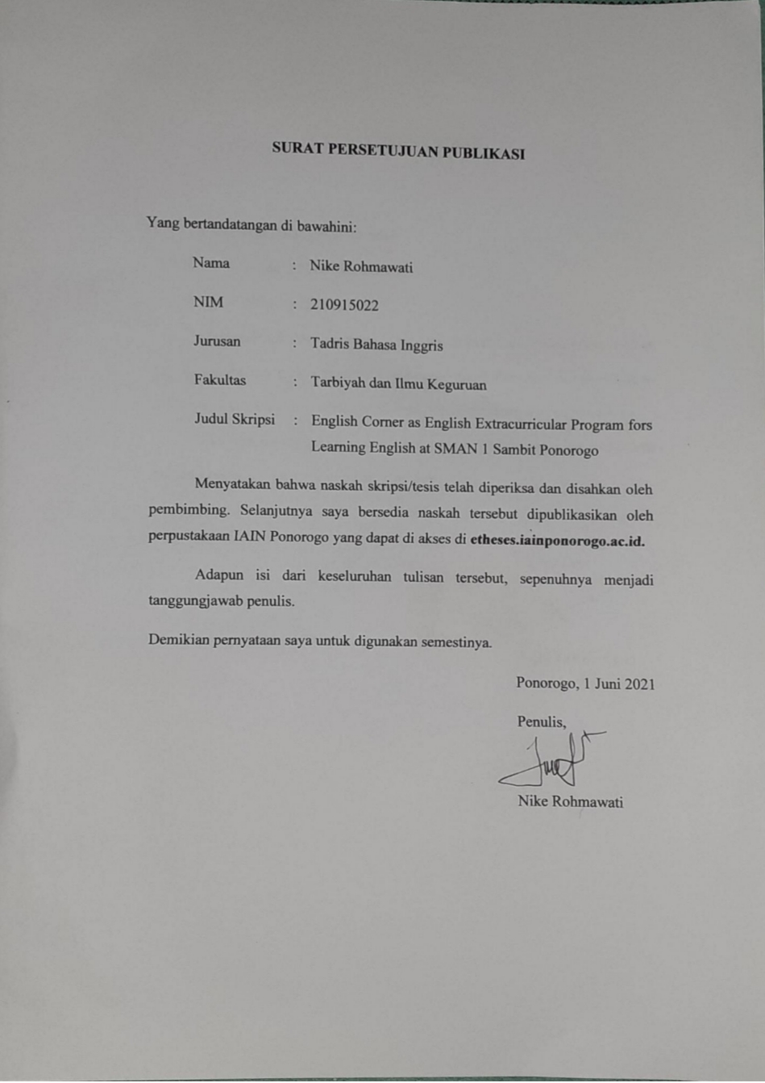
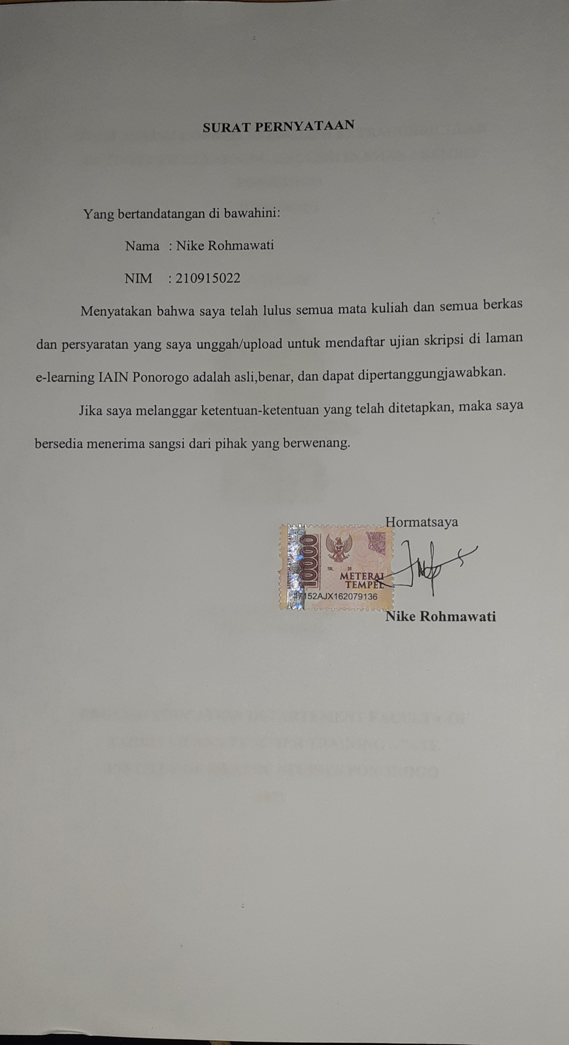
CHAPTER I
INTRODUCTION

- Background of study
English is an international language that must be studied, especially for countries that do not use English as their primary language. Indonesia is one of the countries that used English as a foreign language. In Indonesia English is a compulsory subject taught from elementary school until high school. To improve learning English as Foreign Language (EFL) in developing countries like Indonesia, one must start from an early age.Even though in Indonesia, English still play role as a foreign language, it is necessary to be mastered by Indonesian today.Students are required to master the four main skills they are reading, speaking, writing, and listening. To master the four basic skills, sometimes the lessons that has given by school are not enough. As a salutation to overcome the problem, school create self-development program which is implementations the form of extracurricular program. One of school that implements extracurricular program is SMAN 1 Sambit Ponorogo namely English Corner. Observing that the lesson in formal school are not enough because in one week just has three hours of lesson for learning English.
Based on Government Regulation 19/25 on National Education Standard stated that every school may give an opportunity to develop students’ competence by applying an extracurricular program. Extracurricular program is a program which is no part of the course that a student doing at school, the main reason of the establishment of extracurricular program to accommodate or give spaces for students in developing their talent and interest. Extracurricular program is not the basic program in the school, but this is very important to help students to increase their ability. Usually all school in Indonesia applied extracurricular program which is organized by their own school.
On the other hand, extracurricular a students’ experience and activities that are not included in education curriculum, but it is significant part of education. It has been proved that extracurricular activities are necessary as regular classes for development of skills.It means that extracurricular activities influence on students skill, so it is important to be developed and arranged well.
Extracurricular activities are very important and play a great role in education. The research result indicate that extracurricular activities areas important for building social and academic skills as the regular classes. The point of extracurricular held on school is to help students’ to chance their competence, but it is not compulsory subject so students be able to join it or not.
Extra-curricular activities are an integral part of the total education program. While the Board of Education recognizes the need for providing opportunities for students to participate extracurricular activities, it also realizes that appropriate guidelines must be established regarding this participation. The result of which will be to develop and maintain a high level of confidence by the community and student bodies in the scope and purpose of these extra-curricular activity programs.
Extracurricular program can be categorized into two, namely subject matter and subject non matter extracurricular program.Subject matter extracurricular program can be in the form of study club, for example Science Club, Math Club, and English Club. While non-subject matter extracurricular program, can be the form of Physical or Art extracurricular program.According to Brown students participants in extracurricular activities had better grades, had higher standardized test score, higher educational attainment, attended school more regularly, and had higher self-concept.Darling, Caldwell, and Smith also said that the student who participated in school based extracurricular activities had higher grades, higher academic aspirations, and more positive academic attitudes than those who were not involved in extracurricular activities at all.It is obvious that extracurricular activities bring positive effect in self-development of the students. Not only on students’ academic but also on students’ attitudes and behavior.
In conducting extracurricular program, it is important to consider students’ motivation to participate, Abraham Maslow who is humanist, believes that healthy people motivate themselves by seeking to fulfill experiences. It means that teacher who serve as facilitator need To fulfill all students’ needs at any given level to motivate them to progress to the next level. Therefore, it is essential for teachers to facilitate students in fostering their motivation to learn English. Martin support the argument by stating that teachers should help the students to succeed through positive and behaviors and reduce possibilities for failure by eliminating negative thoughts and behaviors.
Based on the researcher’s observation and interview in the process of learning English in SMAN 1 Sambit Ponorogo, English language skills of students are still lacking. When the researcher try to communicate with English the students still ask to use Indonesia.In English corner activity the teacher made it as interesting as possible with about 1 hour the teacher gave 15% theory and 75% practice using games. In teaching English corner the teacher used so many games. There are about a hundred games that have been used by teachers. Among the many games there are several games that are made by themselves.
Based on explanation above, the researcher concludes that English corner can increase students’ skill in English with the kind of activities in English corner. So the researcher interested in carries out a research by the title “ENGLISH CORNER AS AN EXTRACURRICULAR PROGRAM FOR LEARNING ENGLISH AT SMAN 1 SAMBIT PONOROGO”

- Focus of the Study
- This study will be focused on kinds of activities in English corner, factors influencing, and students’ responses on English corner.
- For the object, they will be specific to the students of the English corner of SMAN 1 Sambit Ponorogo.

- Statement of the Problem
The research concern the phenomenon of the English corner as extracurricular activity `for learning English in SMAN 1 Sambit Ponorogo, the researcher formulates the research problem as follow:
- What Kinds of Activities in English Corner for Learning English in SMAN 1 Sambit Ponorogo?
- What are factors influencing the successful of English Corner in SMAN 1 Sambit Ponorogo?
- How are students’ responses on the English Corner in SMAN 1 Sambit Ponorogo?

- Objectives of the study
Concerning with the problem statement, theobjectivesof research has described as follow:
- To know the kind of activities in English corner for learning English in SMAN 1 Sambit Ponorogo
- To know the factors influencing the successful of English Corner in SMAN 1 Sambit Ponorogo
- To know students’ responses about English corner in SMAN 1 Sambit Ponorogo

- Significance of the study
The result of study is expected beneficial for:
- Theoretical Significance
This result of the study have the potential to add to the existing literature regarding the value of extracurricular activities. This research is hoped to develop the school program in organizing teaching and learning process that relates to academic growth and achievement. Hopefully, the result of this study is useful for students, teachers, and all of the readers.

- Empirical Significance
At the end of this study, the writer hopes that this writing will give a great benefit for the following components:.
- Practically
The result of this study is expected to be benefical for:
- Teacher
The results of the study are expected to be used and useful as a consideration in teaching English for learners, practicullary English teachers in SMAN 1 Sambit Ponorogo
- Students
This study expected to motivate students especially students at SMAN 1 Sambit Ponorogo to learn English more by following English Corner activity
- Readers
This study is expected will be useful for readers knowledge about English corner activity as English extracurricular and would also give some advantages for further research and development efforts as a reference and empirical evidence
- The researcher
As additional information and knowledge of experience in education, especially about English corner as an English extracurricular program for learning English.

- Organization Of The Thesis
Organization of thesis has purpose to easily understand the thesis. This researcher report is organized in five chapters in which they interactone another. In detail, the content of each chapter is presented as follow:
CHAPTER I: First chapter is introduce the whole of the research content. The first chapter is introduction. For the first sub chapter, there is background of the study. Background of study deal with social situation which happen in the field, then seek the relevance with the theory, so that the researcher find the problems. Beside that there are some reason which underlay the researcher for conducting the research.
CHAPTER II: Second sub chapter is research focus deals with limitation of the problem that will be discussed so that it does not occur a far-ranging discussion.
CHAPTER III: Third sub chapter is statement of the problems. In this part the researcher formulates some statements of the problems grounded on background of the study and research focus.
CHAPTER IV: Fourth sub chapter is objectives of the study. This part include what the aims of the research that will be achieved are.
CHAPTER V: Fifth sub chapter is significance of the study. In this sub chapter the researcher should show benefits of the research result both of theoretically and practically.
CHAPTER VI: Sixth sub chapter is closing. After discussion in chapter V, there is the summary of the result based of the statement of the problems. It is called by conclusion. There are also some recommendation that is given to some people.

CHAPTER II
PREVIOUS RESEARCH FINDINGS AND THEORITICAL BACKGROUND

- Previous Research Findings
There are some previous researches related to the topic. They helped the researcher to finish the research. In this part the researcher discussed several previous researches as the guidance to do this thesis.
- The first research that was conducted by Asfarinah Hidayah and Murdibjono by the title The Implementation of English Extracurricular Programs in SMPN 2 Pandaan. This study This study examines the implementation of English extracurricular activities at SMPN 2 Pandaan in the aspects of (1) the purposes of conducting English extracurricular activities, (2) the facilities, media, and materials provided and/or used in English extracurricular activities, (3) the teaching techniques used in English extracurricular activities, and (4) the students’ opinions toward the English extracurricular activities.To obtain the data, this study utilizes a descriptive qualitative research design with the field notes as the main instrument.The result shows that the English extracurricular activities are divided into two activities, the English Club and ‘Pembinaan’ program, which are held in different days with different groups of students.
- The second research was conducted by Diska Fatima Virgiyanti with the title A Study on English Club as an Extracurricular Program at SMPN 1 Malang. This study used descriptive qualitative research, which state that English club give some advantages for both the student and the teacher. The subject of the research were the 7th and 8th grades who joined English Club and one instructor. The researcher used interview guide, field note, and questionnaires to collect the data. They could improve their English competence by joining the English club. Also the aims of the English Club was to support the regular class activities. However, the English club did not significantly support the regular class.
- The third research was conducted by Anna Han and Kyungbin Kwon with the title Students’ Perception of Extracurricular Activities: A Case Study. The study introduces a case study of a system managing the extracurricular activities (ECA) of students at the university level. A survey asking how students perceived the ECA system was administered and 2591 students participated. Results revealed that 1) 85% of the students were aware of the ECA system and showed moderate attitudes towards the system; 2) students perceiving the ECA system as helpful and easy to use expressed that activities discovered through the ECA system were beneficial to their curriculum learning and participation in ECA, and, in turn, to their career development and college life overall.
- The last research was conducted by Nurrahma Sutisna Putri and Fachrurrazy with the title GANESHA YESC (Youth English Study Club): An Extracurricular Program at SMAN 1 Ponorogo. This study used descriptive qualitative research design. She conclude that the English extracurricular program is very well organized and structure which involve board of directors who are expected to facilitate both grade X and XI student to improve their ability in English. Related to activity of GANESHA YESC, it can be concluded that they enable grade X and XI students to get more exposure to get both thought formal setting which is in the form weekly training conducted in the classroom and informal setting in the form of activities held outside the classroom. Based all of the studies, a topic related to the English extracurricular program to improve students’ ability has been work out. It is motivate me to conduct the study. In this research, the researcher want show about English Corner activity which mostly used games.
The similarities between the previous research and this research are discussed about extracurricular and the effect for students who follow English Extracurricular. The student who followed English Extracurricular has more experience and knowledge about English. Than the difference between the previous research and this research are the material that had been taught by the teacher covers the whole of English skills. In this research also used game to teach the students. So, the students can understand the material easily.

- Theoritical Background
- Learning English
- Definition Learning
In all educational process at school, learning is the main activity. Its mean that success of failure of education goal attainment depend on how is student learning process. People point of view about learning will influence their behaviours that related to learning and each person has different point of view. According to James O. Wittaker, learning may be defined as the process by which behavior originates or is altered through training or experience. In “Education Psychology” Cronbach said learning is shown by change in behavior as a result of experience. In learning process, someone interact with the learning object directly using all of the senses. In other definition Howard L. Kingsley state that learning is the process by which behavior (in the broader sense) is originated or changed through practice or training.Learning is the effort to get knowledge or science. The process of learning consist of three steps they are information, transformation, and evaluation.
According to Mattew H. Olson learning is the change on the behavioral potentiality as effect of reinforcement practice which relatively permanent. Learning is the process whereby knowledge is created through the transformation of experience. That definition is constructed from six definition as follows:
- Learning is best conceived as a process, not in term of outcomes. To improve learning in higher education, the primary focus should be on engaging students in a process that best enhances their learning efforts.
- All learning is relearning. Learning is the best facilitated by a process that draws out the students’ beliefs and ideas about the topic so that they can be examined, tested, and integrated with new, more refined ideas.
- Learning requires the resolution of conflict between dialectically opposed modes of adaptation to the world. Conflict, differences, disagreement are what drive the learning process. In the process of learning one is called upon to move back and forth between opposing modes of reflection and action and feeling and thinking.
- Learning is holistic process of adaptation to the world. Not just the result of cognition, learning involves the integrated functioning of the total person thinking, feeling, perceiving, and behaving.
- Learning is the process of creating knowledge.
From thosedefinition above, it can be concluded that learning is a change process of someone behavior through practice and training to get experience from the interaction with environment. The change of people behavior is occurred consciously cover all behavior aspect.
Learning English is what people do when they want to learn how to speak and understand the English language. People learning English often learn to read and write English at the same time. A lot of people learn English at school, where English is a common subject. Many people also want to spend their own personal time to learn English. Some of these people may not know any English, where others will have learned some English in school, and will want to advance their knowledge of it. There are two ways to learn English outside the school:
- Institutional learning
Many people join for spoken English institutes in Hyderabad or spoken English Class in Bhilai any other lessons like school lessons but at learning centres where any people can go, no matter their age. In such a center they will join a class fitting their existing level of learning of English, so that they will be in a group for the teacher to help them learn.

- Individual learning
Other people try to learn English on their own, or in a less formal setting than in a group of people with a teacher. People might meet with others who are trying to learn English, in order to practice their standard of English when speaking. People can also listen to radio broadcasts in English, or watch television programmes in English to help them improve their listening ability. A popular channel to listen to the radio on is broadcast by the BBC, called the BBC World Service.
- Factor Influence Learning
Learning is a process of acquiring new understanding, knowledge, behaviors, skills, values, attitudes, and preferences. The learning process defided into two there are external factor and internal factor.
- External factors
- Heredity
A classroom instructor can neither change or increase heredity, but the students can use or develop it. Some learners are rich in heredity endowment while others are poor. Each student is unique and different abilities. The native intelligence is different in individuals. Heredity governs or condition our ability to learn and the rate of learning. The intelligence learners can establish and see relationship very easily and learn quickly.
- Status of students
Physical and home conditions also matter: certain problems like malnutrition i.e.: inadequate supply of nutrients to the body, fatigue i.e.: tiredness, bodily weakness, and bad health are great obstructers in learning. These are some of physical conditions by which a student can get affected. Home is a place where a family lives. If the home conditions are not proper, the student is affected seriously. Some of the home conditions are bad ventilation, unhygienic living, bad light, etc. these affect the students and his or her rate of learning.
- Physical environment
The design, quality, and setting of a learning space, such as a school or classroom, can each be critical to the success of a learning environment. Size, configuration, comfort, fresh air, temperature, light, acoustic, furniture can all affect the student’s learning. The tools used by both instructors and students directly affect how information is conveyed, from the display and writing surfaces (blackboards, markerboards, tack surfaces) to digital technologies.
- Internal factors
- Goals of purposes
Each and everyone has a goal. A goal should be set to each pupil. According to the standard expected to him. A goal is an aim or desired result. There are two types of goals called immediate and distant goals. A goal that occurs or is done at once is called an immediate goal, and distant goals are those that take time to achieve. Immediate goal should be set before the young learner and distant goals for older learners. Goals should be specific and clear, so that learners understand.
- Motivational behavior
Motivational means to provide with a motive. Motivation learners should be motivated so that they stimulate themselves with interest. This behavior arouses and regulates the student’s internal energies.
- Interest
This is a quality that arouses a feeling. It encourages a student to move over tasks further. During teaching, the instructor must raise interest among students for the best learning. Interest is apparent (clearly seen or understood) behavior.
- Attention
Attention mean consideration. It is concentration or focusing of consciousness upon one object or an idea. If affective learning should take place attention is essential. Instructors must secure the attention of the student.
- Drill or practice
This method includes repeating the tasks “n” number of times like needs, phrases, principal, etc. this makes learning more effective.
- Fatigue
Generally there are three types of fatigue, i.e., muscular, sensory,and mental. Muscular and sensory fatigues are bodily fatigue. Mental fatigue is in the central nervous system. The remedy is to change teaching methods, e.g., use audio visual aids, etc.
- Aptitude
Aptitude is natural ability. It is a condition which an individual’s ability to acquire certain skills, knowledge through training.

- Attitude
It is a way of thinking. The attitude of the student must be tested to find out how much inclination he or she for learning a subject or topic.
- Emotional condition
Emotions are physiological state of being. Students who answer a question properly or give good result should be praised. This encouragement increases their ability and helps them produce better results. Certain attitudes, such as always finding fault in student’s answer or provoking or embarrassing the student in front of a class are counterproductive.
- Speed, accuracy, and retention
Speed is the rapidity of movement. Retention is the act of retaining. These three elements depend upon aptitude, attitude, interest, attention, and motivation of the students.
- Learning activities
Learning depends upon the activities and experiences provided by the teacher, his concept of discipline, method of teaching, and above all his overall personality.
- Testing
Various tests measure individual learner differences at the heart of effective learning. Testing helps eliminate subjective elements of measuring pupil differences and performances.
- Guidance
Everyone needs guidance in some part or some time in life. Some need it constantly and some very rarely depending on the students’ conditions. Small learners need more guidance. Guidance is a piece of advice to solve a problem. Guidance involves the art of helping boys and girls in various aspects of academics, improving vocational aspect like choosing careers and recreational aspects like choosing hobbies. Guidance cover the whole gamut of learners problems learning as well as non-learning.
As a process, learning successful is determined by any factors. Generally, Suryabarata also point out that factor influencing learning can be categorized as:
- Internal factors, includes family (physic condition and physiologies function) and phychologies factors (interest, and motivation).
- External factors, includes family (house situation, parents educational treatment, economic condition of the family, etc.), school (teaching method, curriculum, teacher-student relationship, student-student relationship, and society (mass media, society life, and friends.

- Extracurricular
- Definition of Extracurricular
Extracurricular activities are those activities that fall outside the realm of the curricula or syllabi. As stated by Hornby, extracurricular activities are: "outside the regular course of work or studies at a school or college. Extracurricular activities are activities performance by student that fall outside the realm of the normal curriculum of the school or university education. Extracurricular activities are opportunities to engage the extension of academic activities and/or non-academic activities under school auspices. In special circumstances, for example when they are budget or scheduling constraints, extracurricular activities may provide experiences that would otherwise be offered within the school day.
R. Emmer states that the terms extracurricular activities, co-curricular activities, and non-classroom activities have all been used interchangeably to mean experiences and activities such as debate or speech, athletics, music, drama, school publications, student council, school clubs, contest, and various social events. Extracurricular activities are not belong to academic curriculum, but are offered by an academic institution. The history of extracurricular activities stating that their development was slow in the beginning, however Eventually people, including educators, began to see the benefits of extracurricular activities, but it took a while to inure themselves to them. In fact, before 1900, educators were skeptical of participation in extracurricular activities, believing that “school should focus solely on narrowly defined academic outcomes. Afterwards, much more care was paid to them. According to Yildiz Y extracurricular activities are to be done in class or out of college based on the demands and convenience of extracurricular activities. Yildiz Y states that to be more precise to learn English language, student need to join extracurricular activities in language learning, such as English language debate or speech, journalism club or drama club activities to be more fluent in English.
According to Klesse the activity of extracurricular are also as a way for student to experience what they are learning in class in real world context. Extracurricular activity is a side education activity for student outside of .subject or regular classes in a education institution to support the educational process, that sometimes improve the role of the teachers or instructor.Generally, this outside activity is conducted to have development of students based on their potential, talent, and interest needs.
Therefore, extracurricular activity emphasizes the students needs of knowledge enrichment, potential development and skill excercising outside of classroom. Based on main target of extracurricular activity is the maximum development of potential, talent and interests, along with that, it envisions the growth of students’ independence and happiness that benefit themselves, family and society.
Therefore, extracurricular activities are defined as academic or non-academic activities that are conducted under the auspices of the school but occur outside of normal classroom time and are not part of curriculum. Additionally, extracurricular activities do not involve a grade or academic credit and participation is optional on the part of the student.

- Function of Extracurricular
Extracurricular activities save the same goals and functions and elective courses in the curriculum. However, they provide experiences that are not included in the formal courses of study. They permit the student to apply knowledge acquired in formal courses and to acquired concepts of democratic life. When managed properly, the extracurricular activities program allows for a well-rounded, balanced program by:
- Reinforcing Learning
One function of extracurricular activities is to reinforce the required course of studies. The activity is used to enrich and extend the work in the classroom. Clubs associated with a subject-matter discipline have considerable reinforcement value. The Spanish Club may be used as an example of reinforcing learning. The Spanish Club extends the time students spend working on the Spanish language. During the course of club activities, specific linguistic learnings are reviewed or extended. The names of articles of clothing, of food, and of eating utensils are used in a natural setting. Thus, the mastery of the Spanish language is enriched, which is precisely the objective of the Spanish course.
- Supplementing Courswork
Another function of extracurricular activities is to supplement the required and elective courses of study. This function supplements the curriculum with experiences which are not possible in regular classroom settings. Thus, such activities as schooldances, student council, chess, publications, and sports add opportunities to the total learning experience as well as worthwhile leisure-time activities to the total learning process. These nonsubject-related activities add to and enrich even the most innovative programs of required and elective courses.
- Integrating Knowledge
An important objective of the total learning process is the integration of knowledge. Extracurricular activities are said to be integrative in nature because they tie together many areas of knowledge and experience. They don't provide abstract and isolated pieces of learning, but rather synthesize many aspects of real-life situations. For example, the school committee commissioned to select a site for the prom must consider such factors as size of the establishment, distance from the school, reputation of the facility, language in the contract, decor, and cost to the student. In the same way, the purchase of a home involves many of the same human, artistic, legal, and economic factors. Through the student activities program, the student learns to deal with many important aspects of a problem.
- Democratization
The extracurricular activities program is effective because it carries out in a specially vital way the objectives of present-day democratic life. Generally, American schools devote a part of the required curriculum to the study of the development, structure, and problems of American democracy. The actual living of a democratic life is seriously restricted within the confines of the formal classroom setting. A rich program of student activities can remove such barriers and provide for individual and group interaction in a natural environment.
The extracurricular activities program offers students an opportunity to participate in administration through the student council, teacher-advisory groups, and organized activities. The student council provides opportunities for administrative experience through planning, organizing, initiating, and controlling many aspects of school life. Through teacher-advisory groups an advisory unit is created—the source from which activities flow, and where, through guidance, proper relationships are established between and among the teacher and the students somewhat analogous to a family, team, or department in an organization. Through the clubs, athletics, and intramural sports that emanate from subject-matter disciplines, students develop teamwork and cooperation— ideals of competitiveness in a democratic society.

- English Corner as Extracurricular
- English Corner
English Corner seems a curiously Chinese thing, rarely observed in its public format outside of the People’s Republic of China. It is characterized by ad-hoc, relatively unorganized gatherings of people, who meet together on usually a weekly basis in a public place or inside the confines of a university, to practice speaking English. Attendance is voluntary and in its public format, free of charge. But in as much as it brings together groups of ESL (English as a Second Language) learners whose prima facie intention is to practice their oral English, English Corner can be seen as an informal learning strategy.
The researcher’s approach to understanding English Corner is ethnographic and observational, attending and observing meetings as they take place, interviewing randomly selected participants. The researcher is also interested in the future of English Corner as a public forum in the face of social media and online-moderated communication. Preliminary research outcomes suggest that people attend English Corner for a variety of reasons; certainly to practice oral English but also to expand social contacts, deal with work-related and personal problems, and not least to search for potential partners! While there appears to be no moderation of the group, research also suggests that there are some subjects which are typically avoided in English Corners.
According to Feuer “informal places of learning are settings outside the formal classroom where learning takes place experientially and often through social interaction … a fun atmosphere, group activities, an absence of formal teachers, curriculum or grading scale.” English Corner is an informal learning situation; one of many instances where Chinese people join together for shared learning purposes, or for public exercise/performance. Other examples include daily morning communal tai-chi, usually held in plazas adjacent to residential buildings, evening communal ballroom dancing, usually held in plazas near shopping centres, art galleries and museums, as well as the celebrations that surround yearly festivals such as the Spring Festival and the Mid-autumn Festival.
There are 10compulsory subjects that should be taught in Senior high school and one ofthe subjects is English subject. While thestudents‟.learning time in English classfor senior high school is only twomeetings in a week which 80 minutes foreach meeting. It means that English is animportant subject to be taught in seniorhigh school, but the learning time given for the students is limit.

- English Corner in SMAN 1 Sambit
In this research, the English Corner program is defined as students extracurricular learning program besides regular English class, which more focuses on mastering skills of English through game. English Corner was established in 2000 by Mr. Dion. Not only focused on one English’s skill but also all of English’s skills, such as reading, listening, writing, and speaking.
The teacher used different game for different skills. Before the game the teacher explained the theory first. The book for theory was created by the teacher. After that the teacher invited the students to play the game. There are so many game that used by teacher to teach English Corner. Some of games created by the teacher. English Corner program in SMAN 1 Sambit Ponorogo followed by students from SMAN 1 Sambit.
The students who followed English Corner are from grade X and XI. So, students who come from class XII not allowed to followed the extracurricular. English Corner in SMAN 1 Sambit Ponorogoheld every Tuesday at 15.00 PM. English Corner has an hour, with a half of hour for theory and half of hour to practice game.
For the English Corner annual agenda usually hold prince and princess contests. Prince and princess contest is annual agenda of English Corner, there are so many contests like MC, speech, and story telling for students who follow English Corner. In addition, the English Corner of SMAN 1 Sambit Ponorogo also has been visited Jogjakarta and Bali. After visited Jogjakarta and Bali the students and the teacher made the book about the documentations. The journey was done around 2001.

CHAPTER III
RESEARCH METHOD

- Research design
The researcher employed Qualitative Research. Qualitative research focus on the study of social phenomena and on giving voice to the feelings and perceptions of the participants under study. This is based on the belief that knowledge is derived from the social setting and that understanding social knowledge is a legitimate scientific process.Qualitative research is any kinds of research that produces findings that are not arrived at by means of statistical procedures or other means of quantifications. By employing this design, the researcher will know the depth of understanding phenomenon description.
The researcher is intended to scrutinize the implementation of English corner as English extracurricular for teaching English in SMAN 1 Sambit Ponorogo. It describes how English Corner can become the extracurricular for learning English for students.
The design is Case Study is the type of ethnographic study that focuses on a single unit, such as one individual, one group, one organization, or one program. The goal is to arrive at a detailed description and understanding of the entity. Case study method involves systematically gathering enough information about a particular person, social setting, event, or group to permit the researcher to effectively understand how it operates or function. It means case study investigated in depth phenomenon within its real-context. Thus nature of case study is attempts the shed light of phenomena by studying in depth a single case example of the phenomena. So the researcher must study in depth before concluding the case.
32
In qualitative research, most of technique of data collection that used is observation, interview, and documentation. As a result, for this research, the data is collected naturally by interviewing students and English teacher and finding the document review from this school. Then the data is analyzed and presented in the form of description.

- Researcher Role
A qualitative research promote a human (researcher) as an observer, a participant observer, or some combination of two.In this research the role of the researcher is an observer. Therefore, the researcher must go directly to the field to observe the object of the research directly.

- Research Location
The researcher takes SMAN 1 Sambit Ponorogo as a place to do experiment. It is located at Jln. Ponorogo-Trenggalek RT/RW 1/2 Kelurahan Besuki Kecamatan Sambit Kota/Kabupaten Ponorogo Jawa Timur. The researcher takes this place because the location is strategies. Beside that the researcher consider that this activity is unique because there are only one school in Kecamatan Sambit that applied English extracurricular namely English Corner, which mostly activities use games for teaching the students.

- Data and Data Sources
Data sources is the subject where the data will be found. The prominent data sources on the research is a group of work and an action and the others, like document is an additional. From this statement, data sources in this research which belong to word is the information about English corner as extracurricular activity `for learning English in SMAN 1 Sambit Ponorogo and action is an interview that discussed about the English corner as extracurricular activity `for learning English as primary data. The source of data in this research will be taken from the teacher and student’s interview, documentations, and observation of SMAN 1 Sambit Ponorogo.

- Technique of Data Collection
Qualitative research also have a number of data-gathering tools available for their investigations. The most widely used tools in qualitative research are interviews, document analysis, and observations. Document analysis may include audio and video recordings, photographs, games, artwork, or other items that provide insight related to the context or participants. The researcher may use one more of these methods in a study.

- Observation
Observation is a basic data collecting activity for many branches of research, particularly the natural and technical sciences, for example, observing the results of experiments, the behaviour of models, the appearance of materials. Observation can be used for recording data about events and activities, and the nature or conditions of objects. Observation can record how people react to questions, and whether they act differently to what they say or intend.
The qualitative researcher’s goal is a complete description of behavior in a specific setting rather that a numeric summary of occurrence or duration of observed behaviors. Qualitative observation often rely on narrative or words to describe the setting, the behaviors, and the interactions. The goal is to understand complex interactions in natural setting.
In case of observation is characterized by a careful definition of the units to be observed, the style of recording the observed information, standardized conditions of observation and the selection of pertinent data of observations, than the observation is called as structure observation. Structure observation is considered appropriate in descriptive studies.
In this research observation is applied to figure out the activities of English Corner as Extracurricular Activity for Learning English in SMAN 1 Sambit Ponorogo.
- Interview
The interview is one of the most widely used and basic method or obtaining qualitative data. Interview are used to gather data from people about opinions, beliefs, and feeling about situations in their own word. They are used to help understand the experiences people have and the meaning they make of them rather than to test hypotheses. Interview may provide information that cannot be obtained through observations, or they can be used to verify observations.
Interviewing is commonly used method of collecting information from people. An interview involves an interviewer reading questions to respondent and recording their answer.
Interview is fundamentally a process of social interaction. The interview constitutes a social situation between two persons, the psychological process involved requiring both individuals mutually respond though the social research purpose of the interview call for a varied response from two parties concerned.
The interview method of collecting data involves presentations of oral verbal stimuli and replay in terms of oral verbal responses. This research uses in depth interview to interview the teacher and the students who are participate in English Corner. The aim of that is to get data clearly about the English corner as extracurricular activity for learning English in SMAN 1 Sambit Ponorogo.
- Documentation
A valuable source of information in qualitative research can be documents. Documents consist of public and private records that qualitative researcher obtain about a site or participants in a study, and they can include newspapers, minute of meeting, personal journal, and letters. These course provide valuable information for helping researcher understand central phenomena in qualitative study. Document represent a good source for text (word) data for qualitative study.
Documentation are prepared for personal rather than official reason and include diaries, memos, letters, and field notes, and so on. Documents closer to speech, require more contextualize interpretation.
In this study, the documentary technique is use to get data about kind of activities that used by teacher in English corner, teachers’ role in English corner and students’ responses to English corner. The documentary data needed in the study are presented in the coming chapter.

- Technique of Data Analysis
Data analysis is a systematic search for meaning. It is a way to process qualitative data so that what has been learned can be communicated to others. Analysis mean organizing an interrogating data in ways to allow researchers to see patterns, identify theme, discover relationship, develop explanations, make interpretations, mount critics and generate theories. Based on the statement above, in data analysis the researcher processes the data to be understood by others. The process including identifying patterns, finding relationship among data, making deep explanation among data, making deep explanation, making interpretations, or generating theories of data. Data analysis begins when the researcher conduct the interview with respondents and also complete the process of collecting data. The analysis step in this research is shown in the picture as follows:
Each of the stage is presented in this following:
- Reduction Data
Reduction is stage of summarizing, classifying and focussing on essential things. In this stage the researcher summarize, classifies and focus on essential things that are what Kinds of Activities in English Corner for Learning English, what are factors influencing the successful of English Corner, and how are students’ responses on the English Corner. The researcher also the research needs to separate the accurate data from the accurate ones. Through the reduction data, researcher may focus on the data that will be analysed.
- Display Data
Display data is the stage of organization, compressing and assembling of information that permits conclusion drawing and actions. It means that the researcher will arrange the data systematically to make the simple data. The data display can make the collected easier to be understood. In this stage, the researcher makes assessment of information based on the problem. The data will be displayed in narrative form. Data display will help the researchers to understand what is happening and to do something for further analysis or caution on that understanding.
- Conclusion
In this stage, the researcher make conclusion about the answer of the problem that have been formulated. The conclusion in qualitative research can answer the statement of the problem that have been formulated.

- Checking of Validity
Validity of the data is an important concept of validity and reliability new concept. In qualitative research, some of techniques used to check the credibility of data are observation and triangulation. The level of data validity can be done by using technique:
- Observations
It means that the researcher find the characteristic and elements in the situation that relevant with the chosen issue. Observe the situation in the classroom during the English corner activity going on thoroughly. The researcher can organize it by observing activities of English Corner as English Extracurricular Activity for Learning English in SMAN 1 Sambit Ponorogo exactly and continuously and studying it simultaneously to get the accurate data.
- Triangulation
The researcher used Triangulation is to get the valid and credible data. The use of multiple sight is frequently called triangulation. Triangulation may be defined as the use two or more methods of data collections in the study of some aspect of human behavior.According to Campbel and Fiske, triangulation is a powerful way of demonstrating concurrent validity, particularly in qualitative research.In other word triangulation is the technique used in checking the validity of the data through different tool and time in qualitative method.
Triangulation means using more than one method to collect data on the same topic. This is a way of assuring the validity of research through the use of a variety of methods to collect data on the same topic, which involve different types of samples as well as methods of data collection.
In this research, the researcher used triangulation to investigate data of the activities of English Corner through the way bellow:
- The corporation between result of observation and result of interview,
- The corporation between teacher and students opinion,
- The corporation between result of interview and related of document.
CHAPTER IV
RESEARCH FINDINGS

- General Data
- The History of SMAN 1 Sambit Ponorogo
SMAN 1 Sambit was established on June 1, 1985. In the first year, that school was under the part of SMAN 1 Ponorogo. A year letter, it was moved to Ponorogo-Trenggalek street at Besuki Sambit Ponorogo. In the beginning of this establishment, the school only had three classroom, a headmaster office, a teacher room, an administration room, an extracurricular room, a counseling room, a warehouse, a teacher’s toilet, and a student’s toilet. There were no electricity, telephone, and fence. The soil condition was dry. The weather was hot. Mr. Poedjono as the first headmaster of SMAN 1 Sambit Ponorogo planted a pine tree as a sign of the existence of Senior High School.

- Geographical Location
- School Name : SMAN 1 Sambit
- Address : Ponorogo – Trenggalek Street, Besuki Village
- District : Sambit
- Regency : Ponorogo
- Province : East Java
41
- Vision, Mission and Purpose of SMAN 1 Sambit Ponorogo
- Vision
Building the school which creates graduates that have good abilities in religion, science, and technology, independent, and love the nature.
- Mission
- Developing religious attitudes and behaviors in the school and outside one
- Developing the culture of curiosity, fond of reading, tolerant in cooperation, discipline, respect each other, honesty, hard working,creativeness and independence
- Carrying out the effective, creative, fun, communicative, and democratic learning that can actualize superior student identity
- Utilizing study time, physical, and human resources for the best result from the development of the independent student
- Creating a school environment that is comfortable, safe, neat, clean, and healthy and encourages student independence
- Instilling social and environment care, love for peace, love for the motherland, national spirit and democratic life
- Implementing environmental protection and preservation programs that integrate with curriculum development of the school
- Implementing participative, transparent, and accountable management that will make the as the choice of community.

- School Organization
School organization at SMAN 1 Sambit Ponorogo contains:
- School Committee
- Headmaster
- Unit of library
- Administration staff
- Vice of Curriculum
- Vice of Students
- Vice of infrastructure
- Vice of Public Relation
- Guardianship of Class
- Teachers
- Students
Organization Structure of SMAN 1 Sambit Ponorogo, as follow:
- Headmaster : Agus Prasmono, M. Pd.
- Administration Staff : Parkusnan, SE.
- The data of the teachers and staff
NO | NAME | LESSON | ADRESS
1 | AGUS PRASMONO, M. Pd. | Headmaster (Geography) | Kertosari Indah J 4 Ponorogo 63491
2 | Dra. Hj. ENDANG WIDNARSIH | Biology | Ds. Sambit, Sambit
3 | Drs. AGUS HERU DWI WIYANTO | History | Ds. Sukosari, Babadan
 | Drs. H. SURYONO | Religious Education | Ds. Karanggebang, Jetis
5 | Drs. H. PURNOMO SIDIK KUSTIYONO, M. Hum. | English | Jl. Halim Perdana Kusuma
6 | TRI AGUNG SUSETYONO, S. Pd. | Biology | Ds. Gandu, Mlarak
7 | SUGENG SUBAGYO, S. Pd. | Geography | Ds. Campurejo, Sambit
8 | SRI PURWATI, S. Pd. | Indonesian Language | Dolopo, Madiun
9 | SENTOT DWI BASUKI, S. Pd. | Economy | Jl. Pramuka 30 C Ponorogo
10 | SRI WASIATI, S. Pd. | Chemical | Kerosari Indah M 7 Ponorogo
11 | PARMUJI, S. Pd. | Sport | Ds. Sawuh, Siman
12 | JUNUS, S. Pd. | Counseling | Ds. Sambit, Sambit
13 | Hj. ISRA' INDAR HANDAYANI, S. Pd. | Biology | Ds. Kutukulon, Jetis
14 | MARINI, S. Pd. | Chemical | Kertosari Indah C1 Ponorogo
15 | Dra. Hj. SITI ARNA FARIDA | Mathematic | Ds. Siwalan, Mlarak
16 | ISMU SURURIYATI, S. Pd. | Mathematic | Jl. Ra Kartini 35, Trenggalek
17 | MOH AGUS YUNUS, S. Pd. | Mathematic | Jl. Barong Ponorogo
18 | SUKARNIWATI, S. Pd. | Economy | Ds. Karanggebang, Jetis
19 | NURUL NURWANTI, S. Pd. | Chemical | Jl. Argopuro, Ponorogo
20 | MURJANTI, S. Pd. | Counseling | Ds. Sawoo, Sawoo
21 | Drs. ANANG SULASNO | Civic Education | KPR BTN C 14 Keniten Po.
22 | H. NUR IMAM BADRI, S. Pd. | English | Ds. Ngabar, Siman
23 | Dra. SRI WIDAYATI | Indonesian language | Ds. Jintap, Jetis
24 | SUMIANA, S. Pd. | Civic Education | Ds. Campurejo, Sambit
25 | EDY PURNOMO, S. Pd. | Sport | Ds. Wonoketro, Jetis
26 | KUSUMA KHOIRONI, S. Pd. | Computer | Ds. Sambit, Sambit
27 | MARSUDIONO, S. Pd. | English | Ds. Ronowijayan, Siman
28 | SUGIMAN RUSTAN, M. Pd. | Indonesian language | Jl. Pengkeran Persikan Demangan Siman Kode Pos 63471
29 | USWATUN BAROROH, S. Ag. | Religious education | Ds. Simo, Slahung
30 | RINI NURYANTI, S. Pd. | Geography | Ds. Sawoo, Sawoo
31 | HERNI WAHYUNINGRUM, S. Pd. | Civic Education | Ds. Siwalan, Mlarak
32 | PRIYONO, S. Pd. | Sosiology | Ds. Ngasinan, Jetis
33 | WAHYU INA FITRIA, S. Pd. | Chemical/ Prakarya | Ds. Bangsalan, Sambit
34 | TOTOK WAHYUDIANTO, S. Pd. | Art | Jl. Imam Bonjol, Po.
35 | PRIHATIN, S. Pd. | Java language | Ds. Tempel, Jetis
36 | ANIK MEILINA, S. Pd. | History | Ds. Sraten, Jenangan
40 | CHRISNA DWI ANGGAWATI, S. Pd. | Java language | Jl. Muria Ponorogo
41 | Drs. SUPANDI | Head of the Committee | Ds. Kemuning, Sambit
42 | PARKUSNAN, SE. | Administration | Ds. Ketro, Sawoo
43 | SUWASI | Administration | Ds. Kutukulon, Jetis
44 | ANNY ISTIANA | Administration | Ds. Kutuwetan, Jetis
45 | PARTIYAH | Administration | Ds. Besuki, Sambit
46 | SUPARNU | Staff | Ds. Besuki, Sambit
47 | MIFTAH EFFENDI | Laboraty staff | Ds. Grogol, Sawoo
48 | ANJAR RUDIANA | Staff | Ds. Brajan, sawoo
49 | IMAM AL-GOZALI | Staff | Ds. Besuki, Sambit
50 | NYOTO | Staff | Ds. Besuki, Sambit

- SPECIFIC DATA
For collecting the specific data, the researcher conducted the observation three times on January 16, February 18, and interview on June 30. The specific data that had been collected are analyzed through data reduction, data display, and conclusion English Corner. Then, the results are explained as follows:
- The kinds of activity in English Corner for learning English in SMAN 1 Sambit Ponorogo
On January the researcher was observed in the English Corner class. Then the researcher come into the English Corner class, in the class was playing jeopardy game. Jeopardy game is game when the player should make the questions according to the answer that has been mentions. The original of Jeopardy game is an American television game show created by Merv Griffin. The show features a quiz competition in which contestants are presented with general knowledge clues in the form of answers, and must phrase their responses in the form of questions. Joepardy game in English Corner in SMAN 1 Sambit Ponorogo has different way to play it. When the the generally Jeopardy game used power point to play it in English Corner in SMAN 1 Sambit Ponorogo just used whiteboard and marker to played Jeopardy game. When the researcher doing observation, the student that attend the English Corner is fiveteen students.The teacher come into the classroom and then greeting to the students first. After that the teacher explain about the activity will do today, Mr. Dion explained about Jeopardy game first and then define the student into three groups. Mr. Dion also asked the researcher to join in the game. So, the researcher joined the first group. Then Mr. Dion wrote the questions category on the whiteboard and the score they will get. The students choose the questions category first and choose the score they will get. After that the teacher read the question and students should answer that question.
For the second observation on February the researcher found that sometimes the native speaker come to English Corner to teach the students. When the researcher come to the class the native speaker was teaching vocabulary skill to the students. The native speaker teach the vocabulary using game. The first steps the native explained how to played the game and Mr. Dion help to explained the vocabulary that students can’t understand with Indonesian to the students. After that the native define the students into four groups with five members in every group. Then the native distributethe card to the students. The steps to played the game is the native ask some questions to the students. Then the students answer with give the card to the native. One of the questionis,what thing that you not like? So the students give the answer with show the card to the teacher, to express the thing that students didn’t like.
And the last observation the researcher doing interview with the teacher.The researcher doing interview in the teacher’s room at 09.30 am.
Extracurricular activities are usually described as activities that are not belong to academic curriculum, but are offered by an academic institution. The activities of extracurricular are also as a way for students to experience what they are learning in a class. The extracurricular intends to facilitate the students for improving their ability in English. It is the reason to found Extracurricular in SMAN 1 Sambit Ponorogo, especially namely English Corner (EC). As stated by of the founder English Corner (EC) in SMAN 1 Sambit Ponorogo is Mr. Marsudiono who also called Mr. Dion. Mr. Dion explains that:
“The establishment of English Corner is been a long time since June 2000. At the beginning of the establishment the name is not English Corner but English Speak Up, because we are not only learning speaking so we change into English Corner.”
English Corner in SMAN 1 Sambit Ponorogo have a goal to improve students’ skills of English. Not only just speaking skill but also in another skill, that is reading, speaking, writing, and listening. This samiliar to what Mr. Dion said as the founder of English Corner in SMAN 1 Sambit Ponorogo. Mr. Dion says:
“At the beginning of the establishment the name is not English Corner but English Speak Up, because we not only learning speaking so we change into English Corner.”

English Corner in SMAN 1 Sambit Ponorogo devided into two activities, those are theories and practices with games:
- Theories
English Corner has an hour after school which take place on Tuesday at 03.00 PM. In an hour usually Mr. Dion explained the theory first for half an hour, then the next half an hour to continue with playing game. For the theory, Mr. Dion has his own book that created by himself.

- Practice with Game
After explained the theory for half an hour, Mr. Dion practice the material with game. There are so many game that used by Mr. Dion to teach the student. Some of games are made by Mr. Dion.
Beside attend English Corner’s class every Tuesday, English Corner also has another program. Like a weekly program, first semester program, and second semester program.
- Weekly Program
One of agenda in English Corner is weekly program. Weekly program is the English Corner program that doing in every week. Weekly program held on Tuesday at 15.00 pm until finish.
English Course :
- Language Production
Is the production of spoken and written language. In psycholinguistic, it describe all of the stages between having a concept to express and translating that concept into linguistic form.
- Speaking
Is the delivery of language through the mouth. To speak, we create sounds using many parts of our body. Including the lungs, vocal tract, vocal chords, tongue, teeth, and lips.

- Pronunciation
Is the way in which a word or language is spoken. This may refer to generally agreed-upon sequences of sound used in speaking a given word or language in a specific dialect ( correct pronunciation) or simply the way a particular individual speak a word or language.
- English Accent/ Stress
Accent is the way person speaks. Some people pronounce words differently.
- English Intonation
In phonetics, intonation is primarily a matter of variation in the pitch level of the voice, but in such language as English, stress and rhythm are also involved. Intonation conveys differences of expressive meaning (surprise, anger, wariness).
- English Rhythm
Defined as a strong pattern of sounds, words, or musical note that is used in music, poetry, and dancing.
- English Juncture
In linguistics, is the manner of moving between two successive syllables in speech.

- Strong and weak form
It is very common to use strong form and weak form when speaking in English because English a stress-time language.
- etc
- Writing
Is a medium of human communication that involve the representation of a language with written symbols.
- Word Order
In linguistics, word order typology is the study of the order of the syntactic constituent of language, and how different languages employ different orders.
- Sentence Patterns
Are made up of phrases and clauses. A phrases is a group of connected words, but it is not a complete sentence because it is missing a subject and/or a verb.
- Tenses
Is a category expresses time reference. Tense are usually manifested by the use of specific forms of verbs, particularly in their conjugation patterns. The main tenses found in many languages include the past, present, and future.

- Grammar
The study of the classes of words, their inflections, and their functions and relations in sentence.How to use grammar in a sentence.
- etc
- Language Performance:
- Speaking
- Game
Game is one of method in teaching. When use the game the lesson will become more joyful.
- Quiz
The purpose why the teacher doing quiz are to motivate the students to learning more and to see how much the student’s increasing their English skills.
- Debate
Debate is one way to see the how critical the students is, for some hot topic, how the students delivered it, and how the students maintain their argument. In other way debate can train increase students speaking skill.
- Etc

- Writing
- Story/ recount
Recount text is a text that telling the reader about one story, action or activity. It’s a goal is to entertaining or informing the reader. This text use to increase the students grammar skill. The students can retell their story when they was chill, elementary school, or junior high school.
- Descriptive text
Descriptive text is a text which says what a person or thing is like. The purpose is to describe and reveal a particular person, place, or thing. From the text the students can learn to write about some place, some person, or some activity.
- etc.

- First Semester Program
At first semester program usually English Corner has so many agenda. English Corner will be busy because so many agenda that must be doing. Like recruitment of new member, etc.

- Recruitment of New Members
English Corner will recruitment new member in first semester, because at first semester so many new student that want to join English Corner.
- Registration
The first step to join English Corner is registration. Registration is very important to know students that want to join English corner.
- Placement Test
The next step after registration is placement test. The students who will join English Corner must past the test. The purpose of placement test is to know the student must placement at what department. The department that available in English Corner are public relation department, programme department, research and development department, and publishing department.
- Welcome Meeting
After placement test, the students enter every department. Then the students attend welcome meeting to know about English corner more.
- Media Procurement, equipment for English Corner Activities and Documentation of English Corner Activities
- Provision of basic English language skills and intermediate English language skills
- Making new formation of committee
Making new formation of committee is one of English Corner’s first semester programm. The old formation of committee must be change with new memberof English Corner.
- Inauguration of new members and new formation of committee
After making new formation of committee, the new members and new formation of committee must follow inauguration.
- The selection of The Prince and Princess of English Corner
This contest held once every year. To choose the prince and princess of English Corner the teacher and the committee held some contest. The contest are MC, speech, storytelling, etc. the winner of this contest will prince for a boy and the girl who win the contest will became the princess.
- Vocabulary Builder
This is have the purpose to make the students of English Corner increase their vocabulary.
- Family Quiz contest : Jeopardy Game
This game usually played with make some group. The steps to play this game are the teacher wrote the questions category on the whiteboard and the score they will get. The students choose the questions category first and choose the score they will get. After that the teacher read the question and students should answer that question.
- English day, every Monday in library.
In every Monday the students must follow English day in library. The purpose is to increase the students English skills, especially speaking skill.

- Second Semester Program
Second semester program also have so many agenda. But, some agenda is different from the first semester program. The program is moreabout competition.
- Provision of advance English Language skills
This program have the purpose to provide space for the students to more advance student’s English language skills.
- Vocabulary builder
This program have the purpose to more mastering students vocabulary skill.
- English Language Competition for Junior High School Level
One of the purpose English corner held this program is to introduce the school to junior high school.
- English Talent Contest : Story Telling, News Reading, Speech
English talent contest held for the students of SMAN 1 Sambit Ponorogo. The contest are storytelling, news reading , speech, etc.
- Essay Writing Contest
Essay writing contest also held for the students of SMAN 1 Sambit Ponorogo.
- The Spelling Bee Contest
Is a competition in which contestants are asked to spell a broad selection words, usually with a varying degree of difficulty. To compete, contestant must memorize the spellings of words as written in dictionaries and recite them accordingly.
- English Debate Contest
Debate is one way to see the how critical the students is, for some hot topic, how the students delivered it, and how the students maintain their argument. In other way debate can train increase students speaking skill.
- Send the delegation for competition to another school
When the another school doing the competition, SMAN 1 Sambit Ponorogo also send a delegation for the competition. The students that send to another school are students from English corner. Because the students from English corner have more experience for learning English.
- English day, every Monday in library.In every Monday the students must follow English day in library. The purpose is to increase the students English skills, especially speaking skill.
From the description above can be conclude that teacher of English Corner SMAN 1 Sambit Ponorogo not only focused to improve students speaking ability, but also improve other students skills, like reading, writing, and listening. The teacher also give theory first and then continue to practice with game.

- The factor that influencing the successful of English Corner in SMAN 1 Sambit Ponorogo
The second of data were collected to know about the factor that influencing the successful of English Corner in SMAN 1 Sambit Ponorogo.The researcher used interview to collect the data. The researcher should collect the data with the interview as follow:
In addition to improve English skills, English Corner also give perfect score to student who follow it.
“Students who follow English Corner must have the perfect score. Especially for student who take part in an English competition outside of school. It’s certain that they will get a score of above 95. While for student who take part in English competition in school will get a score above 90.”

Beside that students who follow English Corner will get more knowledge about English. Not only in one aspect but also in all English skills. This is because English Corner not only just focus in speaking but also in other skills like reading, writing, and listening. The teacher always use different game to teach different skills.
“In English Corner not only focus on speaking ability but also focus in other skills like reading, writing, and listening. We want to balance the students English skills, that’s why we are teach all English skills in English Corner. And the we are use different game to teach in different skill to teach the students.”

From the statement above can be concluded that students who follow English Corner want to get perfect score in formal school. The students also want to get more knowledge about English.

- The students responses on the English Corner in SMAN 1 Sambit Ponorogo
The third of data were collected to know about the students responses on the English Corner in SMAN 1 Sambit Ponorogo. The researcher also used interview to collect the data. The researcher should collect the data with interview as follow:
So many students interested with this Extracurricular, because of this Extracurricular students have a place to improve their English. According to Nabila about English Corner could be a place to improve students’ English. Its corresponds to the interviews obtained from Nabila. Nabila said: “I am really happy, because I have a place to improve my English”.
The statement above strengthened by Dila statement. She said that: “I am really interest about English Corner, because I really love English. I am confused to learn where is i should learning English more, because if just in the class i just learn for a minute”.
In addition to improve English abilities, students follow English Corner because the teacher was Mr. Dion. When teach the students, Mr. Dion always uses game according to the material. So many students really like this method because it fun as well as making students quickly understand. This statement is reinforced by Bilqis, she said that: “I am really excited because the teacher was Mr. Dion. I am really like the way he teach the students, because he always use game to give the student understanding easily”.
According to Tiara, Tiara said: “The Mr. Dion’s class really fun. So, I am also follow their class at English Corner”.
According to Ruli, Ruli said that: “Mr. Dion’s explained was easy to be understood because he is using a game to delivered the lesson”.
From the opinion above can be concluded that the students are very happy and response positively with the English Corner. The teacher used game as a method to teaching. This method is easy to be understood and make students improve their ability in English.

CHAPTER V
DISCUSSION

In this chapter, the researcher focuses on the result of the observation which is based on the statement of the problem in this study. They are such as the description of the researcher’s observation, the description of the researcher’s interview and the description of the real documentation which are concluded from the result of the previous chapter. The researcher did the observation on getting the data of The English Corner as English Extracurricular Activity for Learning English in SMAN 1 Sambit Ponorogo. The discussion are explained as follows:
- The Discussion of the kinds of activity in English Corner for learning English in SMAN 1 Sambit Ponorogo
In all educational process at school, learning is the main activity. Its mean that success of failure of education goal attainment depend on how is student learning process.James O. Wittaker, state that learning may be defined as the process by which behavior originates or is altered through training or experience.
In “Education Psychology” Cronbach said learning is shown by change in behavior as a result of experience. In learning process, someone interact with the learning object directly using all of the senses.
In other definition Howard L. Kingsley state that learning is the process by which behavior (in the broader sense) is originated or changed through practice or training.
61
Based on researcher’s observation the students of SMAN 1 Sambit Ponorogo still lack of time to learn English. Beside of that problem, the teacher of SMAN 1 Sambit Ponorogo have an idea to add more time for learning English. The teacher found the solution to set up the English extracurricular called English Corner. English Corner not only focus on one English skill but also focus on fourth English skills. The fourth English skills are listening, speaking, reading, and writing.
The solution from the teacher is set up English extracurricular called English Corner. The teacher used game todelivered the material to the students. The teacher created the game by himself. The teacher also used a famous game from another country and then modify it. Like Jeopardy Game, the teacher take it from famous American TV Program and then modify it to play with students.
Through the game, the researcher could see the students more easily to understood about the material that has been delivered by the teacher. The researcher can see how the students can follow the part of the game and finished the game well.
Based on the researcher’s observation, before the game the teacher explained the theory first. then practice with game. This method make the students not confused during played the game. The students also follow the path of the game well.
English Corner in SMAN 1 Sambit Ponorogo have a purpose to make students more mastering in English lesson. The name of the teacher English Corner in SMAN 1 Sambit Ponorogo is Mr. Marsudiono usually the students called as Mr. Dion. The teachers the teacher is very effective to enhance the students’ English ability. Furthermore the teacher make English Corner of SMAN 1 Sambit Ponorogo make the learning process became fun but serious. So, it can improve students’ ability in English.
According to the data description, the English Corner for learning English in SMAN 1 Sambit Ponorogo that is the teacher must have the best method to give material to the students. The method that used by the coach of English Corner of SMAN 1 Sambit Ponorogo is the best method because was fun and make students understand the material easily.
When doing the observation the researcher know the implementation of English Corner in SMAN 1 Sambit Ponorogo. The material at the time is about grammar lesson. The researcher found the method that used by the teacher in SMAN 1 Sambit Ponorogo. The teacher used games to delivered the material.
Usually the teacher give the theory first and then after that practice with game. The teacher explained the theory for a half time, and then a half time to play game with the student. The game that played related to the material that has been explained. The teacher explained the rules of the game first and then after that the teacher give example how to play the game. When played the game the teacher divided into some group. The student that has been group compete to win the game.
Based on the research conducted by the researcher, the researcher found that the method that used by teacher make the students fun and happy to learning English. Furthermore the teacher is able to make the student having achievement in English lesson.
From the description above can be concluded that teacher of English Corner in SMAN 1 Sambit Ponorogo used games to teach the student.The student not only give theory but also invite the students to played games. This is make the students fun and happy when learning English.

- The Discussion about the factor that influencing the successful of English Corner in SMAN 1 Sambit Ponorogo
Learning is a process of acquiring new understanding, knowledge, behaviors, skills, values, attitudes, and preferences. The learning process defided into two there are external factor and internal factor.
- External factors
- Physical environment
The design, quality, and setting of a learning space, such as a school or classroom, can each be critical to the success of a learning environment. Size, configuration, comfort, fresh air, temperature, light, acoustic, furniture can all affect the student’s learning. The tools used by both instructors and students directly affect how information is conveyed, from the display and writing surfaces (blackboards, markerboards, tack surfaces) to digital technologies.
- Internal factors
- Motivational behavior
Motivational means to provide with a motive. Motivation learners should be motivated so that they stimulate themselves with interest. This behavior arouses and regulates the student’s internal energies.
- Interest
This is a quality that arouses a feeling. It encourages a student to move over tasks further. During teaching, the instructor must raise interest among students for the best learning. Interest is apparent (clearly seen or understood) behavior.
According to the researcher, the researcher found that the student who follow English Corner in SMAN 1 Sambit Ponorogo is students who like to learning English and time to learning English in formal school just a half. So, they followed English Corner to learning English more.This reason relate to the external factor of learning that is physical environment. The students realized that the time to learning english in formal school just limited. So, the students follow English Corner to increase their English skills.
When doing the observation, the researcher also found that the students followed English Corner to get the perfect score in formal school. The teacher of English Corner in SMAN 1 Sambit Ponorogo will give the students the perfect score when the student followed English competition. The students who followed English competition in outside school will get score above 95. Then students who followed English Corner inside school will get score above 90.That become the one of external factor why students want to learning English. Because teacher give an offer that is perfect score in formal school.
The researcher also found that student who followed English Corner make them easy to entry the college and make it easier to work aboard. That observation relate to factor internal factor that is physiologies factor (motivation). The students motivated to followedEnglish Corner because the students want to entry the college and work aboard easier.
Beside that students who follow English corner will get more knowledge, because students who followed English Corner not only learning one aspect of English skills but also learning all aspect of English skills. These are speaking, reading, listening, and writing. That is according to factor interesting to learning (internal factor, physiologies factor, interest). The students follow English Corner because they interest to get many skills in english.
From the statement above can be concluded that, the student of SMAN 1 Sambit Ponorogo followed English Corner because the students will get so many advantages. These are students can improve their English skills. The teacher also give the good offer for students who join English Corner. The students who followed English Corner will get the perfect score in formal school. The students also can entry college and work aboard easily.
- Discussion about the students responses on the English Corner in SMAN 1 Sambit Ponorogo
Based on interviews with the students of Extracurricular Program English Corner can be known that the students greatly helped in joining English Corner because they have fun teacher and have the best method to give understand the student easily.
Student more confident with their English after join English Corner. There is the difference between students who follow English Corner and student who not follow English Corner. Student who follow English Corner become more confident with their English from student who not follow English Corner, because they feel that they have more knowledge about English.
According to the students, the teacher use game to teach the students so the learning is not monotonous and boring. In every meeting the teacher always used different game. The aim used game is to give the students understand easily.
From the opinion above can be sum up everything that has been started so far that students are very happy and response positively with existence of English Corner. The students also like the teacher’s method. The method can make the students understand easily about the material, because the teacher used game to delivered the material.

CHAPTER VI
CONCLUSION AND SUGGESTION

In this chapter, the researcher gives some conclusion and suggestions from the data that have been analyzed. The conclusion and the suggestions are:
- Conclusion
Based on the statement of the problem of data analysis, the researcher concluded that:
- There are two kinds of activity in English Corner of SMAN 1 Sambit Ponorogo, there are theory and game. English corner is famous because the teacher used game to teach the students, but before the game the teacher giving the theory first. The teacher explained the theory first to the students because to make them understand about the material that will teach. Besides that students will easily to follow the game well. After the theory the teacher ask the students to join the game. Then the teacher explained about the game that will played. Start from the teacher explained how to play the game, the rules of the game, and the last divided the students into some group. After that the teacher guide the students to played the game that related the material that day.
- There are two factors that influencing learning, there are internal factor and external factor. In this research the researcher just found the external factor that become the factors of students of SMAN 1 Sambit Ponorogo to learning English in English Corner. The students motivated to follow English Corner because the school environment. The students wants to follow English Corner because of many reason there are the teacher give an offer that is perfect score in formal school, the students get more knowledge, because n English Corner the teacher not only teach one English skill but also teach all of English skills, and the other reason is the students easy to entry the college and make it easier to work aboard.
68
- The students response the English Corner positively. The researcher know this during the observation and interview with the students. When the researcher doing observation the students follow the English Corner happily. Moreover when the game the students very enthusiastic to follow the path of the game. Then from the interview with the students the researcher found that the students follow the English Corner because of the perfect score that offered by the teacher. Some student also state that English Corner is very fun also the teacher, and surely the students who follow English corner get more knowledge than the other students who not follow English Corner.

- Suggestion
From the research, the researcher suggest to the teacher, the students, and the readers.
- For the teacher
This research is expected to give English teacher an insight how to give how to give material to students so that students not boring and the learning become fun. Furthermore the research an insight that the teacher must be give appreciation to student how do something more.
- For the students
The result of this research can give students knowledge about English Corner as English extracurricular activity for learning English.
- For the readers
This thesis can be reference for those who would like continue this research or conduct research with different method of analysis to get more accurate finding.

BIBLIOGRAPHY

Bahdi, Miloud. Disertation, The Impact of Extracurricular Activities On Student Academic Oral Profiecy (The Case Of Third Year Undergraduate LMD Students of English at Ouargla University) (Ouargla: Kasdi Merbah University, 2014) (http//www.Disertation, TheImpactof Extracurricular Activities On Student Academi Oral Profiecy (The Case Of Third Year Undergraduate LMD Studentsof Englisat Ouargla University) diakses 7 Desember 2018)
Cohen, Louis. Research Method in Education 5th Edition, (London: Routledge Falmer, 2012.
Creswell, John W..Educational Research 4th Edition, (Boston, Pearson, 2012)
K. Danzin, Norman and Yvona S . Lincoln. Handbook of Qualitative Research. (USSA: SAGE Publishon, 1994)
Kielman, Karina, Fabian Cataldo, & Janet Seeley.Introduction to Qualitative Research Methodology: A Training Manual(UK: Department for International Development (DfID), 2012)
Khotari, C.R..Research Methodology. Method and Technique 2nd revised edition ()
Kumar, Ranjit. Research Methodology 3rd Edition (Britain: SAGE, 2011)
Lodico, Marguerite G., Dean T. S Paulding, & Kathrerine H. Voegtle. Methods In Educational Research: From Theory To Practice (San Fransisco: Jossey-Bass, 2006)
Lunenburg, Fred C. Extracurricular Activities.Jurnal Shooling (online), Volume 1, Number 1, 2010.www.e-jurnal.asmi.ac.id, (diakses 25 November 2018)
Nicholas Walliman.Research Method the Basic.Taylor & Francis eLibrary, 2011.
Penny.Language Teaching, Practice and Theory. London:cambridge University Press, 1996.
Prabhat Pandey, Meenu Mishra Pandey.Reseach Methodology: Tools and Putri, Nurrahma Sutisna & Fahrurrazy. Journal, Ganesha YESC (Youth English Study Club: An Extracurricular Program At SMAN 1 Ponorogo) (Malang: State University of Malang, 2013) Techniques. Bridge Centre, 2015.
Walliman,Nicholas. Research Method the Basic(Taylor & Francis e-Library: 2011)
Wilson, Nikki. Thesis, Impact Of Extracurricular Activities On Students (Menomonie University of Wisconsin-Stout, 2009) (http//www.Thesis, Impact Of Extracurricular Activities On Students (Menomonie University of Wisconsin-Stout,2009) diakses pada 7 Desember 2018)
Yin, Robert K. Case Study Research: Design and Method Third Edition, (London, New Delhi: Sage Publications, 2003)
Yuliandasri, Aida & Wendi Kusriandi.Students’ Perception On English Club Extracurricular in Speaking Practice at Madrasah, ELT Perspective 3 (Cirebon, Unswagati Cirebon, 2015)
Yildiz, Yunuz. The Key to success in English Learning Can Be Involvement in Extracurricular, International Journal of Thesis Project and Dissertations (IJTPD) Vol. 3, Issue 3 (Iraq: Ishik University, 2015)
Yildiz, Yunus. Dissertation, The role of Extracurricular Activities in the Academic Achievement of English as Foreign Language (EFL) Student in Iraqi universities (Iraq: Ishik University, 2016) (http//www.JournalGaneshaYESC(YouthEnglishStudyClub:AnExtracurricularProgram SMAN1Ponorogo) (Malang: State University of Malang, 2013) diakses 7 Desember 2018)

Eros Meilina Sofa, Moral Values in Western and Indonesian Stories: A Research on the Stories for the Ninth Grade of Junior High School, (Journal of English Education and Teaching (JEET), Volume 4 number 3, September 2020), 450.
Ibid..451.
Observation of Researcher in SMAN 1 Sambit Ponorogo.
Aida Yuliandasri & Wendi Kusriandi, Students’ Perception On English Club Extracurricular in Speaking Practice at Madrasah, ELT Perspective 3(2), (Cirebon: Unswagati Cirebon, 2015), 305.
Yunuz Yildiz, The Key to success in English Learning Can Be Involvement in Extracurricular, International Journal of Thesis Project and Dissertations (IJTPD) Vol. 3, Issue 3, (Iraq: Ishik University,2015), 24.
Yunuz Yildiz, Dissertation, The role of Extracurricular Activities in the Academic Achievement of English as Foreign Language (EFL) Student in Iraqi universities (a Case of Ishik University Preparatory School), (Iraq, Ishik University, 2016), 1.
Nurrahma Sutisna Putri & Fahrurrazy, Journal, Ganesha YESC (Youth English Study Club: An Extracurricular Program At SMAN 1 Ponorogo), (Malang: State University of Malang 2013), 4.
Nikki Wilson, Thesis, Impact Of Extracurricular Activities On Students, (Menomonie University of Wisconsin-Stout, 2009), 12.
Miloud Bahdi, Disertation, The Impact of Extracurricular Activities On Student Academic Oral Profiecy (The Case Of Third Year Undergraduate LMD Students of English at Ouargla University), (Ouargla: Kasdi Merbah University, 2014), 31.
Nurrahma Sutisna Putri & Fahrurrazy, Journal, Ganesha YESC (Youth English Study Club: An Extracurricular Program At SMAN 1 Ponorogo), (Malang: State University of Malang 2013), 4.
Observation of Researcher in SMAN 1 Sambit Ponorogo.
Interview wirh Mr. Marsudiono in SMAN 1 Sambit Ponorogo.
Interview with Mr. Marsudiono in SMAN 1 Sambit Ponorogo.
Asfarinah Hidayah, Murdibjono, “The Implementation of English Extracurricular Programs in SMPN 2 Pandaan,” (Thesis, State University of Malang)
Diska Fatima Virgiyanti, “A Study on English Club as an Extracurricular Program at SMPN 1 Malang,” (Thesis, State University of Malang)
Anna Han & Kyungbin Kwon, “Students’ Perception of Extracurricular Activities: A Case Study,” (Thesis, Department of Education, Daegu Catholic University, Gyeongsan, Korea) Journal of Advances in Education Research, Vol. 3, No. 3, August 2018 https://dx.doi.org/10.22606/jaer.2018.33002
Nurrahma Sutisna Putri and Fachrurrazy, “GANESHA YESC (Youth English Study Club): An Extracurricular Program at SMAN 1 Ponorogo,” (Thesis, State University of Malang)
Observation of Researcher SMAN 1 Sambit Ponorogo.
Hergenhahn, Mattew H. Olson, Theories of Learning (7th Edition), 2.
Alice Y. Kolb, David A. Kolb, Academy of Management Learning & Education: Learning Style and Education: Learning Style and Spaces: Enhancing Experiential Learning in higher education. (2005), 194.
Richard Gross, Psychology: The science of Mind and Behavior 6th Edition, Hachette UK, ISBN 978-1-4441-6436-7.
Aggarwal, J.C, Essentials Of Educational Psychology Second Edition, Vikas Publishing House Pvt Ltd. P. 596. ISBN 978-81-259-2292-6.
New Teachers: Designing Learning Environments, (Retrieved May 07, 2015 From: https://www.edutopia.org/article/new-teachers-designing-classroom-learning-environment-resouces
Mark Phillips, A Place for Learning: The Physical Environment of Classroom, (Retrieved May 20, 2014 From: https://www.edutopia.org/blog/the-physical-environment-of-classrooms-mark-phillips
Bhatia H.R., Elements of Educational Phychology, Orient Blackswan. 558. ISBN 978-81-250-0029-7
Slameto, Belajar dan faktor-faktor yang mempengaruhi (Jakarta: Rineka Cipta, 2010), 60-71.
Hornby, A.S.,Oxford Advanced Learner's Dictionary. New International Students' Edition.(UK: Oxford University Press, 1995), 28.
Wikipedia. (http://en.wikipedia.org/wiki/Extracurricular)
Mary, Elizabeth, What Are Extracurricular Activities? (http://www.wisegeek.com/what-are-extracurricular-activities.htm)
Fred C. Lunenburg, Schooling ,Volume 1, Number 1, 2010: Extracurricular Activities, (Online).
FujitaK, The Effects of Extracurricular Activities on the Academic Performanceof Junior High Students.(Retrieved August 2, 2017 from: http://www.kon.org/urc/v5/fujita.html), 87.
Yildiz, Y. 2015. The Key to Success in English Learning can be Involvement in Extracurricular. International Journal of Thesis Project and Dissertations (IJTPD) Vol. 3, Issue 3, 24-28
H. Campbell. 1973. Extracurricular Foreign Language Activities. New York. American Council on the Teaching Foreign Languages.
M. R., Noor. 2012. The Hidden Curriculum Membangun Karakter Melalui Kegiatan Ektrakurikuler. Yogyakarta; insan Madani.
M. Barbieri. Extracurricular Activities (New York, NY: St.Martin’s Press)
David A. Kellaway, English Corner: At the Crossroads?, (International Journal of Social Science and Humanity, Vol. 3, No. 2, March 2013), 191.
Ibid,.
Ibid.,
Based on the minister of National Education Regulation (Permendiknas) (2006: 10-11).
Marguerite G. Lodico, Dean T. S Paulding, & Kathrerine H. Voegtle, Methods In Educational Research: From Theory To Practice, (San Francisco The researcher is intended to scrutinize the implementation of English corner as English extracurricular for teaching English in SMAN 1 Sambit Ponorogo.: Jossey –Bass) 2006, pg-264
Donal Ary, et al., Introsuction to Research in Education (USA: Wadsworth, 2010), 588.
Nicholas Walliman, Research Method the Basic, (Taylor & Francis e-Library: 2011), 100-101.
C. R. Khotari, Research Methodology. Method and Technique 2nd revised edition, 96.
Ranjit Kumar, Research Methodology 3rd Edition, (Britain: SAGE, 2011), 135.
Prabhat Pandey, Meenu Mishra Pandey, Reseach Methodology: Tools and Techniques, (Bridge Centre: 2015), 59.
C. R. Khotari, Research Methodology. Method and Technique 2nd revised edition, 97.
John W. Creswell. Educational Research 4th Edition, (Boston, Pearson, 2012) 223.
Norman K. Danzin and Yvona S . Lincoln. Handbook of Qualitative Research, (USSA: SAGE Publishon, 1994.
Louis Cohen, Research Method in Education 5th Edition, (London: Routledge Falmer, 2012), 112.
Ibid.,
Karina Kielman, Fabian Cataldo, & Janet Seeley, Introduction to Qualitative Research Methodology: A Training Manual(UK: Department for International Development (DfID), 2012), 16.
Observation of Researcher, January 16 2020, SMAN 1 Sambit Ponorogo
Wikipedia . (https:en.m.wikipedia.org/wiki/Jeopardy!)
Observation of Researcher, February 21 2020, SMAN 1 Sambit Ponorogo
Interview with Mr. Marsudiono, June 30 2020, SMAN 1 Sambit ponorogo
Interview with Mr. Marsudiono, June 30 2020, in SMAN 1 Sambit Ponorogo
Ibid.,
Progam Kerja Ekstrakulikuler Englsih Corner SMAN 1 Sambit Ponorogo tahun Pelajaran 2018/2019, 3.
Ibid., 4.
Progam Kerja Ekstrakulikuler Englsih Corner SMAN 1 Sambit Ponorogo tahun Pelajaran 2018/2019, 4.
Interview with Nabila, June 30 2020, in SMAN 1 Sambit Ponorogo
Interview with Dila, June 30 2020, in SMAN 1 Sambit Ponorogo
Interview with Bilqis, June 30 2020, in SMAN 1 Sambit Ponorogo
Interview with Tiara, June 2020, in SMAN 1 Sambit Ponorogo
Interview with Ruli, June 2020, in SMAN 1 Sambit Ponorogo
Richard Gross, Psychology: The science of Mind and Behavior 6th Edition, Hachette UK, ISBN 978-1-4441-6436-7.
Mark Phillips, A Place for Learning: The Physical Environment of Classroom, (Retrieved May 20, 2014 From: https://www.edutopia.org/blog/the-physical-environment-of-classrooms-mark-phillips

